The Anthropocene Age: Changing Climate, Shifts in the Planet’s Ecology
By Richard Gale and Dr. Gary Null Global Research, March 14, 2018
Theme: Environment In-depth Report: Climate Change

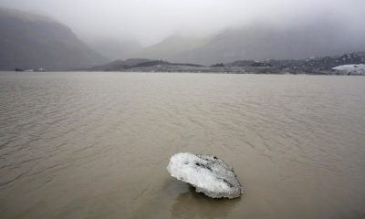

Today climate scientists and environmental activists refer to our postmodern era as the Anthropocene Age whenever they critique Western civilization’s impact upon the changing climate and the planet’s future ecological shifts and transformations. Indeed modern industry and technology is destroying the planet unwittingly. Its carbon footprint is evidenced everywhere we look. But it has become so pervasive that it goes largely unnoticed. The food on our dining table has a history of greenhouse gas release. So do our mobile phones, computers, jeans and sneakers, and so much more. Aside from extreme weather events, we often fail to notice the immediacy and rate of these changes, such as the arrival of certain predatory beetles invading trees on our lawns or the arrival of a plant species in our neighborhood park that should only thrive in a different clime. Or the arrival of new blights decimating forests.

A five-year University of Delaware study predicted that 72% of Southern states’ needlegreen evergreen trees will disappear by 2050 due to the southern pine beetle. The insect is native to Central America, however, since 1990, milder winters have enabled the pest to migrate as far north as New Jersey and more recently onto Long Island. Massive tree die offs are occurring throughout North America and other continents.
When Los Alamos National Laboratory, along with scientists from 18 other institutions and federal agencies, ran multiple global warming simulations to check and cross-check their results, the conclusion remained the same: climate change was the machine driving massive tree and forest die-offs. This includes the great boreal forest reaching around the planet’s northernmost clime and one of the most important and last natural resources that assures we have oxygenated air to breathe. Already it is being observed that peat in the world’s boreal forests is decomposing at an astonishing rate and releasing methane, a greenhouse gas far more potent and dangerous than carbon dioxide.

On the US Pacific coast, a jelly-like creature known as a pyrosome has migrated from its native warmer tropical waters off the Central American coast as far north as the Gulf of Alaska. Pyrosomes are an invasive species, as are many other organisms that are multiplying with increasing global temperatures. These zooids are now so plentiful that fish school populations are threatened. They interfere with the fishing industry and fisheries and as a consequence the proliferation of pyrosomes has a direct adverse impact on communities and economies. In her book Stung! On Jellyfish Blooms and the Future of the Ocean, author Lisa Ann Gershwin writes,

“We are creating a world more like the late Precambrian than the late 1800s–a world where jellyfish ruled the seas and organisms with shells did not exist. We are creating a world where we humans may soon be unable to survive, or want to.”
Gershwin further explains how the increase in jellyfish contribute to global warming. On the one hand, jellyfish consume enormous quantities of diatoms and other plankton, which help sequester carbon dioxide and expel oxygen. Second, jellyfish excrete carbon-rich waste taken up by ocean bacteria. As the number of bacteria increases in parallel to blooming jellyfish populations, they are converted into miniature factories pumping out carbon dioxide into the atmosphere and further acidifying the oceans’ waters.
Or if you go to a market, would you notice that fish, including tuna and cod, are getting smaller? Fish too are directly affected by global warming. This was the conclusion of scientists at the Institute for the Oceans and Fisheries at the University of British Columbia based upon empirical data. Warmer oceans means less oxygen to sustain fishes’ bodily functions because “fish are constrained by their gills in the amount of oxygen they can extract from water.” The study estimates that 3.4 million metric tons of fish will be lost for each degree Celsius of atmospheric warming.

These several short stories reveal adverse effects happening at this very moment in the US alone due to global warming. They are among many thousands of others occurring across the globe. When we speak about climate change, the boundaries that divide national interests become irrelevant. Climate change and the heating planet is a global crisis of our own making. And very little is being done at either the political domestic and international levels to abate the sources and causes of this emergency.
Before the orgy of fossil fuel exploitation and consumption switched into hyper-drive around 1950, there were 90 percent more fish in our oceans. There was 40 percent more phytoplankton, one of the most important manufacturers of our planet’s oxygen and an essential organism necessary to counter acidity caused by human waste and pollution. In less than 70 years, humans have already removed twice the number of trees still standing in the world’s forests and jungles. There would be three times more fresh water. And there would be over 30 percent less greenhouse gases, especially carbon dioxide in the Earth’s atmosphere. What is equally important to run through our mind’s imagination is the gloomy scenario that during this same 70 year period, as the resources to sustain human life dwindle, our population steadily increases. Since 1950 (2.5 billion people) it will nearly triple to 7.6 billion by 2020. The simple math is clear that humanity is headed towards extremely dark and frightening times in the very near future.
It is comforting to become complacent and simply consider the gradual decay and death of the planet’s ecosystems as unusual or freak coincidences. Rarely do we give thought about the deeper causal factors that point directly back to our individual and societal behaviors. Winters start later; spring arrives earlier. Prolonged rainfalls and extreme weather incidents are perceived as mere aberrations, as are months of excessive heat and drought. Scientists are fond of saying this is the new “normal” just as the mainstream media would have us believe that obesity and a shorter life span are new norms as well. But life continues. We passively accept the adverse changes subtlety affecting our lives. Assimilation and adaptation to inimical change is far easier and more comforting than waking up from our ignorance or denial of life-threatening problems. People simply say, “that was a weird year” or “the weather has been very strange lately,” and assume everything will return to a median range the following year. Everything is supposedly cyclic, right? But the later years of normalcy don’t reappear. Each year witnesses new record-breaking weather events somewhere in the world. And this is part of what the Anthropocene Age reflects.
So what is meant when we say that humanity and all other species, and the very planet itself, have entered the Anthropocene Age? The Anthropocene means more than what humanity does today or has done in the past since the dawn of modern industrial society over two hundred years ago when the steam engine was invented. The term is not descriptive solely of our present century but refers to an entire age in geological time. The earlier Cenozoic Era started 65 million years ago after the extinction of non-flying dinosaurs and the rapid appearance of mammals. Earlier geological ages also experienced catastrophic changes. The last and more recent Holocene era began at the end of the ice age approximately 11,700 years ago. But these changes were based upon natural geophysics and phenomena occurring within the planet’s geological systems. Or they were accidental such as the case of an asteroid, roughly 6 miles in diameter, smashing into the Earth’s surface and overnight altering the atmosphere and global temperature, which gave rise to the Cenozoic Era.
The Anthropocene is also utterly unique in geological time. It is not only the geophysical rhythms altering the planet naturally. That was the case for the previous epochs. During the past two hundred years, a new agent of geological change has appeared: modern Homo sapiens and the emergence of an industrialized civilization alienated from Nature and its origins. And this agent has now become so pervasive and independent from its natural lifeline, so alienated from its natural home which brought it forth, that like the Cenozoic asteroid, humanity has morphed into an alien power affecting and reshaping all geo- and eco-systems that would otherwise keep the Earth in a natural state of equilibrium and balance. This is the era of Anthropos, the Greek word for “human” but also appropriately the name of a social robot designed to mimic human behavior by Media Lab Europe. It is a new geological age of our own creation.
In 1873, an Italian geologist named Antonio Stoppani observed that humans were increasing their influence upon the world thereby adversely affecting the Earth’s ecological systems. He proposed that the planet was entering a new era in its geological history, which he called the “anthropozoic era,” the seventh geological age since the Earth formed in the Solar System as a cluster of gas and dust 4.6 billion years ago, and the eighth epoch during the age of mammals which began 65 million years ago. During his lifetime Stoppani’s insights and predictions failed to take hold in the scientific community. Western civilization was still in the midst of the Enlightenment’s euphoric high over the sudden burst of scientific discoveries and the powers of reason over instinct. It was during this Age of Reason when Darwin’s theory of human evolution took hold of the intellectual imagination and gradually merged with utopian myths of infinite industrial and economic progress. The myth has since solidified into the Western consciousness, creating a worldview that today perceives our species as the masters and gods of creation, the supreme rulers of its terrestrial destiny.

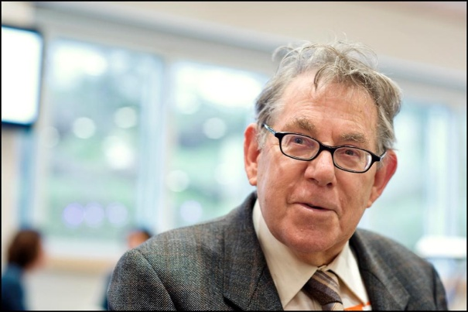
The geological sciences would have to wait another hundred years before a Dutch atmospheric chemist and Nobel Prize laureate who first observed the hole in the ozone layer, Paul Crutzen (image on the left), defined the Anthropocene Age as the arrival of a new epoch in Earth’s geological history. Crutzen observed that human activity had passed a threshold whereby it had become the dominating and overwhelming force shaping the planet’s internal systems and geology. According to Crutzen and his college Eugene Stoermer, a biologist at the University of Michigan, it was towards the end of the eighteenth century that the Anthropocene Age commenced with the first scientific evidence of two greenhouse gases, CO2 and methane, being generated by human industrial society. Today the definition has stuck and is rapidly becoming a household term.
But what does it mean for the Earth to have entered a new geological epoch? To better understand the full significance of the Anthropocene as a new geological era, imagine for a moment that all humans suddenly disappeared from the face of the Earth tomorrow. Or imagine we have all been beamed up into outer space by an alien race to free the Earth from humanity’s destructive actions. Even with humanity absent, for the next ten to fifteen thousand years, all subsequent geological and climatic events will have a direct or indirect relationship to past human activities. Our civilization’s footprints are so pervasive across the Earth’s geo- and atmospheric systems that they will linger for many millennia, well after our species goes extinct. And it is with this arrival of the Anthropocene that humanity has emerged as the primary perpetuator of ecocide, the ruler and destroyer of the planet’s environment, ecosystems and habitats.
A former member of the Australian government’s Climate Change Authority, Clive Hamilton, writes, “The arrival of the Anthropocene contradicts all narratives, philosophies, and theologies that foretell a preordained and continuous rise of humankind to ever-higher levels of material, social and spiritual development.” In his 2017 book, Defiant Earth: The Fate of Humans in the Anthropocene, Hamilton warns of the scientific hubris driving western nations to imagine we can geoengineer the weather, reduce the destructive threats of greenhouse gases, and assure the further growth of human capital and technological development to solve all of our civilization’s and planet’s problems as they arise. For Hamilton, the Anthropocene demands that everything we have taken for granted about our civilization–economic development, globalization and trade, politics and foreign policy, social structures, and more–needs to be reevaluated. More important there is an urgent demand for a completely new relationship humanity must create with the Earth and other species. Finally, it is time for nations, their rulers, and the leaders of industry to come to terms with the fact we are no longer able to turn back the geological clock.

If we limit our definition of the Anthropocene solely to climate change, we fail to grasp the larger picture and won’t recognize what is truly as stake. It is true that climate change has been the primary rationale for the term’s coinage. Yet humans are altering the planet’s geology, ecosystems and biodiversity in numerous other ways that are either indirectly related to the warming planet or something quite different. These other anthropogenic impacts and threats for human survival are more recent and coincide with the burgeoning of post-industrial technology and humanity’s desire to conquer, dominate and manipulate Nature solely for its own greed and needs. Modernity moves further away from the natural fabric of life upon which our lives depend for survival. This trend continues to increase, even among the younger generations, which now spend less time playing outdoors and more time in front of computers, television sets and electronic games.
Richard Heinberg, a director at the Post Carbon Institute in California, warns that the continual expansion of modern civilization has long over-shot the Earth’s capacity to provide the necessary resources upon which our lives depend. This problem, argues Heinberg, is the result of a severe imbalance in our human systems. The problem was first laid bare in 1972, when a group of MIT researchers released the now prophetic study Limits of Growth. The report accurately predicted many of the threats our societies face due to resource depletion, food production, manufacturing industries, over population, rising pollution, etc. It was the first important study to confirm that our civilization’s worldview that there can be infinite economic progress that depends upon finite natural resources is a recipe for catastrophic collapse. For over forty years, leading ecologists have understood the human dilemma by systems thinking. In order to fully comprehend the big issues facing us, including our individual lives, it is imperative we put aside linear, rational thinking, and look at our problems systemically. This includes the many ways we understand our own health and the available solutions to tackling the problems of disease.

Nothing in Nature is linear. Nature operates according to a systems theory. It is inherently holistic, meaning the whole of Nature is greater than simply the sum of its parts (individual ecologies) and there are numerous interdependent relationships between those parts. This is as true for recognizing the larger consequences of climate change as it is for understanding the environmental costs of species extinction, destruction of the planet’s ecosystems, monocrop agriculture and the livestock industry, deforestation, massive mining operations and so much more. Unfortunately, our political institutions and the tunnel vision of private interests are unable to grasp the systemic outcomes behind their actions. If they were, there would no longer be climate change denialists in public office. For this reason, technology will not ultimately save us.
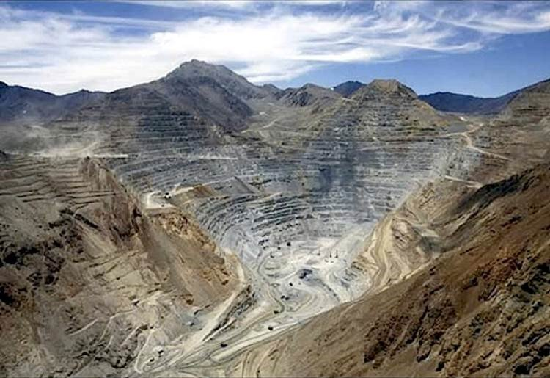 A photo of a massive Antofagasta open pit copper mine in Chile. (Source: D. Gary G Kohls)

Technology itself, including “green” technologies such as solar power and wind turbines, also relies upon resources that leave a carbon footprint. Solar panels require the use of arsenic, aluminum, cadmium, copper, gallium, sliver, tellurium and other metals. Wind turbines require steel alloys, nickel, chromium, aluminum and manganese. Most of these metals require mining, and all mining operations rely upon fossil fuels and emit greenhouse gases. Mining also contributes to ecological depletion of trees, flora and advances soil degradation. For sure, technologies will buy time. But none of them are the silver bullet to slam on the breaks of accelerated warming altogether. Perhaps one of the only promising solutions is an enormous scaling back on progress and development, which follows the old 1970s mantra “reduce, reuse, recycle.” But such a policy is completely contradictory to the entire neoliberal economic machine that fuels corporate globalization and expanding markets. In short, climate change and the environment are moral issues, and free market capitalism, according to Jerry Mander and founder of the International Forum on Globalization, is fundamentally amoral and without any human value other than currency.

Our modern civilization is also reorganizing and shapeshifting the very DNA of terrestrial life. The evolutionary tree of life, which required billions of years of change, innovation, adaptation and development to bring forth the natural vitality of the world we live in today, is being transformed by technological alterations in a laboratory. In an article appearing in Anthropocene Magazine, Andrew Revkin wrote that “the revolutionary genetic editing tool CRISPR is poised to imprint humans’ ambitions at least as profoundly as fossil fuels have changed the physical world.” The tree of life, Revkin observes, and which Darwin envisioned, has been “utterly disrupted now that DNA sequencing allows a more complete view” of living organisms.

Unfortunately the nations of the world have yet to come to grips with the hotly debated long term ramifications of genetic engineering. Even less so, does science fully acknowledge the possible crises that may emerge through the interplay of released genetically modified organisms and abrupt climate change? For example, the Second Green Revolution’s promise of more resilient crops to survive future pest and weed invasions and to produce higher yields from genetic engineering is rapidly crumbling.
If you visit any GMO soy field in the American Mid-West, mixed among the paler green soy plants you will observe taller, lusher and darker green plants or hogweed gradually dominating your view. Similar to microbial resistance to antibiotic therapies due to over-prescribing, super weeds are increasingly becoming resistant to Monsanto’s and the other agri-chemical companies’ toxic products. Crops grown by chemical industrial practices, such as nitrogen fertilizers, an array of pesticides and herbicides, machine tilling, and higher demands for water, are turning out to be nutritionally inferior to their organic counterparts. They have also become more susceptible to pest invasions, which in turn requires further application of potent, toxic chemicals. Yields are decreasing. More frequent episodes of extreme drought and excessive precipitation due to global warming further compound the struggles farmers face. Our entire infrastructure of food security is over-taxed, severely stressed and more difficult to keep afloat as more fertilizers, toxic chemicals and water are demanded. This positive feedback mechanism–an initial chemical based agriculture model that requires more of the same in order to keep pace with climate change–further drags down yields and creates additional economic and health stresses on people and families.
When we step back and take a look at our culture’s anthropogenic footprint, we must also take into account other activities besides burning fossil fuels. Globally, tens of billions of tons of concrete, perhaps one of the most damaging substances on the environment ever invented, is used in construction and development. Private corporations smelt huge amounts of aluminum annually, which is an energy-intensive process. Energy spent on aluminum production is today more costly than the actual cost of the metal. Our soil, our rivers, lakes and the oceans are littered in plastic. The latest study conducted in 2016 estimated approximately eight million tons of plastic are dumped in the oceans annually. Worldwide the US’ reliance on plastic continues to increase, and the plastic industry is petroleum-based. WorldWatch estimates that 4% of petroleum consumed goes into the manufacturing of plastics. And the US leads the developed nations in recycling the least amount of post-consumer plastic. Over 90% of it, approximately 32 million tons, is simply discarded or dumped into landfills.
After water, according to Columbia University’s Earth Institute, “concrete is the most consumed substance on the planet.” The rate of concrete production today is equivalent to every person on the planet consuming three tons worth annually. Concrete manufacturing accounts for 5% of CO2 emissions during the heating process of limestone. And our planet’s landscape continues to be built upon concrete. Even as the Eastern sea board remains under alert for sudden bursts in sea rise (six times the global average between 2011 and 2015), flooding and higher surges during tropical storms, the insanity of rapid construction along the coast continues unabated. “It’s amazing to see construction along the East Coast,” writes University of Florida’s Arnoldo Valle-Levinson in Geophysical Research Letters. “That is the worst place to build anything.” He envisions the cities in the southeastern US becoming “Venice-like,” prone to tidal flooding, as global warming pushes forward.

Because Earth changes are driven by economic and industrial pursuits in the free-market, some researchers, such as Jason Moore at Binghamton University, argue our present age should be call the Capitalocene. For Moore and his followers, this is an age where our ecological degradation is being fueled by “inequality, commodification, imperialism and more.” Moore is certainly correct in many respects. However, the capitalist agenda is not the sole culprit now destroying the planet and human lives. Communist China is equally criminal, the world’s leader in greenhouse gas emissions and contributing to 30% of all anthropogenic CO2 release into the atmosphere. There are so many criminal defendants responsible for our climate catastrophes who are determined to keep the fossil fuel economy alive. In July 2017 the Climate Accountability Institute and its partners released a report charging only 100 corporations as being responsible for 71% of all global greenhouse gas emissions since 1988. If our governments were in fact democratic and possessed any integrity, these firms would be held responsible for untold damage done to the environment, towns and communities and families.
Today there is a growing consensus among many thought leaders who have spent much of their lives in the environmental movement that only widespread systemic change will ward off the colossal human suffering looming before us in the not too distant future. This requires forward-thinking action at every level of our modern society. And this begins with ourselves, dramatic changes in our own personal lives and then reaching out into our neighborhoods, towns, communities. “Even if our efforts cannot save consumerist industrial civilization,” notes Richard Heinberg, “they could still succeed in planting the seeds of a regenerative human culture worthy of survival.” This systemic approach, coupled with a “moral awakening,” Heinberg believes, is the only real hope for survival before us.
*Richard Gale is the Executive Producer of the Progressive Radio Network and a former Senior Research Analyst in the biotechnology and genomic industries.
Dr. Gary Null is the host of the nation’s longest running public radio program on alternative and nutritional health and a multi-award-winning documentary film director, including Poverty Inc and Deadly Deception.

The original source of this article is Global Research
Copyright © Richard Gale and Dr. Gary Null, Global Research, 2018

