The Importance of Integrative Medicine in the Treatment of HIV/AIDS

By Gary Null, PhD
February 10, 2014

On December 2, 2013 president Obama marked the 25th Anniversary of World AIDS Day by pledging $100 million to research on finding a cure for HIV. Discussing his new push for funding, Obama remarked that “The United States should be at the forefront of new discoveries into how to put HIV into long-term remission without requiring lifelong therapies, or better yet, eliminate it completely.” However laudable this commitment to ending the war on HIV/AIDS is, we must question how it is that billions of dollars spent for decades on a pharmaceutical-based treatment has not yielded better results.
For our answers let’s go back to December 9, 1993, when more than 100 persons assembled with their physicians and their medical records in New York City at a major press conference. They had been selected over a twelve month period if they could prove with medical verification, including blood work up, viral load, CD4 and CD8 count, that they had made major improvements without relapse with their AIDS diagnosis. These individuals followed more than 20 different alternative treatments programs. An independent panel of medical and scientific experts brought to the press conference more than 25,000 scientific references (see examples in footnotes below) from the peer-reviewed literature to verify the medical veracity, efficacy and safety of any given protocol used by the patients. Herbs, botanicals, homeopathic and naturopathic remedies, intravenous vitamin drips, ozone therapy, meditation, detoxification, stress reduction, a plant-based diet, and antioxidants therapy were all examined for their antiviral, antibacterial and anti-yeast and/or immune-modulating impacts. Therefore, if one of the patients were to suggest that they were following the Louise Hay, Gerson, or Ann Wigmore protocols, it would not have been difficult to have understood how these protocols were helping these individuals’ bodies.
All of this was precipitated more than a year and a half earlier by a group of AIDS patients who came each day to a medical facility in the Upper West Side of Manhattan to be attended by a group of physicians, nurse practitioners, and other therapists helping them to restore their immune systems and adopt a more positive, optimistic state of mind. The theoretical framework behind our program was simple: instead of trying to kill the virus with antiretroviral pharmaceuticals designed to stop viral replication before it kills patients, we focused on what benefits could be gained by building up the patients’ natural immunity and restoring biochemical integrity so the body could fight for itself.
As they began to make major improvements, one of the patients spoke up one evening. He explained that in addition to his own progress in combating AIDS naturally, he knew of other individuals who were using more natural and holistic modalities all across the country and that the world didn’t know of this. The world only knew of the official AIDS treatment: AZT. He and the other people being treated at the facility all feared the mainstream treatment because they had seen how many of their friends and partners as well as other AIDS patients had died or become extremely sick using these aggressive drugs and yet, the natural modalities had been virtually ignored in any public discussion on AIDS. So it was at their urging that the press conference evolved.
That day in December could have been historic if only members of the press, scientific community, government agencies, activist organizations and foundations had chosen to attend and been open to a different medical paradigm. Despite the fact that more than 7,000 individuals from the media and these other groups had been invited on three separate occasions in the months leading up to the press conference, not one showed up. Clearly this was an intentional boycott. As a result, the patients spent the entire afternoon, each giving their own testimonials, showing their records and having their physicians speak about the remarkable improvements they saw; but the findings presented largely remained a secret from the rest of the world.
Tony Brown, of PBS, learned of the press conference and began to look carefully and meticulously at the AIDS patients who had made remarkable recoveries, inviting more than eight to appear on his national television program. I was also invited to appear on Tony Brown's program since these were my protocols and I had been working every day with these specific individuals for more than 16 months. The program profiled one man named Louie, who submitted medical records showing that he experienced a life-affirming reversal of AIDS and all of its conditions. You can go to Tony Brown’s Journal archives and review the entire film at your leisure.
Up to that point, I had spent every day for years working with people with AIDS-defining conditions, written twenty-two articles on living with AIDS naturally and a 750 page reference book with nearly 100 pages of it covering how to treat AIDS naturally. Further, I had produced a documentary, Living with AIDS Naturally: The Real Heroes, chronicling the story of AIDS patients in the nineties that did not respond well to orthodox therapy but improved after incorporating natural holistic protocols to their treatment programs.
After all this, one would have thought that this information would have permeated into the mainstream AIDS dialogue. In fact, just the opposite occurred. Because I challenged the safety and efficacy of AZT and called into question the science behind conventional AIDS treatment, I was personally attacked as an AIDS denialist, which I categorically deny. There is no debate that HIV exists and that it attacks the immune system. What is still up for debate is whether pharmaceutical drugs are the complete answer. Back then and still today, there is no opportunity for questioning, you are either on board or thrown overboard and then attacked.
Despite the array of devastating side effects that AZT is known to produce, it is still used today in combination with other medications, albeit at much lower doses. Today, if any physician were to prescribe AZT in the same amount that was typical in the 1980s and early 1990s, they would more likely than not be brought up for medical malpractice. While survival rates have increased with the introduction of new anti-retroviral treatments, the mainstream treatments continue to focus on pharmaceutical drugs to the exclusion of holistic lifestyle therapies. This is especially alarming given the extensive body of independent scientific research spanning decades that indicates that we were right all along about the critical importance of treating AIDS patients by incorporating a comprehensive, immunity-enhancing behavior and lifestyle modification approach that incorporates diet and nutritional therapies, detoxification, exercise, meditation and stress reduction.
As public awareness about the therapeutic value of alternative approaches to health and wellness increases, a growing number of individuals and groups within the scientific community are calling attention to the benefits of an integrative approach to AIDS. Given President Obama’s recent pledge of $100 million towards a cure for HIV/AIDS, it is clear that drugs alone are not the answer. By shifting the paradigm to one that embraces and incorporates proven natural methods, we have the potential to revolutionize modern HIV/AIDS treatments and empower individuals to achieve greater health and longevity.

Summary of Appendices

Below in Appendix A, I have included a sample AIDS protocol outlining the program I have used for decades to help countless individuals deal with their HIV/AIDS naturally. In Appendix B I have included recent direct quotations on healing HIV/AIDS from prominent individuals working in the medical and public health fields. Appendix C is a compilation of hundreds of peer-reviewed scientific studies showing the immune-enhancing benefits of a wide range of plant-based foods, herbs, supplements and other natural modalities on patients with HIV/AIDS. This collection of scientific articles contains the scientific justification for a whole-body approach to healing HIV/AIDS. Appendix D features an article on natural AIDS treatments written by me and Adam Atkin, PhD and published in 1996 in the prestigious Townsend Letter for Doctors & Patients. The article offers research-based evidence showing the effectiveness of natural treatments on AIDS from 17 years ago. Since then, our understanding of how to combat AIDS through non-toxic, immune-boosting therapies has expanded a great deal more. Appendix E contains photographs from the AIDS Is Not a Death Sentence Press Conference Photographs- December 9, 1993.

Appendix A:

Sample Protocols

PROTOCOL DISCLAIMER

-The protocol below is not in any way to be construed as a prescription to cure the condition, but as nutritional, lifestyle and behavior modification suggestions only. Always consult with a physician for guidance on specific health issues and before following this or any other protocol.
- Patient’s diagnosis, treatment, and medications must be considered in determining if any of the suggested vitamins, minerals, foods, and herbs in contraindicated. Special considerations should be given to pregnant and nursing mothers. Many supplements do not have a suggested dosage. Individual clinicians must make individual recommendations based on the patient.
-The protocol below must be implemented in gradual steps. It is suggested to begin with low doses of one or two items of the protocols suggested items to determine the patient’s acceptance and tolerance. Once it is determined that the patient has adapted, the dosage should be increased in gradual steps.

Sample HIV/AIDS Protocol

In addition to the detoxification lifestyle protocol (see below), consider the following:

Diet
The diet is an immunosupportive DNA-reparative, cleansing and Ph rebalancing program. It is recommended to begin the day with a large smoothie containing a tablespoon of one of the following healthy oils: black cumin seed oil, coconut oil, flaxseed oil, as well as a handful of either walnuts, almonds cashews, pistachios, sunflower seeds, pumpkin seeds or chia seeds, concentrates from blueberry, pomegranate, tart cherry, noni, papaya, a teaspoon of probiotic powder containing at least 5-10 billion CFU, as well as 30-40 grams of a high-quality, non-GMO protein, either from rice, pea, hemp, or soy.
Include smaller meals throughout the day with a full spectrum of sea vegetables, fermented foods, starchy vegetables, legumes, whole grains, liberal amounts of garlic and onion and wild fish (preferably sardines and salmon).
Drink either wheatgrass juice, bitter melon juice with raw honey and bee propolis,
or combinations of vegetable and fruit juices throughout the day- ideally 16 oz. each.

Supplements
L-Carnosine/Acetyl L-carnitine
Whey protein 30-60g/day
SAMe 400-800mg/day
Magnesium- 400 – 500 elemental mg
Calcium – 400-500 mg
Vit B 6 (pyridoxine)
Vit B 12
Folic acid
SOD
DMG
Pancreatic and proteolytic enzymes
Multimineral supplement
EFA’s: borage, omegas 3&6, GLA, EPA
Lecithin
Co Q 10 1,000mg
Curcumin
DHEA
Citrus bioflavanoids
Ginseng
Milk Thistle
Green Tea Extract
Monolaurin
Melatonin
NAC 1000mg-1800mg three times a day
Grape Seed Extract 400mg
Alpha lipoic acid 300mg twice a day
Vit B 2 (Riboflavin)
Beta carotene/vitamin A
Vit B 1 (thiamin)
Vit B 3 (niacinamide)
Vit B 5 (pantothenic acid)
Evening Primrose Oil
Vit C 2,000-10,000mg/day
Quercetin 3,000mg
St. John’s wort 300mg
Vit E – mixed tocopherols
Vit K
Zinc
Vanadium
Garlic/ cayenne
Green Tea extract
MSM
Selenium 200 mcg twice a day
Chromium picolinate
Activated lipids (AL 7/21)
Germanium
Astragalus
Silymarin
Eurocel
Lactoferrin
Probiotics

Other medically supervised therapies
Ozonated colonics/coffee enemas
HBOT- hyperbaric oxygen therapy
IV Vitamin C drips and bio-oxidative therapies require MD orders
IV DMSO
Chinese herbs/AMMA/Acupuncture
Bach flower remedies
Hyperthermia
Homeopathic remedies
Positive Visualization
Guided Imagery
Stress Management Therapy
Hydrazine sulfate if wasting syndrome occurs
Check cortisol levels regularly

Topical
Virgin Castor oil
Calendula
Aloe/avocado oil baths
Aerobic exercise
Colloidal copper spray

Sample Detoxification Lifestyle Protocol
Take the following daily as directed:
THE FIRST FOUR WEEKS:
Two (2) - 16 ounce glasses of green juice per day:
Juice 4 oz. dark & light green vegetables. Add 12 oz. Water -OR-
1 tablespoon of powdered dry green concentrate. Add 12 oz water.
In the above juices, add 1 oz. of aloe concentrate and add one teaspoon of red fruit dried concentrate.
AT NIGHT:
Antioxidant complex Follow the instructions on the label
Garlic with cayenne powder Follow the instructions on the label
Psyllium bifidis fiber Follow the instructions on the label
Vitamin C 500-2500 mg
AFTER 4 WEEKS ADD:
Quercetin 550mg 3X/day
Pycnogenol 50mg 3X/day
L-Carnitine 250mg 2X/day
AFTER 4 MORE WEEKS ADD:
Brain complex, 3 capsules per day or
Ginkgo Biloba 100 mg (Consult your doctor if on blood thinners)
L-Phenylalanine 75 mg
L-Glutathione
L-Taurine
Choline Bitartrate Complex
Inositol
L-Glutamine
L-Tyrosine
Phosphatidyl Serine Naturleaf (enzyme enhanced)
Plant-Sprout sterols/sitosterolins 500 mg. 4x/day
MGN 3 500 mg 3x/day
Increase antioxidant complex to 5 times per day
B Complex 50 mg

DIETARY GUIDELINES:

1. No meat: Includes beef, poultry and shellfish. Replace with: cold water fish (wild salmon, sardines,) 4 times/ week; nuts, nut butters, seeds, soybeans and soy products, organic eggs, Quinoa (high protein grain): mix grains with beans.
2. No Dairy: Includes milk, yogurt, cheese, butter, ice cream, cream sauces.
Replace with: rice milk, soy milk, almond milk, Amazake, Silken tofu, oat milk. Nothing with “casein” in the ingredients.
3. No caffeine or alcohol: Includes chocolate, coffee, tea, wines, hard liqueur, etc. Replace with: herb teas, grain beverages (postum, cafix, Rajs’s cup), lemon water, and green tea.
4. No sugar/artificial sweeteners: Replace with: stevia root, raw manuka honey, molasses, brown rice syrup and pure maple syrup. May use chromium Picolinate (200 mcg.) for sugar cravings.
5. No carbonated drinks: Includes sodas, seltzer. Replace with: spring water, distilled water, filtered water or fresh squeezed organic fruit juice.
6. No bread or wheat: Replace with: spelt bread, sprouted whole grain bread, rice bread, Essene bread. Read the labels.
7. No non-organic produce: Replace with: organic produce, include potatoes (NOT Idaho), squash, sweet potatoes, yams, grains, beans, fruits, vegetables.
8. No fried/processed foods: Replace with: Steamed, sautéed, stir fried, grilled, broiled meals. Oils for cooking: coconut, macadamia, safflower oils. For baking: hazelnut, macadamia nut; For salads: Walnut, flax seed. Extra virgin cold pressed olive oil is OK to add to cooked foods; avoid cooking with the olive oil.
9. No food additives, preservatives, coloring agents, flavorings. MSG, or miso.

Eat primarily during the day; have your large meal between 1 pm - 3 pm: a very light breakfast and a light dinner (grains and any salad with dressing, sea vegetable and/or soup).

ORGANIC MEAL PROGRAM
Quality protein and amino acids 9/10th gr. / kg. of body weight / day
Approximately 40-60 gr./day for women and 50-80 gr./day for males
Suggestion: Begin by getting your protein from grains, legumes and seeds. If needed, protein powder supplements are useful in guaranteeing sufficient amounts. The diet should provide you with 40-50 grams of fiber per day.
Tofu & Tempeh
Grains & Sprouts: Millet, Buckwheat, Brown Rice, Spelt, Rye, Quinoa.
Organic raw vegetables and fruits - all types
Fatty Deep Water Fish: Salmon or Sardines 6-8 oz.
Raw Seeds, Raw Nuts
Tubers: Yams, Potatoes, or Sweet Potatoes
3-4 servings of the Cruciferous vegetables daily:
Broccoli, Cabbage, Cauliflower & Onions. Sea Vegetables.
Drink a minimum of 1 gallon of liquids which include purified water and juice.
1-2 cups green tea daily.
Lemon juices daily - to alkalize the body.
Digestive enzymes for fatigue.
If candida is present - use grapefruit seed extract 5-10 drops in water 3 X / day
Oil of oregano- as directed
Olive leaf extract-as directed

Exercise - Build up gradually to 1 hour/day of aerobic activity. Take your pulse throughout your aerobic work-out to make sure you are neither under nor over exerting yourself. Generally, your target rate is determined by taking 220 and subtracting your age and then multiplying the result by 70 percent. So a 31 year old person would have a rate of 220 minus 31 times 70 percent or 132.
In addition aerobic exercise you must do weight training 3 times per week.

Appendix B:

"There is a growing body of evidence that food and nutritional support are essential for keeping people living with HIV healthy for longer and for improving the effectiveness of treatment"
-Martin Bloem, Head of Nutrition and HIV, The United Nations World Food Programme

"Tens of billions of dollars have been pledged to combat AIDS, yet donor countries have largely overlooked the role of nutrition, somehow ignoring both the scientists and the beneficiaries,"
-Princess Haya Bint Al Hussein, United Nations Messenger of Peace

"Nutritional interventions for those living with HIV are so important to help maintain a strong and healthy body. I would strongly urge anyone who has been diagnosed with HIV to ask their treating doctor or nurse to refer them to a specialist Dietitian."
-Karen Percy, Lead Dietitian in the Multi-disciplinary Team of HIV and Infectious Disease at Chelsea and Westminster Hospital in Australia

Food is medicine in so many ways and with regard to so many medical conditions. For patients living with HIB and AIDS, it quite literally can mean the difference between tolerating medications and maximizing their benefit or suffering debilitating symptoms and a more rapid progression of infection.
-Rebecca Haag, CEO of AIDS Action Committee of Massachusetts and David B Waters, CEO of Community Servings Inc. From the Boston Globe, December, 10, 2012.
http://www.bostonglobe.com/opinion/2012/12/10/podiumaids/wLybFillREG0yU33BLX33I/story.html

“Nutritional interventions should be an integral part of all HIV treatment programmes.”
-World Health Organization, Geneva. “Nutrient Requirements for People Living with HIV/AIDS Report of a Technical Consultation” http://www.who.int/nutrition/publications/Content_nutrient_requirements.pdf

“Optimal nutrition is an important adjunct in the clinical care of patients with HIV. Nutritional interventions may improve the quality and span of life and symptom management, support the effectiveness of medications, and improve the patient’s resistance to infections and other disease complications by altering immunity.”
-Somarriba, G., Neri, D., Schaefer, N., Miller, T.L. "The Effect of Aging, Nutrition, and Exercise during HIV Infection." HIV AIDS (Aukl) 2 (2010): 191-201. http://www.ncbi.nlm.nih.gov/pmc/articles/PMC3218696

“The more diverse and nutrient-rich the diet before starting antiretroviral treatment, the less severe HIV disease progression is, and the less likely death occurs.”

-Rawat R et al. “Poor diet quality is associated with low CD4 count and anemia and predicts mortality among antiretroviral therapy naive HIV-positive adults in Uganda.” Advance online edition J Acquir Immun Defic Syndr. Doi: 10.1097/QAI.0b013e3182797363, 2012.

Also among the individuals calling for nutrition-based protocols is the scientist who actually discovered the AIDS virus, French virologist and Nobel Laureate Dr. Luc Montagnier. In a 1995 interview with Richard A, Passwater, PhD, Dr. Montagnier, stated the following:

I am convinced that oxidative stress is indeed involved in the progression of going from HIV infection to the AIDS stage. I believe, therefore, that antioxidants are necessary in the treatment , but antioxidants are not sufficient by themselves.
I advocate adapting the treatment to the patient. Antioxidants are important, but in order to be effective, they must be rationally used. We must take into account the parameters of each individual. Some may lack selenium, or zinc, or vitamin E, or other nutrients, or any combination. So our treatment must be planned according to these parameters, and thus, our treatment may change from one individual to another. The treatment must be adapted to the individual to restore these parameters that we are measuring back to normal.
We should monitor the markers of oxidative stress such as lipid peroxides which increase when opportunistic infection occurs, as well as the carbonyl content of lymphocyte proteins, cytokines and Tumor Necrosis Factor (TNF). We have laboratory studies showing that the proteins of lymphocytes are very rapidly degraded due to oxidative stress.
These parameters will be evaluated and then patient treatment may include several antioxidants such as NAC, beta carotene, vitamins A, C and E, the enzymes superoxide dismutase (SOD) and catalase, proteins such as metallothionine, plant extracts and other nutrients as indicated.
Appendix C:

Topic: Acetyl-l-carnitine
Acetyl L-carnitine has a therapeutic effect in the symptomatic treatment of antiretroviral toxic neuropathy in patients with HIV-1 infection. - GMI Summary
Pubmed Data : HIV Med. 2007 May;8(4):241-50. PMID: 17461852
Article Published Date : May 01, 2007
Authors : M Youle, M Osio,
Study Type : Human Study
Additional Links: Substances : Acetyl-l-carnitine : CK(650) : AC(37)
Diseases : HIV Drug-Induced Toxicity : CK(68) : AC(13), HIV Infections : CK(551) : AC(183), Neuropathic Pain : CK(177) : AC(23)
Pharmacological Actions : Anti-HIV Agents : CK(116) : AC(59)

Acetyl L-carnitine treatment improves symptoms and causes peripheral nerve regeneration in HIV-associated anteretroviral toxic neuropathy. - GMI Summary
Pubmed Data : AIDS. 2004 Jul 23;18(11):1549-60. PMID: 15238773
Article Published Date : Jul 23, 2004
Authors : Andrew M Hart, Andrew D H Wilson, Cristina Montovani, Colette Smith, Margaret Johnson, Giorgio Terenghi, Mike Youle
Study Type : Human Study
Additional Links: Substances : Acetyl-l-carnitine : CK(650) : AC(37)
Diseases : HIV Drug-Induced Toxicity : CK(68) : AC(13), HIV Infections : CK(551) : AC(183), Neuropathic Pain : CK(177) :AC(23)
Pharmacological Actions : Reverse Transcriptase Inhibitors : CK(42) : AC(24)

Acetyl-L-carnitine has a positive long-term effect in the treatment of antiretroviral toxic
neuropathy. - GMI Summary
Pubmed Data : HIV Clin Trials. 2005 Nov-Dec;6(6):344-50. PMID: 16566084
Article Published Date : Nov 01, 2005
Authors : Christian Herzmann, Margaret A Johnson, Mike Youle
Study Type : Human Study
Additional Links: Substances : Acetyl-l-carnitine : CK(650) : AC(37)
Diseases : HIV Drug-Induced Toxicity : CK(68) : AC(13), HIV Infections : CK(551) : AC(183), Neuropathic Pain : CK(177) : AC(23)
Pharmacological Actions : Reverse Transcriptase Inhibitors : CK(42) : AC(24)

Acetyl-l-carnitine was effective and well tolerated in symptomatic treatment of painful
neuropathy associated with antiretroviral toxicity. - GMI Summary
Pubmed Data : J Peripher Nerv Syst. 2006 Mar;11(1):72-6. PMID: 16519785
Article Published Date : Mar 01, 2006
Authors : Maurizio Osio, Francesco Muscia, Luisa Zampini, Caterina Nascimbene, Enrico Mailland, Antonietta Cargnel, Claudio Mariani
Study Type : Human Study
Additional Links: Substances : Acetyl-l-carnitine : CK(650) : AC(37)
Diseases : HIV Drug-Induced Toxicity : CK(68) : AC(13), HIV Infections : CK(551) : AC(183), Neuropathic Pain : CK(177) : AC(23)

Topic: Bitter Melon
Bitter melon appears to have therapeutic activity in the treatment of HIV infection.
- GMI Summary
Pubmed Data : AIDS Asia. 1995 Jul-Aug;2(4):6-7. PMID: 12346831
Article Published Date : Jul 01, 1995
Authors : S P Rebultan
Study Type : Human Study
Additional Links: Substances : Bitter Melon : CK(65) : AC(18)
Diseases : HIV Infections : CK(551) : AC(183)
Pharmacological Actions : Anti-HIV Agents : CK(116) : AC(59)

Bitter melon contains compounds with anti-HIV activity. - GMI Summary
Pubmed Data : Thyroid. 2000 Aug;10(8):659-63. PMID: 7665070
Article Published Date : Aug 01, 2000
Authors : S Lee-Huang, P L Huang, H C Chen, P L Huang, A Bourinbaiar, H I Huang,
H F Kung
Study Type : Human Study
Additional Links: Substances : Bitter Melon : CK(65) : AC(18)
Diseases : HIV Infections : CK(551) : AC(183)
Pharmacological Actions : Antiviral Agents : CK(627) : AC(290)

Topic: Curcumin
Curcumin is an effective treatment for HIV-associated diarrhea. - GMI Summary
Pubmed Data : Dig Dis Sci. 2009 Oct;54(10):2188-91. Epub 2008 Dec 3. PMID: 19051018
Article Published Date : Oct 01, 2009
Authors : Chris N Conteas, Abraham M Panossian, Timothy T Tran, Hardeep M Singh
Study Type : Human Study
Additional Links: Substances : Curcumin : CK(2802) : AC(1470)
Diseases : Diarrhea : CK(519) : AC(69), HIV Infections : CK(551) : AC(183)

Curcumin improves spatial memory impairment induced by human immunodeficiency virus type 1 in rats. - GMI Summary
Pubmed Data : Life Sci. 2009 Jul 3;85(1-2):1-10. Epub 2009 Apr 5. PMID: 19345695
Article Published Date : Jul 03, 2009
Authors : Hongmei Tang, Daxiang Lu, Rui Pan, Xuebin Qin, Huangui Xiong, Jun Dong
Study Type : Animal Study
Additional Links: Substances : Curcumin : CK(2802) : AC(1470)
Diseases:HIV-1-associated dementia(HAD):CK(2):AC(1),HIV Infections:CK(551):AC(183)

Curcumin and beta-lapachone inhibit HIV virus replication. - GMI Summary
Pubmed Data : Proc Natl Acad Sci U S A. 1993 Mar 1;90(5):1839-42. PMID: 8446597
Article Published Date : Mar 01, 1993
Authors : C J Li, L J Zhang, B J Dezube, C S Crumpacker, A B Pardee
Study Type : In Vitro Study
Additional Links
Substances : Curcumin : CK(2802) : AC(1470), Pau D'Arco : CK(14) : AC(14)
Diseases : HIV Infections : CK(551) : AC(183)
Pharmacological Actions : Antiviral Agents : CK(627) : AC(290)

Curcumin and curcumin-boron complexes exhibit anti-HIV activity. - GMI Summary
Pubmed Data : Bioorg Med Chem. 1993 Dec;1(6):415-22. PMID: 8087563
Article Published Date : Dec 01, 1993
Authors : Z Sui, R Salto, J Li, C Craik, P R Ortiz de Montellano
Study Type : In Vitro Study
Additional Links
Substances : Boron : CK(3) : AC(3), Curcumin : CK(2802) : AC(1470)
Diseases : HIV Infections : CK(551) : AC(183)
Pharmacological Actions : HIV Protease Inhibitors : CK(26) : AC(15)

Curcumin enhances indinavir antiretroviral activity in HIV-1 persistently infected cells. – GMI Summary
Pubmed Data : Arch Virol. 2008;153(3):561-5. Epub 2008 Jan 4. PMID: 18175040
Article Published Date : Jan 01, 2008
Authors : D A Riva, P N Fernández-Larrosa, G L Dolcini, L A Martínez-Peralta,
F C Coulombié, S E Mersich
Study Type : In Vitro Study
Additional Links: Substances : Curcumin : CK(2802) : AC(1470)
Diseases : HIV Infections : CK(551) : AC(183)
Pharmacological Actions : Antiviral Agents : CK(627) : AC(290), Enzyme Inhibitors : CK(385) : AC(210)
Additional Keywords : Drug-Plant-Vitamin Synergies : CK(1011) : AC(275)

Curcumin exhibits anti-HIV activity. - GMI Summary
Pubmed Data : Res Virol. 1998 Jan-Feb;149(1):43-52. PMID: 9561563
Article Published Date : Jan 01, 1998
Authors : S Barthelemy, L Vergnes, M Moynier, D Guyot, S Labidalle, E Bahraoui
Study Type : In Vitro Study
Additional Links
Substances : Curcumin : CK(2802) : AC(1470)
Diseases : HIV Infections : CK(551) : AC(183)
Pharmacological Actions : Antioxidants : CK(3471) : AC(1278)

Curcumin inhibits HIV-1 integrase activity. - GMI Summary
Pubmed Data : Biochem Pharmacol. 1995 Apr 18;49(8):1165-70. PMID: 7748198
Article Published Date : Apr 18, 1995
Authors : A Mazumder, K Raghavan, J Weinstein, K W Kohn, Y Pommier
Study Type : In Vitro Study
Additional Links: Substances : Curcumin : CK(2802) : AC(1470)
Diseases : HIV Infections : CK(551) : AC(183)
Pharmacological Actions : Antiviral Agents : CK(627) : AC(290)

Curcumin inhibits ultraviolet light induced HIV gene expression. - GMI Summary
Pubmed Data : Mol Cell Biochem. 2003 Dec;254(1-2):289-97. PMID: 14674708
Article Published Date : Dec 01, 2003
Authors : Mohiuddin M Taher, Guido Lammering, Chad Hershey, Kristoffer Valerie
Study Type : In Vitro Study
Additional Links: Substances : Curcumin : CK(2802) : AC(1470)
Diseases : HIV Infections : CK(551) : AC(183)
Pharmacological Actions : Enzyme Inhibitors : CK(385) : AC(210), NF-kappaB Inhibitor : CK(581) : AC(390)

Curcumin may have inhibitory activity against HIV-1 protease and integrase. –
GMI Summary
Pubmed Data : Am J Clin Nutr. 1995 Mar;61(3):585-9. PMID: 15950462
Article Published Date : Mar 01, 1995
Authors : Opa Vajragupta, Preecha Boonchoong, Garrett M Morris, Arthur J Olson
Study Type : In Vitro Study
Additional Links: Substances : Curcumin : CK(2802) : AC(1470)
Diseases : HIV Infections : CK(551) : AC(183)
Pharmacological Actions : Anti-HIV Agents : CK(116) : AC(59), Antiviral Agents : CK(627) : AC(290), Enzyme Inhibitors : CK(385) : AC(210), HIV Protease Inhibitors : CK(26) : AC(15)

Curcumin may have therapeutic value in HIV infection. - GMI Summary
Pubmed Data : Mol Nutr Food Res. 2010 Feb 19. Epub 2010 Feb 19. PMID: 15383533
Article Published Date : Feb 19, 2010
Authors : Karanam Balasubramanyam, Radhika A Varier, Mohammed Altaf, Venkatesh Swaminathan, Nagadenahalli B Siddappa, Udaykumar Ranga, Tapas K Kundu
Study Type : In Vitro Study
Additional Links: Substances : Curcumin : CK(2802) : AC(1470)
Diseases : HIV Infections : CK(551) : AC(183)
Pharmacological Actions : Antiproliferative : CK(939) : AC(711), Apoptotic : CK(1396) : AC(1086), Enzyme Inhibitors : CK(385) : AC(210), Histone deacetylase inhibitor : CK(25) : AC(16), Tumor Suppressor Protein p53 Upregulation : CK(119) : AC(96)

Topic: Fruit: All
A polyphenol and antioxidant rich fruit and vegetable concentrate has therapeutic value in HIV patients due to enhanced proliferation, which could restore disturbances in T-cell
homeostasis. - GMI Summary
Pubmed Data : Eur J Clin Nutr. 2004 Feb;58(2):317-25. PMID: 14749753
Article Published Date : Feb 01, 2004
Authors : P Winkler, S Ellinger, A M Boetzer, B M Arendt, H K Berthold, J K Rockstroh, U Spengler, R Goerlich
Study Type : Human Study
Additional Links
Substances : Fruit: All : CK(1902) : AC(468), Polyphenols : CK(415) : AC(171), Vegetables: All : CK(589) : AC(70)
Diseases : AIDS : CK(610) : AC(9), HIV Infections : CK(551) : AC(183)
Pharmacological Actions : Antioxidants : CK(3471) : AC(1278), Immunomodulatory : CK(514) : AC(144)

Plasma antioxidant capacity can be increased by long-term ingestion of polyphenols from fruit juices or fruit-vegetable-concentrate in HIV-seropositive patients.
- GMI Summary
Pubmed Data : Toxicol In Vitro. 2000 Oct;14(5):405-8. PMID: 11528495
Article Published Date : Oct 01, 2000
Authors : B M Arendt, A M Boetzer, H Lemoch, P Winkler, J K Rockstroh, H K Berthold, U Spengler, R Goerlich
Study Type : Human Study
Additional Links
Substances : Antioxidant formulas : CK(477) : AC(72), Fruit: All : CK(1902) : AC(468), Polyphenols : CK(415) : AC(171), Vegetables: All : CK(589) : AC(70)
Diseases : HIV Infections : CK(551) : AC(183)
Pharmacological Actions : Antioxidants : CK(3471) : AC(1278)

Topic: Neem
Neem has antimalarial and anti-HIV activity. - GMI Summary
Pubmed Data : Toxicol In Vitro. 2009 Mar;23(2):251-8. Epub 2008 Dec 13. PMID: 15138081
Article Published Date : Mar 01, 2009
Authors : I J Udeinya, A U Mbah, C P Chijioke, E N Shu
Study Type : Human Study
Additional Links: Substances : Neem : CK(88) : AC(19)
Diseases : HIV Infections : CK(551) : AC(183), Malaria : CK(56) : AC(25)
Pharmacological Actions:Anti-HIV Agents:CK(116):AC(59),Antimalarials:CK(22):AC(12)
Additional Keywords : Plant Extracts : CK(3263) : AC(1119)

Neem leaf extract safely increases CD4 cell levels in patients with HIV/AIDS.
- GMI Summary
Pubmed Data : Am J Ther. 2007 Jul-Aug;14(4):369-74. PMID: 17667213
Article Published Date : Jul 01, 2007
Authors : A U Mbah, I J Udeinya, E N Shu, C P Chijioke, T Nubila, F Udeinya,
Angela Muobuike, Ancila Mmuobieri, Maria S Obioma
Study Type : Human Study
Additional Links: Substances : Neem : CK(88) : AC(19)
Diseases : AIDS : CK(610) : AC(9), HIV Infections : CK(551) : AC(183)

Topic: Polyphenols
A polyphenol and antioxidant rich fruit and vegetable concentrate has therapeutic value in HIV patients due to enhanced proliferation, which could restore disturbances in T-cell homeostasis. - GMI Summary
Pubmed Data : Eur J Clin Nutr. 2004 Feb;58(2):317-25. PMID: 14749753
Article Published Date : Feb 01, 2004
Authors : P Winkler, S Ellinger, A M Boetzer, B M Arendt, H K Berthold, J K Rockstroh, U Spengler, R Goerlich
Study Type : Human Study
Additional Links: Substances : Fruit: All : CK(1902) : AC(468), Polyphenols : CK(415) : AC(171), Vegetables: All : CK(589) : AC(70)
Diseases : AIDS : CK(610) : AC(9), HIV Infections : CK(551) : AC(183)
Pharmacological Actions : Antioxidants : CK(3471) : AC(1278), Immunomodulatory : CK(514) : AC(144)

Plasma antioxidant capacity can be increased by long-term ingestion of polyphenols from fruit juices or fruit-vegetable-concentrate in HIV-seropositive patients.
- GMI Summary
Pubmed Data : Toxicol In Vitro. 2000 Oct;14(5):405-8. PMID: 11528495
Article Published Date : Oct 01, 2000
Authors : B M Arendt, A M Boetzer, H Lemoch, P Winkler, J K Rockstroh, H K Berthold, U Spengler, R Goerlich
Study Type : Human Study
Additional Links:
Substances : Antioxidant formulas : CK(477) : AC(72), Fruit: All : CK(1902) : AC(468), Polyphenols : CK(415) : AC(171), Vegetables: All : CK(589) : AC(70)
Diseases : HIV Infections : CK(551) : AC(183)
Pharmacological Actions : Antioxidants : CK(3471) : AC(1278)

Topic: Selenium
HIV-infected patients may have selenium deficiency associated with increased oxidative
stress. - GMI Summary
Pubmed Data : Bull Soc Pathol Exot. 2009 Feb;102(1):11-3. PMID: 19343912
Article Published Date : Feb 01, 2009
Authors : J Djinhi, G Tiahou, G Zirihi, E Lohoues, A Monde, C Camara, E Sess
Study Type : Human Study
Additional Links: Substances : Selenium : CK(571) : AC(93)
Diseases : HIV Infections : CK(551) : AC(183)

Selenium supplementation suppresses the progression of HIV-1 viral burden and improves CD4 count. - GMI Summary
Pubmed Data : Arch Intern Med. 2007 Jan 22;167(2):148-54. PMID: 17242315
Article Published Date : Jan 22, 2007
Authors : Barry E Hurwitz, Johanna R Klaus, Maria M Llabre, Alex Gonzalez,
Peter J Lawrence, Kevin J Maher, Jeffrey M Greeson, Marianna K Baum, Gail Shor-Posner, Jay S Skyler, Neil Schneiderman
Study Type : Human Study
Additional Links: Substances : Selenium : CK(571) : AC(93)
Diseases : HIV Infections : CK(551) : AC(183)

Topic: Vegetables: All
A polyphenol and antioxidant rich fruit and vegetable concentrate has therapeutic value in HIV patients due to enhanced proliferation, which could restore disturbances in T-cell
homeostasis. - GMI Summary
Pubmed Data : Eur J Clin Nutr. 2004 Feb;58(2):317-25. PMID: 14749753
Article Published Date : Feb 01, 2004
Authors : P Winkler, S Ellinger, A M Boetzer, B M Arendt, H K Berthold, J K Rockstroh, U Spengler, R Goerlich
Study Type : Human Study
Additional Links: Substances : Fruit: All : CK(1902) : AC(468), Polyphenols : CK(415) : AC(171), Vegetables: All : CK(589) : AC(70)
Diseases : AIDS : CK(610) : AC(9), HIV Infections : CK(551) : AC(183)
Pharmacological Actions : Antioxidants : CK(3471) : AC(1278), Immunomodulatory : CK(514) : AC(144)

Plasma antioxidant capacity can be increased by long-term ingestion of polyphenols from fruit juices or fruit-vegetable-concentrate in HIV-seropositive patients. –
GMI Summary
Pubmed Data : Toxicol In Vitro. 2000 Oct;14(5):405-8. PMID: 11528495
Article Published Date : Oct 01, 2000
Authors : B M Arendt, A M Boetzer, H Lemoch, P Winkler, J K Rockstroh, H K Berthold, U Spengler, R Goerlich
Study Type : Human Study
Additional Links
Substances : Antioxidant formulas : CK(477) : AC(72), Fruit: All : CK(1902) : AC(468), Polyphenols : CK(415) : AC(171), Vegetables: All : CK(589) : AC(70)
Diseases : HIV Infections : CK(551) : AC(183)
Pharmacological Actions : Antioxidants : CK(3471) : AC(1278)

Topic: Cinnamon
Cinnamomum zeylanicum has therapeutic activity in HIV-associated oral candidiasis. – GMI Summary
Pubmed Data : Am J Chin Med. 1996;24(2):103-9. PMID: 8874667
Article Published Date : Jan 01, 1996
Authors : J M Quale, D Landman, M M Zaman, S Burney, S S Sathe
Study Type : Human Study
Additional Links: Substances : Cinnamon : CK(142) : AC(63)
Diseases : Candida Infection : CK(197) : AC(92), Candidiosis: Oral : CK(20) : AC(2), Fungal Infection : CK(238) : AC(116), HIV Infections : CK(551) : AC(183)
Pharmacological Actions : Antifungal Agents : CK(170) : AC(108)
Additional Keywords : Plant Extracts : CK(3263) : AC(1119)

Cinnamon cassia and Cardiospermum helicacabum have significant anti-HIV activity. – GMI Summary
Pubmed Data : Indian J Med Res. 2000 Sep;112:73-7. PMID: 11094851
Article Published Date : Sep 01, 2000
Authors : M Premanathan, S Rajendran, T Ramanathan, K Kathiresan, H Nakashima,
N Yamamoto
Study Type : In Vitro Study
Additional Links
Substances: Cardiospermum helicacabum: CK(1): AC(1), Cinnamon: CK(142) : AC(63)
Diseases : HIV Infections : CK(551) : AC(183)
Pharmacological Actions : Anti-HIV Agents : CK(116) : AC(59)

Elderberry, green tea and cinnamon extracts rich in certain flavonoid compounds were shown to block HIV-1 entry and infection. - GMI Summary
Pubmed Data : Antivir Chem Chemother. 2009;19(6):243-55. PMID: 19641233
Article Published Date : Jan 01, 2009
Authors : Ryan C Fink, Bill Roschek, Randall S Alberte
Study Type : In Vitro Study
Additional Links: Substances : Cinnamon : CK(142) : AC(63), Elderberry : CK(84) : AC(10), Green Tea : CK(931) : AC(279)
Diseases : HIV Infections : CK(551) : AC(183)
Pharmacological Actions : Anti-HIV Agents : CK(116) : AC(59), HIV Fusion Inhibitors : CK(5) : AC(4)

Topic: Licorice
Licorice contains the compound glycyrrhizin which has significantly inhibits HIV replication in the peripheral blood mononuclear cells from HIV-seropositive patients. - GMI Summary
Pubmed Data : Pathobiology. 2002-2003;70(4):229-36. PMID: 12679601
Article Published Date : Jan 01, 2002
Authors : Hidetaka Sasaki, Miwa Takei, Makiko Kobayashi, Richard B Pollard,
Fujio Suzuki
Study Type : Human Study
Additional Links: Substances : Licorice : CK(254) : AC(79)
Diseases : HIV Infections : CK(551) : AC(183)
Additional Keywords : Plant Extracts : CK(3263) : AC(1119)

Licorice contains the compound glycyrrhizin which inhibits HIV replication. –
GMI Summary
Pubmed Data : Antiviral Res. 1988 Dec 11;10(6):289-98. PMID: 3250333
Article Published Date : Dec 11, 1988
Authors : M Ito, A Sato, K Hirabayashi, F Tanabe, S Shigeta, M Baba, E De Clercq,
H Nakashima, N Yamamoto
Study Type : In Vitro Study
Additional Links: Substances : Licorice : CK(254) : AC(79)
Diseases : HIV Infections : CK(551) : AC(183)
Pharmacological Actions : Antiviral Agents : CK(627) : AC(290)

Licorice contains the compound glycyrrhizin which inhibits infectivity and cytopathic activity of HIV. - GMI Summary
Pubmed Data : Antiviral Res. 1987 Mar;7(3):127-37. PMID: 3475037
Article Published Date : Mar 01, 1987
Authors : M Ito, H Nakashima, M Baba, R Pauwels, E De Clercq, S Shigeta,
N Yamamoto
Study Type : In Vitro Study
Additional Links: Substances : Licorice : CK(254) : AC(79)
Diseases : HIV Infections : CK(551) : AC(183)
Pharmacological Actions : Antiviral Agents : CK(627) : AC(290), HIV Fusion Inhibitors : CK(5) : AC(4)

Topic: Sumac
Sumac (Rhus chinensis) contains compounds with anti-HIV activity - Article 3.
- GMI Summary
Pubmed Data : J Ethnopharmacol. 2006 Apr 21;105(1-2):269-73. Epub 2005 Dec 20. PMID: 16368204
Article Published Date : Apr 21, 2006
Authors : Rui-Rui Wang, Qiong Gu, Liu-Meng Yang, Ji-Jun Chen, Shun-Ying Li,
Yong-Tang Zheng
Study Type : Human Study
Additional Links: Substances : Sumac : CK(37) : AC(16)
Diseases : HIV Infections : CK(551) : AC(183)
Pharmacological Actions : Anti-HIV Agents : CK(116) : AC(59)
Additional Keywords : Plant Extracts : CK(3263) : AC(1119)

Sumac (Rhus chinensis) contains compounds with anti-HIV activity - Article 2.
- GMI Summary
Pubmed Data : J Ethnopharmacol. 2008 May 8;117(2):249-56. Epub 2008 Feb 9. PMID: 18343612
Article Published Date : May 08, 2008
Authors : Rui-Rui Wang, Qiong Gu, Yun-Hua Wang, Xue-Mei Zhang, Liu-Meng Yang, Jun Zhou, Ji-Jun Chen, Yong-Tang Zheng
Study Type : In Vitro Study
Additional Links: Substances : Sumac : CK(37) : AC(16)
Diseases : HIV Infections : CK(551) : AC(183)
Pharmacological Actions : Anti-HIV Agents : CK(116) : AC(59)
Additional Keywords : Plant Extracts : CK(3263) : AC(1119)

Sumac (Rhus chinensis) contains compounds with anti-HIV activity. - GMI Summary
Pubmed Data : Planta Med. 2007 Mar;73(3):279-82. Epub 2007 Feb 9. PMID: 17290322
Article Published Date : Mar 01, 2007
Authors : Qiong Gu, Rui-Rui Wang, Xue-Mei Zhang, Yun-Hua Wang,
Yong-Tang Zheng, Jun Zhou, Ji-Jun Chen
Study Type : In Vitro Study
Additional Links: Substances : Sumac : CK(37) : AC(16)
Diseases : HIV Infections : CK(551) : AC(183)
Pharmacological Actions : Anti-HIV Agents : CK(116) : AC(59)
Additional Keywords : Plant Extracts : CK(3263) : AC(1119)

Topic: Humic Acid
Oxihumante has immunstimulatory properties. - GMI Summary
Pubmed Data : Z Naturforsch C. 2003 Mar-Apr;58(3-4):263-7. PMID: 12710739
Article Published Date : Mar 01, 2003
Authors : Gisela Käthe Jooné, Johan Dekker, Constance Elizabeth Jansen van Rensburg
Study Type : Human Study
Additional Links: Substances : Humic Acid : CK(15) : AC(5)
Diseases : HIV Infections : CK(551) : AC(183), Immune Disorders: Low Immune Function : CK(483) : AC(116)
Pharmacological Actions : Immunostimulatory : CK(141) : AC(32), Interleukin-10 downregulation : CK(69) : AC(20), Interleukin-2 upregulation : CK(43) : AC(8)

Oxihumate reduces HIV-1 infectivity. - GMI Summary
Pubmed Data : Chemotherapy. 2002 Jul;48(3):138-43. PMID: 12138330
Article Published Date : Jul 01, 2002
Authors : C E J van Rensburg, J Dekker, R Weis, T-L Smith, E Janse van Rensburg,
J Schneider
Study Type : In Vitro Study
Additional Links: Substances : Humic Acid : CK(15) : AC(5)
Diseases : HIV Infections : CK(551) : AC(183)
Pharmacological Actions : Anti-HIV Agents : CK(116) : AC(59), Antiviral Agents : CK(627) : AC(290)

Topic: Lactoferrin
Lactoferrin may inhibit HIV virus infection in children. - GMI Summary
Pubmed Data : Int J Antimicrob Agents. 2007 Mar;29(3):353-5. Epub 2007 Feb 2. PMID: 17276659
Article Published Date : Mar 01, 2007
Authors : Gian Vincenzo Zuccotti, Alessandra Vigano, Manuela Borelli,
Marina Saresella, Vania Giacomet, Mario Clerici
Study Type : Human Study
Additional Links: Substances : Lactoferrin : CK(118) : AC(31)
Diseases : HIV Infections : CK(551) : AC(183)

Lactoferrin from milk containts potent antiviral activity against HIV and cytomegalovirus
replication. - GMI Summary
Pubmed Data : J Infect Dis. 1995 Aug;172(2):380-8. PMID: 7622881
Article Published Date : Aug 01, 1995
Authors : M C Harmsen, P J Swart, M P de Béthune, R Pauwels, E De Clercq, T H The, D K Meijer
Study Type : In Vitro Study
Additional Links
Substances : Breast Milk : CK(398) : AC(45), Lactoferrin : CK(118) : AC(31)
Diseases : Cytomegalovirus Infections : CK(85) : AC(33), HIV Infections : CK(551) : AC(183)
Pharmacological Actions : Antiviral Agents : CK(627) : AC(290)

Topic: Alternanthera pungens
The use of Alternanthera pungens herb tea by HIV-infected patients may lead to significant increase T lymphocytes and decrease in biomarkers of oxidative stress, and might help in the prevention of the opportunist diseases - GMI Summary
Pubmed Data : Ann Biol Clin (Paris). 2009 Sep-Oct;67(5):563-8. PMID: 19789129
Article Published Date : Sep 01, 2009
Authors : Yf Djohan, C Camara, Aa Mondé, G Koffi, G Niamké, L Déré, G Tiahou,
P Djessou, D Sess
Study Type : Human Study
Additional Links: Substances : Alternanthera pungens : CK(10) : AC(1)
Diseases : HIV Infections : CK(551) : AC(183)
Pharmacological Actions : Antioxidants : CK(3471) : AC(1278), Immunomodulatory : CK(514) : AC(144)

Topic: Antioxidant formulas
Plasma antioxidant capacity can be increased by long-term ingestion of polyphenols from fruit juices or fruit-vegetable-concentrate in HIV-seropositive patients. –
GMI Summary
Pubmed Data : Toxicol In Vitro. 2000 Oct;14(5):405-8. PMID: 11528495
Article Published Date : Oct 01, 2000
Authors : B M Arendt, A M Boetzer, H Lemoch, P Winkler, J K Rockstroh, H K Berthold, U Spengler, R Goerlich
Study Type : Human Study

Additional Links:
Substances : Antioxidant formulas : CK(477) : AC(72), Fruit: All : CK(1902) : AC(468), Polyphenols : CK(415) : AC(171), Vegetables: All : CK(589) : AC(70)
Diseases : HIV Infections : CK(551) : AC(183)
Pharmacological Actions : Antioxidants : CK(3471) : AC(1278)

Topic: Ginseng (American)
American ginseng reduces oxidative stress in patients taking the antiviral medication
zidovudine without altering drug pharmacokinetics. - GMI Summary
Pubmed Data : J Clin Pharmacol. 2008 May;48(5):599-609. Epub 2008 Mar 4. PMID: 18319359
Article Published Date : May 01, 2008
Authors : Lawrence S Lee, Stephen D Wise, Clark Chan, Teresa L Parsons,
Charles Flexner, Paul S Lietman
Study Type : Human Study
Additional Links
Substances : Ginseng (American) : CK(160) : AC(40), Ginsenosides : CK(47) : AC(18)
Diseases : HIV Infections : CK(551) : AC(183)
Pharmacological Actions : Anti-HIV Agents : CK(116) : AC(59), Antioxidants : CK(3471) : AC(1278), HIV Protease Inhibitors : CK(26) : AC(15)
Additional Keywords : Drug: Zidovudine : CK(11) : AC(2), Plant Extracts : CK(3263) : AC(1119)

Topic: Ginseng (Korean)
Korean ginseng improves treatment outcomes in HIV-infected patients on antiretroviral
therapy. - GMI Summary
Pubmed Data : Clin Vaccine Immunol. 2009 Aug;16(8):1127-31. Epub 2009 Jun 17. PMID: 19535541
Article Published Date : Aug 01, 2009
Authors : Heungsup Sung, You-Sun Jung, Young-Keol Cho
Study Type : Human Study
Additional Links: Substances : Ginseng (Korean) : CK(44) : AC(13)
Diseases : HIV Infections : CK(551) : AC(183)
Additional Keywords : Drug-Plant-Vitamin Synergies : CK(1011) : AC(275)

Topic: Ginsenosides
American ginseng reduces oxidative stress in patients taking the antiviral medication
zidovudine without altering drug pharmacokinetics. - GMI Summary
Pubmed Data : J Clin Pharmacol. 2008 May;48(5):599-609. Epub 2008 Mar 4. PMID: 18319359
Article Published Date : May 01, 2008
Authors : Lawrence S Lee, Stephen D Wise, Clark Chan, Teresa L Parsons, Charles Flexner, Paul S Lietman
Study Type : Human Study
Additional Links
Substances : Ginseng (American) : CK(160) : AC(40), Ginsenosides : CK(47) : AC(18)
Diseases : HIV Infections : CK(551) : AC(183)
Pharmacological Actions : Anti-HIV Agents : CK(116) : AC(59), Antioxidants : CK(3471) : AC(1278), HIV Protease Inhibitors : CK(26) : AC(15)
Additional Keywords : Drug: Zidovudine : CK(11) : AC(2), Plant Extracts : CK(3263) : AC(1119)

Topic: Glycyrrhiza uralensis
Glycyrrhiza uralensis improves immune function in HIV-infected patients. –
GMI Summary
Pubmed Data : Zhongguo Zhong Xi Yi Jie He Za Zhi. 1993 Jun;13(6):340-2, 324. PMID: 8257836
Article Published Date : Jun 01, 1993
Authors : W B Lu
Study Type : Human Study
Additional Links: Substances : Glycyrrhiza uralensis : CK(10) : AC(1)
Diseases : HIV Infections : CK(551) : AC(183)
Pharmacological Actions : Immunomodulatory : CK(514) : AC(144)

Topic: Guduchi
Guduchi (Tinospora cordifolia) has therapeutic activity as an ajunct to HIV/AIDS management. - GMI Summary
Pubmed Data : Indian J Pharmacol. 2008 Jun;40(3):107-10. PMID: 20040936
Article Published Date : Jun 01, 2008
Authors : M V Kalikar, V R Thawani, U K Varadpande, S D Sontakke, R P Singh,
R K Khiyani
Study Type : Human Study
Additional Links: Substances : Guduchi : CK(32) : AC(4)
Diseases : AIDS : CK(610) : AC(9), HIV Infections : CK(551) : AC(183)
Additional Keywords : Drug-Plant-Vitamin Synergies : CK(1011) : AC(275)

Topic: Lemon Juice
Lemon juice and lemon grass have therapeutic value in the treatment of oral thrush in HIV/AIDS patients. - GMI Summary
Pubmed Data : Phytomedicine. 2009 Mar;16(2-3):118-24. Epub 2008 Dec 23. PMID: 19109001
Article Published Date : Mar 01, 2009
Authors : S C Wright, J E Maree, M Sibanyoni
Study Type : Human Study
Additional Links
Substances : Lemon Juice : CK(46) : AC(8), Lemongrass : CK(14) : AC(6)
Diseases : Candidiosis: Oral : CK(20) : AC(2), HIV Infections : CK(551) : AC(183), Thrush : CK(59) : AC(2)

Topic: Lemongrass
Lemon juice and lemon grass have therapeutic value in the treatment of oral thrush in HIV/AIDS patients. - GMI Summary
Pubmed Data : Phytomedicine. 2009 Mar;16(2-3):118-24. Epub 2008 Dec 23. PMID: 19109001
Article Published Date : Mar 01, 2009
Authors : S C Wright, J E Maree, M Sibanyoni
Study Type : Human Study
Additional Links
Substances : Lemon Juice : CK(46) : AC(8), Lemongrass : CK(14) : AC(6)
Diseases : Candidiosis: Oral : CK(20) : AC(2), HIV Infections : CK(551) : AC(183), Thrush : CK(59) : AC(2)

Topic: Omega-3 Fatty Acids
Omega-3 fatty acids have a therapeutic role to play in HIV-associated hypertriglyceridemia. - GMI Summary
Pubmed Data : Int J STD AIDS. 2009 Aug;20(8):580-1. PMID: 19625595
Article Published Date : Aug 01, 2009
Authors : K Falasca, C Ucciferri, P Mancino, E Pizzigallo, L Calza, J Vecchiet
Study Type : Human Study
Additional Links: Substances : Omega-3 Fatty Acids : CK(3345) : AC(322)
Diseases: HIV Infections: CK(551 : AC(183), Triglycerides: Elevated: CK(364): AC(67)

Topic: Tea Tree
Tea tree is an effective therapy for fluconazole-refractory oropharyngeal candidiasis. – GMI Summary
Pubmed Data : HIV Clin Trials. 2002 Sep-Oct;3(5):379-85. PMID: 12407487
Article Published Date : Sep 01, 2002
Authors : Jose A Vazquez, Ahmad A Zawawi
Study Type : Human Study
Additional Links: Substances : Tea Tree : CK(108) : AC(24)
Diseases : AIDS : CK(610) : AC(9), Candidiasis : CK(197) : AC(92), Fungal Infection : CK(238) : AC(116), HIV: Opportunist Infection. : CK(12) : AC(3), HIV Infections : CK(551) : AC(183)
Pharmacological Actions : Antifungal Agents : CK(170) : AC(108)
Additional Keyword : Superiority of Natural Substances versus Drugs:CK(895):AC(172)

Topic: St. Johns Wort
St. John's wort (H. perforatum) inhibits HIV-1 viral infection. - GMI Summary
Pubmed Data : Virol J. 2009;6:101. Epub 2009 Jul 13. PMID: 19594941
Article Published Date : Jan 01, 2009
Authors : Wendy Maury, Jason P Price, Melinda A Brindley, ChoonSeok Oh, Jeffrey D Neighbors, David F Wiemer, Nickolas Wills, Susan Carpenter, Cathy Hauck, Patricia Murphy, Mark P Widrlechner, Kathleen Delate, Ganesh Kumar, George A Kraus, Ludmila Rizshsky, Basil Nikolau
Study Type : In Vitro Study
Additional Links: Substances : St. Johns Wort : CK(186) : AC(48)
Diseases : HIV Infections : CK(551) : AC(183)
Pharmacological Actions : Antiviral Agents : CK(627) : AC(290)
Additional Keywords : Plant Extracts : CK(3263) : AC(1119)

St. John's Wort contains a novel protein p27SJ which suppresses the HIV-1 virus.
- GMI Summary
Pubmed Data : Clin Infect Dis. 2008 Sep 15;47(6):804-11. PMID: 18378326
Article Published Date : Sep 15, 2008
Authors : Nune Darbinian, Yuri Popov, Kamel Khalili, Shohreh Amini
Study Type : In Vitro Study
Additional Links: Substances : St. Johns Wort : CK(186) : AC(48)
Diseases : HIV Infections : CK(551) : AC(183)

St. John's Wort suppresses HIV-1 virus. - GMI Summary
Pubmed Data : Gene Ther. 2006 Feb;13(4):288-95. PMID: 16251997
Article Published Date : Feb 01, 2006
Authors : N Darbinian-Sarkissian, A Darbinyan, J Otte, S Radhakrishnan, B E Sawaya, A Arzumanyan, G Chipitsyna, Y Popov, J Rappaport, S Amini, K Khalili
Study Type : In Vitro Study
Additional Links: Substances : St. Johns Wort : CK(186) : AC(48)
Diseases : HIV Infections : CK(551) : AC(183)

St. John's Wort suppresses Sindbis and HIV-1 virus. - GMI Summary
Pubmed Data : Antiviral Res. 1991 Feb;15(2):101-12. PMID: 1650164
Article Published Date : Feb 01, 1991
Authors : J B Hudson, I Lopez-Bazzocchi, G H Towers
Study Type : In Vitro Study
Additional Links: Substances : St. Johns Wort : CK(186) : AC(48)
Diseases : HIV Infections : CK(551) : AC(183), Sindbis virus infections : CK(1) : AC(1)

St. Jonh's wort inhibits ultraviolet light-induced activation of HIV gene expression in HeLa cells. - GMI Summary
Pubmed Data : IUBMB Life. 2002 Dec;54(6):357-64. PMID: 12665247
Article Published Date : Dec 01, 2002
Authors : Mohiuddin M Taher, Guido M Lammering, Chad M Hershey,
Kristoffer C Valerie
Study Type : In Vitro Study
Additional Links: Substances : St. Johns Wort : CK(186) : AC(48)
Diseases : HIV Infections : CK(551) : AC(183)
Pharmacological Actions : Anti-HIV Agents : CK(116) : AC(59), NF-kappaB Inhibitor : CK(581) : AC(390)

The anti-HIV-1 activity of hypercin (St. John's wort) is dependent on activation through visible light. - GMI Summary
Pubmed Data : Antiviral Res. 1993 Feb;20(2):173-8. PMID: 8460933
Article Published Date : Feb 01, 1993
Authors : J B Hudson, L Harris, G H Towers
Study Type : Commentary
Additional Links: Substances : St. Johns Wort : CK(186) : AC(48)
Diseases : HIV Infections : CK(551) : AC(183)
Therapeutic Actions : Light Therapy : CK(67) : AC(17)
Pharmacological Actions : Antiviral Agents : CK(627) : AC(290)

Topic: Phyllanthus niruri (Stonebreaker)
Phyllanthus niruri (syn. P. amarus) inhibits HIV replication in vitro and in vivo. –
GMI Summary
Pubmed Data : Antiviral Res. 2004 Nov;64(2):93-102. PMID: 15498604
Article Published Date : Nov 01, 2004
Authors : Frank Notka, Georg Meier, Ralf Wagner
Study Type : Animal Study
Additional Links: Substances : Phyllanthus niruri (Stonebreaker) : CK(21) : AC(9)
Diseases : HIV Infections : CK(551) : AC(183)
Pharmacological Actions : Anti-HIV Agents : CK(116) : AC(59), HIV Protease Inhibitors : CK(26) : AC(15)
Additional Keywords : Plant Extracts : CK(3263) : AC(1119)

Phyllanthus niruri (syn. P. amarus) inhibit wild-type HIV virus and reverse reverse transcriptase inhibitor-resistant variants. - GMI Summary
Pubmed Data : Biol Pharm Bull. 2004 Sep;27(9):1471-5. PMID: 15340243
Article Published Date : Sep 01, 2004
Authors : Maira Huerta-Reyes, Maria Del Carmen Basualdo, Fumiko Abe,
Manuel Jimenez-Estrada, Carmen Soler, Ricardo Reyes-Chilpa
Study Type : In Vitro Study
Additional Links: Substances : Phyllanthus niruri (Stonebreaker): CK(21): AC(9)
Diseases: HIV Infections:CK(551):AC(183),Virus Infections:Drug Resistant:CK(1):AC(1)
Pharmacological Actions : Anti-HIV Agents : CK(116) : AC(59), Reverse Transcriptase Inhibitors : CK(42) : AC(24)
Additional Keywords : Plant Extracts : CK(3263) : AC(1119)

Phyllanthus niruri contains the compound nirurisde which has anti-HIV activity.
- GMI Summary
Pubmed Data : J Nat Prod. 1996 Feb;59(2):196-9. PMID: 8991954
Article Published Date : Feb 01, 1996
Authors : J Qian-Cutrone, S Huang, J Trimble, H Li, P F Lin, M Alam, S E Klohr,
K F Kadow
Study Type : In Vitro Study
Additional Links: Substances : Phyllanthus niruri (Stonebreaker) : CK(21) : AC(9)
Diseases : HIV Infections : CK(551) : AC(183)
Pharmacological Actions : Antiviral Agents : CK(627) : AC(290), Reverse Transcriptase Inhibitors : CK(42) : AC(24)
Additional Keywords : Plant Extracts : CK(3263) : AC(1119)

Phyllanthus niruri inhibits HIV replication. - GMI Summary
Pubmed Data : Indian J Med Sci. 2003 Sep;57(9):387-93. PMID: 14515028
Article Published Date : Sep 01, 2003
Authors : A D Naik, A R Juvekar
Study Type : In Vitro Study
Additional Links: Substances: Phyllanthus niruri (Stonebreaker): CK(21): AC(9)
Diseases : HIV Infections : CK(551) : AC(183)
Pharmacological Actions : Anti-HIV Agents : CK(116) : AC(59)
Additional Keywords : Plant Extracts : CK(3263) : AC(1119)

Topic: Schisandra
Lignans found within Schisandra demonstrate anti-HIV virus activity. - GMI Summary
Pubmed Data : J Nat Prod. 2009 Jun;72(6):1133-41. PMID: 19413342
Article Published Date : Jun 01, 2009
Authors : Xiao-Nian Li, Jian-Xin Pu, Xue Du, Liu-Meng Yang, Hui-Mei An, Chun Lei, Fei He, Xiao Luo, Yong-Tang Zheng, Yang Lu, Wei-Lie Xiao, Han-Dong Sun
Study Type : In Vitro Study
Additional Links: Substances : Schisandra : CK(129) : AC(44)
Diseases : HIV Infections : CK(551) : AC(183)
Pharmacological Actions : Antiviral Agents : CK(627) : AC(290)

Schisandra lancifolia contains compounds with anti-HIV-1 activity. - GMI Summary
Pubmed Data : J Nat Prod. 2006 Feb;69(2):277-9. PMID: 16499331
Article Published Date : Feb 01, 2006
Authors : Wei-Lie Xiao, Ren-Rong Tian, Jian-Xin Pu, Xian Li, Li Wu, Yang Lu, Sheng-Hong Li, Rong-Tao Li, Yong-Tang Zheng, Qi-Tai Zheng, Han-Dong Sun
Study Type : In Vitro Study
Additional Links: Substances : Schisandra : CK(129) : AC(44)
Diseases : HIV Infections : CK(551) : AC(183)
Pharmacological Actions : Anti-HIV Agents : CK(116) : AC(59)

Schisandra rubiflora contains compounds with anti-HIV-1 activity. - GMI Summary
Pubmed Data : J Nat Prod. 2010 Feb 10. Epub 2010 Feb 10. PMID: 20146529
Article Published Date : Feb 10, 2010
Authors : Wei-Lie Xiao, Shi-Ying Yang, Liu-Meng Yang, Guang-Yu Yang, Rui-Rui Wang, Hai-Bo Zhang, Wei Zhao, Jian-Xin Pu, Yang Lu, Yong-Tang Zheng,
Han-Dong Sun
Study Type : In Vitro Study
Additional Links: Substances : Schisandra : CK(129) : AC(44)
Diseases : HIV Infections : CK(551) : AC(183)
Pharmacological Actions : Antiviral Agents : CK(627) : AC(290)

Schisandra sphaerandra contains a compound which inhibits HIV-1 reverse transcriptase. - GMI Summary
Pubmed Data : J Nat Prod. 1996 May;59(5):525-7. PMID: 8778243
Article Published Date : May 01, 1996
Authors : H D Sun, S X Qiu, L Z Lin, Z Y Wang, Z W Lin, T Pengsuparp, J M Pezzuto,
H H Fong, G A Cordell, N R Farnsworth
Study Type : In Vitro Study
Additional Links: Substances : Schisandra : CK(129) : AC(44)
Diseases : HIV Infections : CK(551) : AC(183)
Pharmacological Actions : Reverse Transcriptase Inhibitors : CK(42) : AC(24)

Topic: Calophyllum brasiliense
Calophyllum brasiliense and Clusia quadrangula exhibit HIV-1 inhibitory activity, in vitro. – GMI Summary
Pubmed Data : Curr Eye Res. 2010 Apr;35(4):335-51. PMID: 15187447
Article Published Date : Apr 01, 2010
Authors : Maira Huerta-Reyes, Maria del Carmen Basualdo, Lucio Lozada,
Manuel Jimenez-Estrada, Carmen Soler, Ricardo Reyes-Chilpa
Study Type : In Vitro Study
Additional Links
Substances: Calophyllum brasiliense: CK(4): AC(4), Clusia quadrangula: CK(1) : AC(1)
Diseases : HIV Infections : CK(551) : AC(183)
Pharmacological Actions : Anti-HIV Agents : CK(116) : AC(59)
Additional Keywords : Plant Extracts : CK(3263) : AC(1119)

Calophyllum brasiliense leaves contain HIV-1 inhibitory compounds - Article 2. –
GMI Summary
Pubmed Data : Planta Med. 2002 Jan;68(1):86-7. PMID: 11842340
Article Published Date : Jan 01, 2002
Authors : H R W Dharmaratne, G T Tan, G P K Marasinghe, J M Pezzuto
Study Type : In Vitro Study
Additional Links: Substances : Calophyllum brasiliense : CK(4) : AC(4)
Diseases : HIV Infections : CK(551) : AC(183)
Pharmacological Actions : Anti-HIV Agents : CK(116) : AC(59),
Reverse Transcriptase Inhibitors : CK(42) : AC(24)
Additional Keywords: Plant Extracts: CK(3263) : AC(1119), Xanthones: CK(50) : AC(29)

Calophyllum brasiliense leaves contain HIV-1 inhibitory compounds. - GMI Summary
Pubmed Data : Biol Pharm Bull. 2004 Sep;27(9):1471-5. PMID: 15340243
Article Published Date : Sep 01, 2004
Authors : Maira Huerta-Reyes, Maria Del Carmen Basualdo, Fumiko Abe,
Manuel Jimenez-Estrada, Carmen Soler, Ricardo Reyes-Chilpa
Study Type : In Vitro Study
Additional Links: Substances : Calophyllum brasiliense : CK(4) : AC(4)
Diseases : HIV Infections : CK(551) : AC(183)
Pharmacological Actions : Anti-HIV Agents : CK(116) : AC(59), Reverse Transcriptase Inhibitors : CK(42) : AC(24)
Additional Keywords : Plant Extracts : CK(3263) : AC(1119)

Calophyllum seed oil contain coumarins with anti-HIV activity. - GMI Summary
Pubmed Data : Bioorg Med Chem Lett. 1998 Dec 15;8(24):3475-8. PMID: 9934455
Article Published Date : Dec 15, 1998
Authors : C Spino, M Dodier, S Sotheeswaran
Study Type : In Vitro Study
Additional Links: Substances : Calophyllum brasiliense : CK(4) : AC(4)
Diseases : HIV Infections : CK(551) : AC(183)
Pharmacological Actions : Anti-HIV Agents : CK(116) : AC(59), Reverse Transcriptase Inhibitors : CK(42) : AC(24)

Topic: Flavonoids
Chrysanthemum morifolium contains a flavonoid with anti-HIV activity. - GMI Summary
Pubmed Data : Planta Med. 2003 Sep;69(9):859-61. PMID: 14598216
Article Published Date : Sep 01, 2003
Authors : Ji Sun Lee, Hyoung Ja Kim, Yong Sup Lee
Study Type : In Vitro Study
Additional Links
Substances: Chrysanthemum Morifolium: CK(4) : AC(3), Flavonoids: CK(885): AC(288)
Diseases : HIV Infections : CK(551) : AC(183)
Pharmacological Actions : Anti-HIV Agents : CK(116) : AC(59)
Additional Keywords : Plant Extracts : CK(3263) : AC(1119)

Chrysanthemum morifolium contains anti-HIV activity. - GMI Summary
Pubmed Data : J Nat Prod. 1994 Jan;57(1):42-51. PMID: 8158164
Article Published Date : Jan 01, 1994
Authors : C Q Hu, K Chen, Q Shi, R E Kilkuskie, Y C Cheng, K H Lee
Study Type : In Vitro Study
Additional Links
Substances: Chrysanthemum Morifolium: CK(4) : AC(3), Flavonoids: CK(885): AC(288)
Diseases : HIV Infections : CK(551) : AC(183)
Pharmacological Actions : Antiviral Agents : CK(627) : AC(290)

Ochna integerrima contains a flavonoid with anti-HIV activity. - GMI Summary
Pubmed Data : Planta Med. 2007 Jun;73(7):683-8. Epub 2007 Jun 11. PMID: 17562490
Article Published Date : Jun 01, 2007
Authors : Vichai Reutrakul, Niwat Ningnuek, Manat Pohmakotr, Chalobon Yoosook, Chanita Napaswad, Jitra Kasisit,Thawatchai Santisuk, Patoomratana Tuchinda
Study Type : In Vitro Study
Additional Links
Substances : Flavonoids : CK(885) : AC(288), Ochna integerrima : CK(1) : AC(1)
Diseases : HIV Infections : CK(551) : AC(183)
Pharmacological Actions : Anti-HIV Agents : CK(116) : AC(59)
Additional Keywords : Plant Extracts : CK(3263) : AC(1119)

Pycnogenol, a procyanidin-rich extract from French maritime pine, inhibits intracellular
replication of HIV-1 as well as its binding to host cells. - GMI Summary
Pubmed Data : Jpn J Infect Dis. 2008 Jul;61(4):279-85. PMID: 18653969
Article Published Date : Jul 01, 2008
Authors : Wu Yu Feng, Ritsuko Tanaka, Yoshio Inagaki, Yasunori Saitoh,
Myint Oo Chang, Tohti Amet, Norio Yamamoto, Shoji Yamaoka, Yoshiyuki Yoshinaka
Study Type : In Vitro Study
Additional Links: Substances : Catechin : CK(408) : AC(130), Flavonoids : CK(885) : AC(288), Pycnogenol : CK(500) : AC(65)
Diseases : HIV Infections : CK(551) : AC(183)
Pharmacological Actions : Anti-HIV Agents : CK(116) : AC(59)
Additional Keywords : Plant Extracts : CK(3263) : AC(1119), Proanthocyanidins : CK(167) : AC(45)

Topic: Seaweed
Seawead (S. fusiforme) inhibits HIV-1 fusion and reverse transcriptase. - GMI Summary
Pubmed Data : Virol J. 2008;5:8. Epub 2008 Jan 15. PMID: 18197976
Article Published Date : Jan 01, 2008
Authors : Elena E Paskaleva, Xudong Lin, Karen Duus, James J McSharry,
Jean-Claude L Veille, Carol Thornber, Yanze Liu, David Yu-Wei Lee, Mario Canki
Study Type : In Vitro Study
Additional Links: Substances : Seaweed : CK(83) : AC(16)
Diseases : HIV Infections : CK(551) : AC(183)
Pharmacological Actions : Enzyme Inhibitors : CK(385) : AC(210)

Seawead (S. fusiforme) inhibits HIV-1 infection in T cells, primary human macrophages,
microglia, and astrocytes. - GMI Summary
Pubmed Data : AIDS Res Ther. 2006;3:15. Epub 2006 May 25. PMID: 16725040
Article Published Date : Jan 01, 2006
Authors : Elena E Paskaleva, Xudong Lin, Wen Li, Robin Cotter, Michael T Klein, Emily Roberge, Er K Yu, Bruce Clark, Jean-Claude Veille, Yanze Liu, David Y-W Lee,
Mario Canki
Study Type : In Vitro Study
Additional Links: Substances : Seaweed : CK(83) : AC(16)
Diseases : HIV Infections : CK(551) : AC(183)
Pharmacological Actions : Antiviral Agents : CK(627) : AC(290)

The seaweed Dygenea simplex C. Agardh exhibits anti-HIV activity. - GMI Summary
Pubmed Data : Chem Pharm Bull (Tokyo). 1995 Sep;43(9):1580-4. PMID: 7586085
Article Published Date : Sep 01, 1995
Authors : H Sekine, N Ohonuki, K Sadamasu, K Monma, Y Kudoh, H Nakamura,
Y Okada, T Okuyama
Study Type : In Vitro Study
Additional Links: Substances : Seaweed : CK(83) : AC(16)
Diseases : HIV Infections : CK(551) : AC(183)
Pharmacological Actions : Antiviral Agents : CK(627) : AC(290)
Additional Keywords : Plant Extracts : CK(3263) : AC(1119)

The seaweed Monostroma latissimum contains a polysaccharide which exhibits inhibitory effects against herpes simplex virus type 1 (HSV-1), human cytomegalovirus (HCMV), and human immunodeficiency virus type 1 (HIV-1) in vitro. - GMI Summary
Pubmed Data : Planta Med. 1999 Jun;65(5):439-41. PMID: 10418331
Article Published Date : Jun 01, 1999
Authors : J B Lee, K Hayashi, T Hayashi, U Sankawa, M Maeda
Study Type : In Vitro Study
Additional Links: Substances : Seaweed : CK(83) : AC(16)
Diseases : Cytomegalovirus Infections : CK(85) : AC(33), HIV Infections : CK(551) : AC(183), HSV-1 : CK(59) : AC(48)
Pharmacological Actions : Antiviral Agents : CK(627) : AC(290)
Additional Keywords : Drug-Plant-Vitamin Synergies : CK(1011) : AC(275)

Topic: Cynomorium songaricum
Croton tiglium, Cynomorium songaricum, Xanthoceras sorbifolia, and oleanolic acid derivates exhibit anti-HIV activity. - GMI Summary
Pubmed Data : Yakugaku Zasshi. 2004 Aug;124(8):519-29. PMID: 15297721
Article Published Date : Aug 01, 2004
Authors : Norio Nakamura Study Type : Animal Study
Additional Links
Substances : Croton Tiglium : CK(2) : AC(1), Cynomorium songaricum : CK(5) : AC(3), Oleanolic acid : CK(7) : AC(4), Xanthoceras sorbifolia : CK(3) : AC(2)
Diseases : HIV Infections : CK(551) : AC(183)
Pharmacological Actions : Anti-HIV Agents : CK(116) : AC(59), HIV Protease Inhibitors : CK(26) : AC(15)
Additional Keywords : Plant Extracts : CK(3263) : AC(1119)

Cynomorium songaricum and related derivatives exhibit inhibitory effects on HIV-1 protease. - GMI Summary
Pubmed Data : Chem Pharm Bull (Tokyo). 1999 Feb;47(2):141-5. PMID: 10071849
Article Published Date : Feb 01, 1999
Authors : C Ma, N Nakamura, H Miyashiro, M Hattori, K Shimotohno
Study Type : In Vitro Study
Additional Links: n Substances : Cynomorium songaricum : CK(5) : AC(3)
Diseases : HIV Infections : CK(551) : AC(183)
Pharmacological Actions : Anti-HIV Agents : CK(116) : AC(59), HIV Protease Inhibitors : CK(26) : AC(15)
Additional Keywords : Plant Extracts : CK(3263) : AC(1119)

Topic: Green Tea
Black and green tea contain compounds which inhibit HIV-1 entry. - GMI Summary
Pubmed Data : Biochim Biophys Acta. 2005 May 25;1723(1-3):270-81. Epub 2005 Mar 24. PMID: 15823507
Article Published Date : May 25, 2005
Authors : Shuwen Liu, Hong Lu, Qian Zhao, Yuxian He, Jinkui Niu, Asim K Debnath, Shuguang Wu, Shibo Jiang
Study Type : In Vitro Study
Additional Links: Substances: Black Tea:CK(166):AC(39),Catechin:CK(408):AC(130),
Green Tea : CK(931) : AC(279)
Diseases : HIV Infections : CK(551) : AC(183)
Pharmacological Actions : Anti-HIV Agents : CK(116) : AC(59)

Elderberry, green tea and cinnamon extracts rich in certain flavonoid compounds were shown to block HIV-1 entry and infection. - GMI Summary
Pubmed Data : Antivir Chem Chemother. 2009;19(6):243-55. PMID: 19641233
Article Published Date : Jan 01, 2009
Authors : Ryan C Fink, Bill Roschek, Randall S Alberte
Study Type : In Vitro Study
Additional Links
Substances : Cinnamon : CK(142) : AC(63), Elderberry : CK(84) : AC(10),
Green Tea : CK(931) : AC(279)
Diseases : HIV Infections : CK(551) : AC(183)
Pharmacological Actions: Anti-HIV Agents: CK(116) : AC(59),
HIV Fusion Inhibitors : CK(5) : AC(4)

The green tea catechin, EGCG, significantly inhibit HIV-1 infectivity on human T-cells and macrophages in a dose-dependant manner. - GMI Summary
Pubmed Data : J Allergy Clin Immunol. 2009 Feb;123(2):459-65. PMID: 19203663
Article Published Date : Feb 01, 2009
Authors : Christina L Nance, Edward B Siwak, William T Shearer
Study Type : In Vitro Study
Additional Links:
Substances : EGCG (Epigallocatechin gallate) : CK(176) : AC(115),
Green Tea : CK(931) : AC(279)
Diseases : HIV Infections : CK(551) : AC(183)
Pharmacological Actions : Antiviral Agents : CK(627) : AC(290)

Topic: Oleanolic acid
Croton tiglium, Cynomorium songaricum, Xanthoceras sorbifolia, and oleanolic acid derivates exhibit anti-HIV activity. - GMI Summary
Pubmed Data : Yakugaku Zasshi. 2004 Aug;124(8):519-29. PMID: 15297721
Article Published Date : Aug 01, 2004
Authors : Norio Nakamura
Study Type : Animal Study
Additional Links
Substances : Croton Tiglium : CK(2) : AC(1), Cynomorium songaricum : CK(5) : AC(3), Oleanolic acid : CK(7) : AC(4), Xanthoceras sorbifolia : CK(3) : AC(2)
Diseases : HIV Infections : CK(551) : AC(183)
Pharmacological Actions : Anti-HIV Agents : CK(116) : AC(59), HIV Protease Inhibitors : CK(26) : AC(15)
Additional Keywords : Plant Extracts : CK(3263) : AC(1119)

Oleanolic acid has anti-HIV activity on infected human mononuclear cells, in vitor. –
GMI Summary
Pubmed Data : Planta Med. 2002 Feb;68(2):111-4. PMID: 11859458
Article Published Date : Feb 01, 2002
Authors : Fabio Mengoni, Miriam Lichtner, Lucia Battinelli, Monica Marzi, Claudio Maria Mastroianni, Vincenzo Vullo, Gabriela Mazzanti
Study Type : In Vitro Study
Additional Links: Substances : Oleanolic acid : CK(7) : AC(4)
Diseases : HIV Infections : CK(551) : AC(183)
Pharmacological Actions : Anti-HIV Agents : CK(116) : AC(59), Reverse Transcriptase Inhibitors : CK(42) : AC(24)

Topic: Olive leaf extract
Elderberry, Chondroitin, Glucosamine Sulfate and Olive Leaf have been found to block HIV replication. - GMI Summary
Pubmed Data : Posit Health News. 1998 Fall;(No 17):12-4. PMID: 11366542
Article Published Date : Sep 01, 1998
Authors : M Konlee
Study Type : In Vitro Study
Additional Links
Substances : Chondroitin Sulfate : CK(36) : AC(8), Elderberry : CK(84) : AC(10), Glucosamine : CK(116) : AC(21), Olive leaf extract : CK(116) : AC(23)
Diseases : Acquired Immunodeficiency Syndrome : CK(26) : AC(14), HIV Infections : CK(551) : AC(183)

Olive Leaf contains compounds with anti-HIV activity - GMI Summary
Pubmed Data : Biochem Biophys Res Commun. 2007 Mar 23;354(4):872-8. Epub 2007 Jan 24. PMID: 17275783
Article Published Date : Mar 23, 2007
Authors : Sylvia Lee-Huang, Philip Lin Huang, Dawei Zhang, Jae Wook Lee, Ju Bao, Yongtao Sun, Young-Tae Chang, John Zhang, Paul Lee Huang
Study Type : In Vitro Study
Additional Links: Substances : Hydroxytyrosol : CK(13) : AC(11), Oleuropein : CK(41) : AC(29), Olive leaf extract : CK(116) : AC(23)
Diseases : HIV Infections : CK(551) : AC(183)
Pharmacological Actions : HIV Fusion Inhibitors : CK(5) : AC(4)

Olive Leaf extract exhibits anti-HIV activity. - GMI Summary
Pubmed Data : Biochem Biophys Res Commun. 2003 Aug 8;307(4):1029-37. PMID: 12878215
Article Published Date : Aug 08, 2003
Authors : Sylvia Lee-Huang, Li Zhang, Philip Lin Huang, Young-Tae Chang,
Paul L Huang
Study Type : In Vitro Study
Additional Links: Substances : Olive leaf extract : CK(116) : AC(23)
Diseases : HIV Infections : CK(551) : AC(183)

Topic: Prunella vulgaris.
Melissa, Sweet Basil, Perilla, Prunella vulgaris and Savory has anti-HIV-1 activity. –
GMI Summary
Pubmed Data : Zh Mikrobiol Epidemiol Immunobiol. 1986 Jan;(1):62-5. PMID: 9743251
Article Published Date : Jan 01, 1986
Authors : K Yamasaki, M Nakano, T Kawahata, H Mori, T Otake, N Ueba, I Oishi,
R Inami, M Yamane, M Nakamura, H Murata, T Nakanishi
Study Type : In Vitro Study
Additional Links
Substances : Basil: Sweet : CK(2) : AC(2), Melissa (Lemonbalm) : CK(78) : AC(14), Perilla : CK(16) : AC(10), Prunella vulgaris. : CK(6) : AC(5), Savory : CK(5) : AC(9)
Diseases : HIV Infections : CK(551) : AC(183)
Pharmacological Actions : Reverse Transcriptase Inhibitors : CK(42) : AC(24)
Additional Keywords : Plant Extracts : CK(3263) : AC(1119)

Prunella vulgaris inhibits HIV-1 infection. - GMI Summary
Pubmed Data : Virology. 1992 Mar;187(1):56-62. PMID: 1371029
Article Published Date : Mar 01, 1992
Authors : X J Yao, M A Wainberg, M A Parniak
Study Type : In Vitro Study
Additional Links: Substances : Prunella vulgaris. : CK(6) : AC(5)
Diseases : HIV Infections : CK(551) : AC(183)

Tannin from the herbs Prunella vulgaris and Rhizoma cibotte may responsible for anti-HIV activity. - GMI Summary
Pubmed Data : Life Sci. 2002 Aug 30;71(15):1779-91. PMID: 12151056
Article Published Date : Aug 30, 2002
Authors : Shuwen Liu, Shibo Jiang, Zhihua Wu, Lin Lv, Jiajie Zhang, Zhengguang Zhu, Shuguang Wu
Study Type : In Vitro Study
Additional Links
Substances : Prunella vulgaris. : CK(6) : AC(5), Rhizoma cibotte : CK(1) : AC(1)
Diseases : HIV Infections : CK(551) : AC(183)
Pharmacological Actions : Antiviral Agents : CK(627) : AC(290)
Additional Keywords : Plant Extracts : CK(3263) : AC(1119)

Topic: Shiitake Mushroom
A shiitake/rice bran combination known as MGN-3 has potent anti-HIV activity. –
GMI Summary
Pubmed Data : Biochem Biophys Res Commun. 1998 Feb 4;243(1):25-9. PMID: 9473473
Article Published Date : Feb 04, 1998
Authors : M Ghoneum
Study Type : In Vitro Study
Additional Links
Substances : Modified Arabinoxylan Rice Bran (MGN-3) : CK(2) : AC(2), Rice Bran : CK(29) : AC(14), Shiitake Mushroom : CK(72) : AC(17)
Diseases : HIV Infections : CK(551) : AC(183)
Pharmacological Actions : Anti-HIV Agents : CK(116) : AC(59)

Lentin, a beta-glucan rich protein from shitake mushroom, demonstrates inhibitory effects on activity of HIV-1 reverse transcriptase and proliferation of leukemia cells. - GMI Summary
Pubmed Data : J Med Chem. 2009 Dec 10;52(23):7887-91. PMID: 19526990
Article Published Date : Dec 10, 2009
Authors : Zhao Dang, Weihong Lai, Keduo Qian, Phong Ho, Kuo-Hsiung Lee, Chin-Ho Chen, Li Huang
Study Type : In Vitro Study
Additional Links
Substances : Beta-glucan : CK(223) : AC(41), Shiitake Mushroom : CK(72) : AC(17)
Diseases : HIV Infections : CK(551) : AC(183), Leukemia : CK(691) : AC(270)
Pharmacological Actions : Anti-HIV Agents : CK(116) : AC(59), Antifungal Agents : CK(170) : AC(108)

Lentin, a novel and potent antifungal protein from shitake mushroom exhibits inhibitory effects on activity of human immunodeficiency virus-1 reverse transcriptase and proliferation of leukemia cells. - GMI Summary
Pubmed Data : Life Sci. 2003 Nov 14;73(26):3363-74. PMID: 14572878
Article Published Date : Nov 14, 2003
Authors : Patrick H K Ngai, T B Ng
Study Type : In Vitro Study
Additional Links: Substances : Shiitake Mushroom : CK(72) : AC(17)
Diseases : Fungal Infection : CK(238) : AC(116), HIV Infections : CK(551) : AC(183), Leukemia : CK(691) : AC(270)
Pharmacological Actions : Antifungal Agents : CK(170) : AC(108)
Additional Keywords : Plant Extracts : CK(3263) : AC(1119)

Topic: Xanthoceras sorbifolia
Croton tiglium, Cynomorium songaricum, Xanthoceras sorbifolia, and oleanolic acid derivates exhibit anti-HIV activity. - GMI Summary
Pubmed Data : Yakugaku Zasshi. 2004 Aug;124(8):519-29. PMID: 15297721
Article Published Date : Aug 01, 2004
Authors : Norio Nakamura
Study Type : Animal Study
Additional Links:
Substances : Croton Tiglium : CK(2) : AC(1), Cynomorium songaricum : CK(5) : AC(3), Oleanolic acid : CK(7) : AC(4), Xanthoceras sorbifolia : CK(3) : AC(2)
Diseases : HIV Infections : CK(551) : AC(183)
Pharmacological Actions : Anti-HIV Agents : CK(116) : AC(59), HIV Protease Inhibitors : CK(26) : AC(15)
Additional Keywords : Plant Extracts : CK(3263) : AC(1119)

Xanthocerase sorbifolia contains compounds with inhibitory effects on HIV-1 protease. – GMI Summary
Pubmed Data : J Nat Prod. 2000 Feb;63(2):238-42. PMID: 10691716
Article Published Date : Feb 01, 2000
Authors : C Ma, N Nakamura, M Hattori, H Kakuda, J Qiao, H Yu
Study Type : In Vitro Study
Additional Links: Substances : Xanthoceras sorbifolia : CK(3) : AC(2)
Diseases : HIV Infections : CK(551) : AC(183)
Pharmacological Actions : HIV Protease Inhibitors : CK(26) : AC(15)

Topic: Ailanthus altissima
Ailanthus inhibts HIV-1 fusion. - GMI Summary
Pubmed Data : Phytother Res. 2003 Apr;17(4):426-9. PMID: 12722157
Article Published Date : Apr 01, 2003 Authors : Young-Su Chang, Eun-Rhan Woo
Study Type : Animal Study
Additional Links: Substances : Ailanthus altissima : CK(2) : AC(1)
Diseases : HIV Infections : CK(551) : AC(183)
Pharmacological Actions : Anti-HIV Agents : CK(116) : AC(59), HIV Fusion Inhibitors : CK(5) : AC(4)
Additional Keywords : Plant Extracts : CK(3263) : AC(1119)

Topic: Banana
Banana contains a lectin with immunomodulatory activity capable of inhibiting HIV virus and acting as an antitumor agent. - GMI Summary
Pubmed Data : Phytomedicine. 2009 Jun;16(6-7):594-600. Epub 2009 Feb 4. PMID: 19195858
Article Published Date : Jun 01, 2009
Authors : Allen H K Cheung, Jack H Wong, T B Ng
Study Type : In Vitro Study
Additional Links: Substances : Banana : CK(111) : AC(29)
Diseases : HIV Infections : CK(551) : AC(183), Tumors : CK(179) : AC(107)

Banana lectin is a potent inhibitor of HIV replication. - GMI Summary
Pubmed Data : J Biol Chem. 2010 Mar 19;285(12):8646-55. Epub 2010 Jan 15. PMID: 20080975 Article Published Date : Mar 19, 2010
Authors : Michael D Swanson, Harry C Winter, Irwin J Goldstein, David M Markovitz
Study Type : In Vitro Study
Additional Links: Substances : Banana : CK(111) : AC(29)
Diseases : HIV Infections : CK(551) : AC(183)
Pharmacological Actions : Anti-HIV Agents : CK(116) : AC(59), Antiviral Agents : CK(627) : AC(290)
Additional Keywords : Lectins : CK(61) : AC(37), Plant Extracts : CK(3263) : AC(1119)

Topic: Beta-glucan
Beta-glucan derived from oatbran has potent activity against HIV-1 cells. –
GMI Summary
Pubmed Data : Planta Med. 2002 May;68(5):397-401. PMID: 18376844
Article Published Date : May 01, 2002
Authors : Shun Chun Wang, S W Annie Bligh, Chang Lian Zhu, Song Shan Shi, Zheng Tao Wang, Zhi Bi Hu, John Crowder, Christopher Branford-White, Cherelyn Vella
Study Type : In Vitro Study
Additional Links
Substances : Beta-glucan : CK(223) : AC(41), Oat Bran : CK(55) : AC(8)
Diseases: HIV Infections: CK(551): AC(183), HIV Infections: Transmission: CK(3):AC(3)
Pharmacological Actions : Antiviral Agents : CK(627) : AC(290)

Lentin, a beta-glucan rich protein from shitake mushroom, demonstrates inhibitory effects on activity of HIV-1 reverse transcriptase and proliferation of leukemia cells. - GMI Summary
Pubmed Data : J Med Chem. 2009 Dec 10;52(23):7887-91. PMID: 19526990
Article Published Date : Dec 10, 2009
Authors : Zhao Dang, Weihong Lai, Keduo Qian, Phong Ho, Kuo-Hsiung Lee,
Chin-Ho Chen, Li Huang
Study Type : In Vitro Study
Additional Links
Substances : Beta-glucan : CK(223) : AC(41), Shiitake Mushroom : CK(72) : AC(17)
Diseases : HIV Infections : CK(551) : AC(183), Leukemia : CK(691) : AC(270)
Pharmacological Actions : Anti-HIV Agents : CK(116) : AC(59), Antifungal Agents : CK(170) : AC(108)

Topic: Betulinic acid
Betulinic acid appears to be the predominant anti-HIV-1 constituent of Peltophorum africanum. - GMI Summary
Pubmed Data : Tohoku J Exp Med. 2009 Feb;217(2):93-9. PMID: 19212101
Article Published Date : Feb 01, 2009
Authors : Andros Theo, Tracy Masebe, Yasuhiro Suzuki, Haruhisa Kikuchi, Shoko Wada, Chikwelu Larry Obi, Pascal Obong Bessong, Motoki Usuzawa,
Yoshiteru Oshima, Toshio Hattori
Study Type : In Vitro Study
Additional Links
Substances : Betulinic acid : CK(6) : AC(6), Peltophorum africanum : CK(1) : AC(1)
Diseases : HIV Infections : CK(551) : AC(183)
Pharmacological Actions : Anti-HIV Agents : CK(116) : AC(59)
Additional Keywords : Plant Extracts : CK(3263) : AC(1119)

Betulinic acid has therapeutic potential in the prevention and treatment of cancer and HIV infection. - GMI Summary
Pubmed Data : Med Res Rev. 2004 Jan;24(1):90-114. PMID: 14595673
Article Published Date : Jan 01, 2004
Authors : Robert H Cichewicz, Samir A Kouzi
Study Type : Commentary
Additional Links: Substances : Betulinic acid : CK(6) : AC(6)
Diseases : Cancers: All : CK(7702) : AC(2551), HIV Infections : CK(551) : AC(183)
Pharmacological Actions : Anti-HIV Agents : CK(116) : AC(59), Apoptotic : CK(1396) : AC(1086) Additional Keywords : Selective Cytotoxicity : CK(41) : AC(36)

Topic: Catechin
Black and green tea contain compounds which inhibit HIV-1 entry. - GMI Summary
Pubmed Data : Biochim Biophys Acta. 2005 May 25;1723(1-3):270-81. Epub 2005 Mar 24. PMID: 15823507
Article Published Date : May 25, 2005
Authors : Shuwen Liu, Hong Lu, Qian Zhao, Yuxian He, Jinkui Niu, Asim K Debnath, Shuguang Wu, Shibo Jiang
Study Type : In Vitro Study
Additional Links: Substances : Black Tea : CK(166) : AC(39), Catechin : CK(408) : AC(130), Green Tea : CK(931) : AC(279)
Diseases : HIV Infections : CK(551) : AC(183)
Pharmacological Actions : Anti-HIV Agents : CK(116) : AC(59)

Pycnogenol, a procyanidin-rich extract from French maritime pine, inhibits intracellular
replication of HIV-1 as well as its binding to host cells. - GMI Summary
Pubmed Data : Jpn J Infect Dis. 2008 Jul;61(4):279-85. PMID: 18653969
Article Published Date : Jul 01, 2008
Authors : Wu Yu Feng, Ritsuko Tanaka, Yoshio Inagaki, Yasunori Saitoh, Myint Oo Chang, Tohti Amet, Norio Yamamoto, Shoji Yamaoka, Yoshiyuki Yoshinaka
Study Type : In Vitro Study
Additional Links
Substances : Catechin : CK(408) : AC(130), Flavonoids : CK(885) : AC(288), Pycnogenol : CK(500) : AC(65)
Diseases : HIV Infections : CK(551) : AC(183)
Pharmacological Actions : Anti-HIV Agents : CK(116) : AC(59)
Additional Keywords : Plant Extracts : CK(3263) : AC(1119), Proanthocyanidins : CK(167) : AC(45)

Topic: Chondroitin Sulfate
Chondroitin sulfate and glucosamine sulfate are potent inhibitors of HIV. –
GMI Summary
Pubmed Data : Posit Health News. 1998 Fall;(No 17):4-7. PMID: 11366556
Article Published Date : Sep 01, 1998
Authors : M Konlee
Study Type : Commentary
Additional Links
Substances : Chondroitin Sulfate : CK(36) : AC(8), Glucosamine : CK(116) : AC(21)
Diseases : HIV Infections : CK(551) : AC(183)

Elderberry, Chondroitin, Glucosamine Sulfate and Olive Leaf have been found to block HIV replication. - GMI Summary
Pubmed Data : Posit Health News. 1998 Fall;(No 17):12-4. PMID: 11366542
Article Published Date : Sep 01, 1998
Authors : M Konlee
Study Type : In Vitro Study
Additional Links
Substances : Chondroitin Sulfate : CK(36) : AC(8), Elderberry : CK(84) : AC(10), Glucosamine : CK(116) : AC(21), Olive leaf extract : CK(116) : AC(23)
Diseases : Acquired Immunodeficiency Syndrome : CK(26) : AC(14), HIV Infections : CK(551) : AC(183)

Topic: Chrysanthemum Morifolium
Chrysanthemum morifolium contains a flavonoid with anti-HIV activity. - GMI Summary
Pubmed Data : Planta Med. 2003 Sep;69(9):859-61. PMID: 14598216
Article Published Date : Sep 01, 2003
Authors : Ji Sun Lee, Hyoung Ja Kim, Yong Sup Lee
Study Type : In Vitro Study
Additional Links
Substances: Chrysanthemum Morifolium: CK(4): AC(3), Flavonoids: CK(885): AC(288)
Diseases : HIV Infections : CK(551) : AC(183)
Pharmacological Actions : Anti-HIV Agents : CK(116) : AC(59)
Additional Keywords : Plant Extracts : CK(3263) : AC(1119)

Chrysanthemum morifolium contains anti-HIV activity. - GMI Summary
Pubmed Data : J Nat Prod. 1994 Jan;57(1):42-51. PMID: 8158164
Article Published Date : Jan 01, 1994
Authors : C Q Hu, K Chen, Q Shi, R E Kilkuskie, Y C Cheng, K H Lee
Study Type : In Vitro Study
Additional Links
Substances: Chrysanthemum Morifolium: CK(4): AC(3), Flavonoids: CK(885): AC(288)
Diseases: HIV Infections: CK(551) : AC(183)
Pharmacological Actions : Antiviral Agents : CK(627) : AC(290)
Topic: Croton Tiglium
Croton tiglium, Cynomorium songaricum, Xanthoceras sorbifolia, and oleanolic acid derivates exhibit anti-HIV activity. - GMI Summary
Pubmed Data : Yakugaku Zasshi. 2004 Aug;124(8):519-29. PMID: 15297721
Article Published Date : Aug 01, 2004
Authors : Norio Nakamura
Study Type : Animal Study
Additional Links
Substances : Croton Tiglium : CK(2) : AC(1), Cynomorium songaricum : CK(5) : AC(3), Oleanolic acid : CK(7) : AC(4), Xanthoceras sorbifolia : CK(3) : AC(2)
Diseases : HIV Infections : CK(551) : AC(183)
Pharmacological Actions : Anti-HIV Agents : CK(116) : AC(59), HIV Protease Inhibitors : CK(26) : AC(15)
Additional Keywords : Plant Extracts : CK(3263) : AC(1119)

Topic: Elderberry
Elderberry, Chondroitin, Glucosamine Sulfate and Olive Leaf have been found to block HIV replication. - GMI Summary
Pubmed Data : Posit Health News. 1998 Fall;(No 17):12-4. PMID: 11366542
Article Published Date : Sep 01, 1998
Authors : M Konlee
Study Type : In Vitro Study
Additional Links
Substances : Chondroitin Sulfate : CK(36) : AC(8), Elderberry : CK(84) : AC(10), Glucosamine : CK(116) : AC(21), Olive leaf extract : CK(116) : AC(23)
Diseases : Acquired Immunodeficiency Syndrome : CK(26) : AC(14), HIV Infections : CK(551) : AC(183)

Elderberry, green tea and cinnamon extracts rich in certain flavonoid compounds were shown to block HIV-1 entry and infection. - GMI Summary
Pubmed Data : Antivir Chem Chemother. 2009;19(6):243-55. PMID: 19641233
Article Published Date : Jan 01, 2009
Authors : Ryan C Fink, Bill Roschek, Randall S Alberte
Study Type : In Vitro Study
Additional Links
Substances : Cinnamon : CK(142) : AC(63), Elderberry : CK(84) : AC(10), Green Tea : CK(931) : AC(279)
Diseases : HIV Infections : CK(551) : AC(183)
Pharmacological Actions : Anti-HIV Agents : CK(116) : AC(59), HIV Fusion Inhibitors : CK(5) : AC(4)

Topic: Fulvic Acid
Fulvic acid (Secomet-V) has antiviral activity against HIV, pox virus, and SARS. –
GMI Summary
Pubmed Data : Ann N Y Acad Sci. 2005 Nov;1056:293-302. PMID: 16387696
Article Published Date : Nov 01, 2005
Authors : Girish J Kotwal, Jennifer N Kaczmarek, Steven Leivers, Yohannes T Ghebremariam, Amod P Kulkarni, Gabriele Bauer, Corena De Beer, Wolfgang Preiser, Abdu Rahman Mohamed
Study Type : In Vitro Study
Additional Links
Substances : Fulvic Acid : CK(2) : AC(2)
Diseases : HIV Infections : CK(551) : AC(183), Pox Virus : CK(1) : AC(1), SARS : CK(13) : AC(11)
Pharmacological Actions : Antiviral Agents : CK(627) : AC(290)

Pomegranate and fulvic acid may have therapeutic value in a wide range of viruses. – GMI Summary
Pubmed Data : Vaccine. 2008 Jun 6;26(24):3055-8. Epub 2007 Dec 26. PMID: 18241960
Article Published Date : Jun 06, 2008
Authors : Girish J Kotwal
Study Type : Commentary
Additional Links
Substances : Fulvic Acid : CK(2) : AC(2), Pomegranate : CK(120) : AC(56)
Diseases : Avian Influenza : CK(23) : AC(11), Enveloped Viruses : CK(2) : AC(2), Hepatitis B : CK(214) : AC(37), HIV Infections : CK(551) : AC(183), SARS : CK(13) : AC(11), Vaccinia virus : CK(22) : AC(4)
Pharmacological Actions : Antiviral Agents : CK(627) : AC(290)

Topic: Garcinia hanburyi
Garcinia hanburyl contains compounds which exhibit anti-HIV-1 and anti-inflammatory activity. - GMI Summary
Pubmed Data : Planta Med. 2009 Oct 14. Epub 2009 Oct 14. PMID: 19830655
Article Published Date : Oct 14, 2009
Authors : Vichai Reutrakul, Natthinee Anantachoke, Manat Pohmakotr,
Thaworn Jaipetch, Chalobon Yoosook, Jittra Kasisit, Chanita Napaswa, Ampai Panthong, Thawatchai Santisuk, Samran Prabpai, Palangpon Kongsaeree,
Patoomratana Tuchinda
Study Type : In Vitro Study
Additional Links
Substances : Garcinia hanburyi : CK(2) : AC(2)
Diseases : HIV Infections : CK(551) : AC(183), Inflammation : CK(975) : AC(341)
Pharmacological Actions : Anti-Inflammatory Agents : CK(1117) : AC(412),
Antiviral Agents : CK(627) : AC(290)

The resin and fruit of Garcinia hanburyi contain compounds with anti-HIV activity.
- GMI Summary
Pubmed Data : Planta Med. 2007 Jan;73(1):33-40. Epub 2006 Nov 21. PMID: 17117343
Article Published Date : Jan 01, 2007
Authors : Vichai Reutrakul, Natthinee Anantachoke, Manat Pohmakotr,
Thaworn Jaipetch, Samaisukh Sophasan, Chalobon Yoosook, Jittra Kasisit,
Chanita Napaswat, Thawatchai Santisuk, Patoomratana Tuchinda
Study Type : In Vitro Study
Additional Links
Substances : Garcinia hanburyi : CK(2) : AC(2)
Diseases : HIV Infections : CK(551) : AC(183)
Pharmacological Actions : Anti-HIV Agents : CK(116) : AC(59)
Additional Keywords: Plant Extracts: CK(3263): AC(1119), Xanthones: CK(50) : AC(29)

Topic: Garlic
Ajoene, a component of garlic, suppresses HIV-1 replication through blockade of integrindependent processes. - GMI Summary
Pubmed Data : Vestn Ross Akad Med Nauk. 1992(11-12):6-10. PMID: 1284227
Article Published Date : Jan 01, 1992
Authors : A V Tatarintsev, P V Vrzhets, D E Ershov, A A Shchegolev, A S Turgiev,
E V Karamov, G V Kornilaeva, T V Makarova, N A Fedorov, S D Varfolomeev
Study Type : In Vitro Study
Additional Links
Substances : Garlic : CK(487) : AC(156)
Diseases : HIV Infections : CK(551) : AC(183)
Pharmacological Actions : Antiviral Agents : CK(627) : AC(290),
HIV-1 Integrase Inhibitor : CK(3) : AC(3)
Additional Keywords : Plant Extracts : CK(3263) : AC(1119)

Ajoene, a component of garlic, suppresses HIV-1 replication. - GMI Summary
Pubmed Data : Biomed Pharmacother. 1997;51(9):397-403. PMID: 9452790
Article Published Date : Jan 01, 1997
Authors : R Walder, Z Kalvatchev, D Garzaro, M Barrios, R Apitz-Castro
Study Type : In Vitro Study
Additional Links
Substances : Garlic : CK(487) : AC(156)
Diseases : HIV Infections : CK(551) : AC(183)
Pharmacological Actions : Antiviral Agents : CK(627) : AC(290)
Additional Keywords : Plant Extracts : CK(3263) : AC(1119)

Topic: Geum japonicum
Geum japonicum contains a compound with anti-HIV activity. - GMI Summary
Pubmed Data : Chem Pharm Bull (Tokyo). 2000 Sep;48(9):1367-9. PMID: 10993241
Article Published Date : Sep 01, 2000
Authors : H X Xu, D S Ming, H Dong, P P But
Study Type : In Vitro Study
Additional Links
Substances : Geum japonicum : CK(11) : AC(8)
Diseases : HIV Infections : CK(551) : AC(183)
Pharmacological Actions : Anti-HIV Agents : CK(116) : AC(59), HIV Protease Inhibitors : CK(26) : AC(15)

Geum japonicum contains compounds which exhibit potent anti-HIV protease activity.
- GMI Summary
Pubmed Data : J Nat Prod. 1996 Jul;59(7):643-5. PMID: 8759159
Article Published Date : Jul 01, 1996
Authors : H X Xu, F Q Zeng, M Wan, K Y Sim
Study Type : In Vitro Study
Additional Links
Substances : Geum japonicum : CK(11) : AC(8)
Diseases : HIV Infections : CK(551) : AC(183)
Pharmacological Actions : Antiviral Agents : CK(627) : AC(290)

Topic: Ginger
Various extracts of ginger inhibit Cytomegalovirus, HSV-1, and HIV virus. –
GMI Summary
Pubmed Data : Pharmazie. 2006 Aug;61(8):717-21. PMID: 16964717
Article Published Date : Aug 01, 2006
Authors : K Sookkongwaree, M Geitmann, S Roengsumran, A Petsom, U H Danielson
Study Type : Animal Study
Additional Links
Substances : Ginger : CK(259) : AC(78)
Diseases : Cytomegalovirus Infections : CK(85) : AC(33), HIV Infections : CK(551) : AC(183), HSV-1 : CK(59) : AC(48)
Pharmacological Actions : Antiviral Agents : CK(627) : AC(290)
Additional Keywords : Plant Extracts : CK(3263) : AC(1119)

Topic: Glucosamine
Chondroitin sulfate and glucosamine sulfate are potent inhibitors of HIV. –
GMI Summary
Pubmed Data : Posit Health News. 1998 Fall;(No 17):4-7. PMID: 11366556
Article Published Date : Sep 01, 1998
Authors : M Konlee
Study Type : Commentary
Additional Links
Substances : Chondroitin Sulfate : CK(36) : AC(8), Glucosamine : CK(116) : AC(21)
Diseases : HIV Infections : CK(551) : AC(183)

Elderberry, Chondroitin, Glucosamine Sulfate and Olive Leaf have been found to block HIV replication. - GMI Summary
Pubmed Data : Posit Health News. 1998 Fall;(No 17):12-4. PMID: 11366542
Article Published Date : Sep 01, 1998
Authors : M Konlee
Study Type : In Vitro Study
Additional Links
Substances : Chondroitin Sulfate : CK(36) : AC(8), Elderberry : CK(84) : AC(10), Glucosamine : CK(116) : AC(21), Olive leaf extract : CK(116) : AC(23)
Diseases : Acquired Immunodeficiency Syndrome : CK(26) : AC(14), HIV Infections : CK(551) : AC(183)

Topic: Hydroxytyrosol
Oleuropein and hydroxytyrosol inhibit HIV-1 integrase activities. - GMI Summary
Pubmed Data : Biochem Biophys Res Commun. 2007 Mar 23;354(4):879-84. Epub 2007 Jan 22. PMID: 17261269
Article Published Date : Mar 23, 2007
Authors : Sylvia Lee-Huang, Philip Lin Huang, Dawei Zhang, Jae Wook Lee, Ju Bao, Yongtao Sun, Young-Tae Chang, John Zhang, Paul Lee Huang
Study Type : In Vitro Study

Additional Links
Substances : Hydroxytyrosol : CK(13) : AC(11), Oleuropein : CK(41) : AC(29)
Diseases : HIV Infections : CK(551) : AC(183)
Pharmacological Actions : Antiviral Agents : CK(627) : AC(290), HIV-1 Integrase Inhibitor : CK(3) : AC(3)

Olive Leaf contains compounds with anti-HIV activity - GMI Summary
Pubmed Data : Biochem Biophys Res Commun. 2007 Mar 23;354(4):872-8. Epub 2007 Jan 24. PMID: 17275783
Article Published Date : Mar 23, 2007
Authors : Sylvia Lee-Huang, Philip Lin Huang, Dawei Zhang, Jae Wook Lee, Ju Bao, Yongtao Sun, Young-Tae Chang, John Zhang, Paul Lee Huang
Study Type : In Vitro Study
Additional Links
Substances : Hydroxytyrosol : CK(13) : AC(11), Oleuropein : CK(41) : AC(29),
Olive leaf extract : CK(116) : AC(23)
Diseases : HIV Infections : CK(551) : AC(183)
Pharmacological Actions : HIV Fusion Inhibitors : CK(5) : AC(4)

Topic: Hyssop
Hyssop and Dittrichia viscosa have anti-HIV-1 activity. - GMI Summary
Pubmed Data : Phytother Res. 2002 Sep;16(6):550-4. PMID: 12237813
Article Published Date : Sep 01, 2002
Authors : L M Bedoya, S Sanchez Palomino, M J Abad, P Bermejo, J Alcami
Study Type : In Vitro Study
Additional Links
Substances : Dittrichia viscosa : CK(1) : AC(1), Hyssop : CK(2) : AC(2)
Diseases : HIV Infections : CK(551) : AC(183)
Pharmacological Actions : Anti-HIV Agents : CK(116) : AC(59)
Additional Keywords : Plant Extracts : CK(3263) : AC(1119)

Hyssop officinalis contains a polysaccharide with strong activity against HIV-1. –
GMI Summary
Pubmed Data : Biochem Biophys Res Commun. 1995 May 5;210(1):145-51. PMID: 7741735
Article Published Date : May 05, 1995
Authors : S Gollapudi, H A Sharma, S Aggarwal, L D Byers, H E Ensley, S Gupta
Study Type : In Vitro Study
Additional Links
Substances : Hyssop : CK(2) : AC(2)
Diseases : HIV Infections : CK(551) : AC(183)
Pharmacological Actions : Antiviral Agents : CK(627) : AC(290)

Topic: Oleuropein
Oleuropein and hydroxytyrosol inhibit HIV-1 integrase activities. - GMI Summary
Pubmed Data : Biochem Biophys Res Commun. 2007 Mar 23;354(4):879-84.
Epub 2007 Jan 22. PMID: 17261269
Article Published Date : Mar 23, 2007
Authors : Sylvia Lee-Huang, Philip Lin Huang, Dawei Zhang, Jae Wook Lee, Ju Bao, Yongtao Sun, Young-Tae Chang, John Zhang, Paul Lee Huang
Study Type : In Vitro Study
Additional Links
Substances : Hydroxytyrosol : CK(13) : AC(11), Oleuropein : CK(41) : AC(29)
Diseases : HIV Infections : CK(551) : AC(183)
Pharmacological Actions : Antiviral Agents : CK(627) : AC(290),
HIV-1 Integrase Inhibitor : CK(3) : AC(3)

Olive Leaf contains compounds with anti-HIV activity - GMI Summary
Pubmed Data : Biochem Biophys Res Commun. 2007 Mar 23;354(4):872-8. Epub 2007 Jan 24. PMID: 17275783
Article Published Date : Mar 23, 2007
Authors : Sylvia Lee-Huang, Philip Lin Huang, Dawei Zhang, Jae Wook Lee, Ju Bao, Yongtao Sun, Young-Tae Chang, John Zhang, Paul Lee Huang
Study Type : In Vitro Study
Additional Links
Substances : Hydroxytyrosol : CK(13) : AC(11), Oleuropein : CK(41) : AC(29), Olive leaf extract : CK(116) : AC(23)
Diseases : HIV Infections : CK(551) : AC(183)
Pharmacological Actions : HIV Fusion Inhibitors : CK(5) : AC(4)

Topic: Pomegranate
Pomegranate and fulvic acid may have therapeutic value in a wide range of viruses. – GMI Summary
Pubmed Data : Vaccine. 2008 Jun 6;26(24):3055-8. Epub 2007 Dec 26. PMID: 18241960
Article Published Date : Jun 06, 2008
Authors : Girish J Kotwal
Study Type : Commentary
Additional Links
Substances : Fulvic Acid : CK(2) : AC(2), Pomegranate : CK(120) : AC(56)
Diseases : Avian Influenza : CK(23) : AC(11), Enveloped Viruses : CK(2) : AC(2), Hepatitis B : CK(214) : AC(37), HIV Infections : CK(551) : AC(183), SARS : CK(13) : AC(11), Vaccinia virus : CK(22) : AC(4)
Pharmacological Actions : Antiviral Agents : CK(627) : AC(290)

Pomegranate exhibits antiviral activity. - GMI Summary
Pubmed Data : Foodborne Pathog Dis. 2011 Jul 21. Epub 2011 Jul 21. PMID: 21777065
Article Published Date : Jul 21, 2011
Authors : Xiaowei Su, Mark Y Sangster, Doris H D'Souza
Study Type : In Vitro Study
Additional Links
Substances : Pomegranate : CK(120) : AC(56)
Diseases : Herpes family viruses : CK(1069) : AC(200), HIV Infections : CK(551) : AC(183), Poxviruses : CK(155) : AC(19), Viral Infections : CK(9) : AC(9)
Pharmacological Actions : Antiviral Agents : CK(627) : AC(290)

Topic: Resveratrol
Resveratraol protect against HIV drug (protease inhibitor) induced toxicity. –
GMI Summary
Pubmed Data : AIDS. 2010 Jun 19;24(10):1437-47. PMID: 20539089
Article Published Date : Jun 19, 2010
Authors : Olivia Touzet, Alexandre Philips
Study Type : In Vitro Study
Additional Links
Substances : Resveratrol : CK(960) : AC(597)
Diseases : Drug-Induced Toxicity : CK(528) : AC(76), HIV Infections : CK(551) : AC(183), Oxidative Stress : CK(1833) : AC(699)
Pharmacological Actions : Antioxidants : CK(3471) : AC(1278), HIV Protease Inhibitors : CK(26) : AC(15)
Additional Keywords : Stilbenes : CK(414) : AC(245)

Resveratrol represents a potential candidate for novel anti-HIV therapeutics. –
GMI Summary
Pubmed Data : Free Radic Biol Med. 2008 Oct 1;45(7):1019-26. Epub 2008 Jul 16. PMID: 19664641
Article Published Date : Oct 01, 2008
Authors : Hong-Sheng Zhang, Yue Zhou, Meng-Ran Wu, Hong-Sen Zhou, Fei Xu
Study Type : In Vitro Study
Additional Links
Substances : Resveratrol : CK(960) : AC(597)
Diseases : HIV Infections : CK(551) : AC(183)
Pharmacological Actions : Anti-HIV Agents : CK(116) : AC(59)
Additional Keywords : Stilbenes : CK(414) : AC(245)

Topic: Rooibos
A polysaccharide from Rooibois leaves has a strong anti-HIV activity. - GMI Summary
Pubmed Data : Biosci Biotechnol Biochem. 1997 Feb;61(2):267-71. PMID: 9058964
Article Published Date : Feb 01, 1997
Authors : M Nakano, Y Itoh, T Mizuno, H Nakashima
Study Type : In Vitro Study
Additional Links
Substances : Rooibos : CK(20) : AC(13)
Diseases : HIV Infections : CK(551) : AC(183)

Oligosaccharides extracted from Rooibos tea have anti-HIV activity in vitro. –
GMI Summary
Pubmed Data : Leukemia. 1997 Apr;11 Suppl 3:128-30. PMID: 9209319
Article Published Date : Apr 01, 1997
Authors : M Nakano, H Nakashima, Y Itoh
Study Type : In Vitro Study
Additional Links
Substances : Rooibos : CK(20) : AC(13)
Diseases : HIV Infections : CK(551) : AC(183)

Topic: Rose
Rosa damascena contains compounds with anti-HIV activity. - GMI Summary
Pubmed Data: Biochem Biophys Res Commun. 1996 Dec 4;229(1):73-9. PMID:
8954085
Article Published Date : Dec 04, 1996
Authors : N Mahmood, S Piacente, C Pizza, A Burke, A I Khan, A J Hay
Study Type : In Vitro Study
Additional Links
Substances : Rose : CK(106) : AC(25)
Diseases : HIV Infections : CK(551) : AC(183)
Pharmacological Actions : Anti-HIV Agents : CK(116) : AC(59), HIV Protease Inhibitors : CK(26) : AC(15)
Additional Keywords : Plant Extracts : CK(3263) : AC(1119)

Rose flowers contain compounds with with human immunodeficiency virus (HIV) type 1
reverse transcriptase inhibitory activity. - GMI Summary
Pubmed Data : J Pharm Pharmacol. 2006 Sep;58(9):1275-80. PMID: 16945187
Article Published Date : Sep 01, 2006
Authors : M Fu, T B Ng, Y Jiang, Z F Pi, Z K Liu, L Li, F Liu
Study Type : In Vitro Study
Additional Links
Substances : Flowers : CK(27) : AC(14), Rose : CK(106) : AC(25)
Diseases : HIV Infections : CK(551) : AC(183)
Pharmacological Actions : Reverse Transcriptase Inhibitors : CK(42) : AC(24)
Additional Keywords : Plant Extracts : CK(3263) : AC(1119)

Topic: Rosemary
Carnosic acid, a component found within Rosemary, inhibits HIV-1 protease. –
GMI Summary
Pubmed Data : J Nat Prod. 1993 Aug;56(8):1426-30. PMID: 8229021
Article Published Date : Aug 01, 1993
Authors : A Paris, B Strukelj, M Renko, V Turk, M Pukl, A Umek, B D Korant
Study Type : In Vitro Study
Additional Links
Substances : Carnosic Acid : CK(157) : AC(3), Rosemary : CK(154) : AC(60)
Diseases : HIV Infections : CK(551) : AC(183)
Pharmacological Actions : HIV Protease Inhibitors : CK(26) : AC(15)

Rosemary contains the compound carnasol with exhibits anti-HIV activity at a concentration that is not cytotoxic. - GMI Summary
Pubmed Data : Food Chem Toxicol. 1996 May;34(5):449-56. PMID: 8655093
Article Published Date : May 01, 1996
Authors : O I Aruoma, J P Spencer, R Rossi, R Aeschbach, A Khan, N Mahmood,
A Munoz, A Murcia, J Butler, B Halliwell
Study Type : In Vitro Study
Additional Links: Substances : Rosemary : CK(154) : AC(60)
Diseases : DNA damage : CK(684) : AC(287), HIV Infections : CK(551) : AC(183)
Pharmacological Actions : Antioxidants : CK(3471) : AC(1278), Antiviral Agents : CK(627) : AC(290)
Additional Keywords : Plant Extracts : CK(3263) : AC(1119)

Topic: Spirulina
Calcium spirulan, an inhibitor of enveloped virus replication, from a blue-green alga Spirulina, exhibits activity against a variety of viruses. - GMI Summary
Pubmed Data : J Nat Prod. 1996 Jan;59(1):83-7. PMID: 8984158
Article Published Date : Jan 01, 1996
Authors : T Hayashi, K Hayashi, M Maeda, I Kojima
Study Type : In Vitro Study
Additional Links: Substances : Spirulina : CK(55) : AC(20)
Diseases : Cytomegalovirus Infections : CK(85) : AC(33), HIV Infections : CK(551) : AC(183), HSV-1 : CK(59) : AC(48), Influenza A : CK(303) : AC(77), Measles : CK(53) : AC(8), Mumps : CK(1) : AC(1)
Pharmacological Actions : Antiviral Agents : CK(627) : AC(290)

Spirulina inhibits HIV-1 replication. - GMI Summary
Pubmed Data : J Acquir Immune Defic Syndr Hum Retrovirol. 1998 May 1;18(1):7-12. PMID: 9593452
Article Published Date : May 01, 1998
Authors : S Ayehunie, A Belay, T W Baba, R M Ruprecht
Study Type : In Vitro Study
Additional Links: Substances : Spirulina : CK(55) : AC(20)
Diseases : HIV Infections : CK(551) : AC(183)
Pharmacological Actions : Antiviral Agents : CK(627) : AC(290)

Topic: Tannic Acid
Tannin inhibits HIV-1 entry into target cells. - GMI Summary
Pubmed Data : Acta Pharmacol Sin. 2004 Feb;25(2):213-8. PMID: 14769212
Article Published Date : Feb 01, 2004
Authors : Lin Lü, Shu-wen Liu, Shi-bo Jiang, Shu-guang Wu
Study Type : In Vitro Study
Additional Links: Substances : Tannic Acid : CK(20) : AC(16)
Diseases : HIV Infections : CK(551) : AC(183)
Pharmacological Actions : Antiviral Agents : CK(627) : AC(290)

Tuberaria lignosa contains ellagitannins which inhibit HIV entry. - GMI Summary
Pubmed Data : Phytomedicine. 2010 Jan;17(1):69-74. Epub 2009 Sep 11. PMID: 19748255
Article Published Date : Jan 01, 2010
Authors : L M Bedoya, M J Abad, S Sánchez-Palomino, J Alcami, P Bermejo
Study Type : In Vitro Study
Additional Links
Substances : Tannic Acid : CK(20) : AC(16), Tuberaria : CK(1) : AC(1)
Diseases : HIV Infections : CK(551) : AC(183)
Pharmacological Actions : Antiviral Agents : CK(627) : AC(290)

Topic: Aduki bean
Aduki contains angularin, a novel peptide, which has anti-fungal and anti-HIV activity.
- GMI Summary
Pubmed Data : J Pept Sci. 2002 Mar;8(3):101-6. PMID: 11931582
Article Published Date : Mar 01, 2002
Authors : X Y Ye, T B Ng
Study Type : In Vitro Study
Additional Links
Substances : Aduki bean : CK(15) : AC(5)
Diseases : Fungal Infection : CK(238) : AC(116), HIV Infections : CK(551) : AC(183)
Pharmacological Actions : Anti-Bacterial Agents : CK(866) : AC(275), Antifungal Agents : CK(170) : AC(108), Reverse Transcriptase Inhibitors : CK(42) : AC(24)

Topic: Alchornea cordifolia
Ocimum gratissimum, Ficus polita, Clausena anisata, Alchornea cordifolia, and Elaeophorbia drupifera are superior to the drug AZT for inhibiting HIV-1 and HIV-2 infections. - GMI Summary
Pubmed Data : Antiviral Res. 2003 Mar;58(1):25-33. PMID: 12719004
Article Published Date : Mar 01, 2003
Authors : Nana K Ayisi, Caesar Nyadedzor
Study Type : In Vitro Study

Additional Links:
Substances : Alchornea cordifolia : CK(1) : AC(1), Clausena anisata : CK(1) : AC(1), Elaeophorbia drupifera : CK(1) : AC(1), Ficus : CK(1) : AC(1), Ocimum gratissimum : CK(1) : AC(1)
Diseases : HIV Infections : CK(551) : AC(183)
Pharmacological Actions : Anti-HIV Agents : CK(116) : AC(59), Reverse Transcriptase Inhibitors : CK(42) : AC(24)
Additional Keywords : Plant Extracts : CK(3263) : AC(1119), Superiority of Natural Substances versus Drugs : CK(895) : AC(172)

Topic: Alpinia galangal
Alpinia glanga inhibits an HIV-1 viral regulatory protein, in vitro. - GMI Summary
Pubmed Data : Bioorg Med Chem Lett. 2009 May 1;19(9):2555-7. Epub 2009 Mar 17. PMID: 19342232
Article Published Date : May 01, 2009
Authors : Satoru Tamura, Atsushi Shiomi, Masafumi Kaneko, Ying Ye, Minoru Yoshida, Masayuki Yoshikawa, Tominori Kimura, Motomasa Kobayashi, Nobutoshi Murakami
Study Type : In Vitro Study
Additional Links: Substances : Alpinia galanga : CK(5) : AC(4)
Diseases : HIV Infections : CK(551) : AC(183)
Pharmacological Actions : Anti-HIV Agents : CK(116) : AC(59)
Additional Keywords : Plant Extracts : CK(3263) : AC(1119)

Topic: Astragalus
A compound found within astragalus called cycloastragenol may enhance immune function by retarding telomere loss in white blood cells associated with chronic viral infection. – GMI Summary
Pubmed Data : J Immunol. 2008 Nov 15;181(10):7400-6. PMID: 18981163
Article Published Date : Nov 15, 2008
Authors : Steven Russell Fauce, Beth D Jamieson, Allison C Chin, Ronald T Mitsuyasu, Stan T Parish, Hwee L Ng, Christina M Ramirez Kitchen, Otto O Yang, Calvin B Harley, Rita B Effros
Study Type : In Vitro Study
Additional Links
Substances : Astragalus : CK(284) : AC(57), Cycloastragenol : CK(285) : AC(1)
Diseases : HIV Infections : CK(551) : AC(183)
Pharmacological Actions : Enzyme Inhibitors : CK(385) : AC(210), Immunomodulatory : CK(514) : AC(144), Telomerase Upregulation : CK(75) : AC(24)
Additional Keywords : Upregulation of Telemere Length : CK(4) : AC(3)

Topic: Basil: Sweet
Melissa, Sweet Basil, Perilla, Prunella vulgaris and Savory has anti-HIV-1 activity.
- GMI Summary
Pubmed Data : Zh Mikrobiol Epidemiol Immunobiol. 1986 Jan;(1):62-5. PMID: 9743251
Article Published Date : Jan 01, 1986
Authors : K Yamasaki, M Nakano, T Kawahata, H Mori, T Otake, N Ueba, I Oishi,
R Inami, M Yamane, M Nakamura, H Murata, T Nakanishi
Study Type : In Vitro Study
Additional Links
Substances : Basil: Sweet : CK(2) : AC(2), Melissa (Lemonbalm) : CK(78) : AC(14), Perilla : CK(16) : AC(10), Prunella vulgaris. : CK(6) : AC(5), Savory : CK(5) : AC(9)
Diseases : HIV Infections : CK(551) : AC(183)
Pharmacological Actions : Reverse Transcriptase Inhibitors : CK(42) : AC(24)
Additional Keywords : Plant Extracts : CK(3263) : AC(1119)

Topic: Berberine
Berberine prevents HIV protease inhibitor-induced inflammation. - GMI Summary
Pubmed Data : PLoS One. 2010;5(2):e9069. Epub 2010 Feb 9. PMID: 20161729
Article Published Date : Jan 01, 2010
Authors : Weibin Zha, Guang Liang, Jian Xiao, Elaine J Studer, Phillip B Hylemon, William M Pandak, Guangji Wang, Xiaokun Li, Huiping Zhou
Study Type : In Vitro Study
Additional Links: Substances : Berberine : CK(142) : AC(67)
Diseases : HIV Drug-Induced Toxicity : CK(68) : AC(13), HIV Infections : CK(551) : AC(183), Inflammation : CK(975) : AC(341)
Pharmacological Actions : HIV Protease Inhibitors : CK(26) : AC(15), Interleukin-6 Downregulation : CK(486) : AC(133),
Tumor Necrosis Factor (TNF) Alpha Inhibitor : CK(989) : AC(340)

Topic: Black Cohosh
Black cohosh contains a compound Actein which exhibits anti-HIV activity.
- GMI Summary
Pubmed Data : Bioorg Med Chem Lett. 2004 Mar 8;14(5):1329-32. PMID: 14980692
Article Published Date : Mar 08, 2004
Authors : Nobuko Sakurai, Jiu-Hong Wu, Yutaka Sashida, Yoshihiro Mimaki, Tamotsu Nikaido, Kazuo Koike, Hideji Itokawa, Kuo-Hsiung Lee
Study Type : In Vitro Study
Additional Links: Substances : Black Cohosh : CK(47) : AC(16)
Diseases : HIV Infections : CK(551) : AC(183)
Pharmacological Actions : Anti-HIV Agents : CK(116) : AC(59)
Additional Keywords : Plant Extracts : CK(3263) : AC(1119)

Topic: Black Tea
Black and green tea contain compounds which inhibit HIV-1 entry. - GMI Summary
Pubmed Data : Biochim Biophys Acta. 2005 May 25;1723(1-3):270-81. Epub 2005 Mar 24. PMID: 15823507
Article Published Date : May 25, 2005
Authors : Shuwen Liu, Hong Lu, Qian Zhao, Yuxian He, Jinkui Niu, Asim K Debnath, Shuguang Wu, Shibo Jiang
Study Type : In Vitro Study
Additional Links
Substances : Black Tea : CK(166) : AC(39), Catechin : CK(408) : AC(130), Green Tea : CK(931) : AC(279)
Diseases : HIV Infections : CK(551) : AC(183)
Pharmacological Actions : Anti-HIV Agents : CK(116) : AC(59)

Topic: Blue-Green Algae
Blue-green algae extracts inhibit reverse transcriptases of HIV-1 virus. - GMI Summary
Pubmed Data : Planta Med. 1993 Apr;59(2):148-51. PMID: 7683817
Article Published Date : Apr 01, 1993
Authors : A F Lau, J Siedlecki, J Anleitner, G M Patterson, F R Caplan, R E Moore
Study Type : In Vitro Study
Additional Links: Substances : Blue-Green Algae : CK(21) : AC(5)
Diseases : HIV Infections : CK(551) : AC(183)
Pharmacological Actions : Antiviral Agents : CK(627) : AC(290)

Topic: Boron
Curcumin and curcumin-boron complexes exhibit anti-HIV activity. - GMI Summary
Pubmed Data : Bioorg Med Chem. 1993 Dec;1(6):415-22. PMID: 8087563
Article Published Date : Dec 01, 1993
Authors : Z Sui, R Salto, J Li, C Craik, P R Ortiz de Montellano
Study Type : In Vitro Study
Additional Links: Substances : Boron : CK(3) : AC(3), Curcumin : CK(2802) : AC(1470)
Diseases : HIV Infections : CK(551) : AC(183)
Pharmacological Actions : HIV Protease Inhibitors : CK(26) : AC(15)

Topic: Breast Milk
Lactoferrin from milk containts potent antiviral activity against HIV and cytomegalovirus
replication. - GMI Summary
Pubmed Data : J Infect Dis. 1995 Aug;172(2):380-8. PMID: 7622881
Article Published Date : Aug 01, 1995
Authors : M C Harmsen, P J Swart, M P de Béthune, R Pauwels, E De Clercq, T H The, D K Meijer
Study Type : In Vitro Study
Additional Links
Substances : Breast Milk : CK(398) : AC(45), Lactoferrin : CK(118) : AC(31)
Diseases: Cytomegalovirus Infections: CK(85): AC(33), HIV Infections: CK(551): AC(183)
Pharmacological Actions : Antiviral Agents : CK(627) : AC(290)
Topic: Capparis spinosa (caper)
Caper seeds contain antiproliferative, antifungal and HIV-1 reverse transcriptase inhibitory activities. - GMI Summary
Pubmed Data : Zhong Yao Cai. 2004 Nov;27(11):848-50. PMID: 19019643
Article Published Date : Nov 01, 2004
Authors : Sze-Kwan Lam, Tzi-Bun Ng
Study Type : In Vitro Study
Additional Links: Substances : Capparis spinosa (caper) : CK(4) : AC(3)
Diseases : Breast Cancer : CK(1934) : AC(551), Colon Cancer : CK(375) : AC(230), HIV Infections : CK(551) : AC(183), Liver Cancer : CK(1532) : AC(264)
Pharmacological Actions : Antifungal Agents : CK(170) : AC(108), Antiproliferative : CK(939) : AC(711), Reverse Transcriptase Inhibitors : CK(42) : AC(24)

Topic: Cardiospermum helicacabum
Cinnamon cassia and Cardiospermum helicacabum have significant anti-HIV activity.
- GMI Summary
Pubmed Data : Indian J Med Res. 2000 Sep;112:73-7. PMID: 11094851
Article Published Date : Sep 01, 2000
Authors : M Premanathan, S Rajendran, T Ramanathan, K Kathiresan, H Nakashima,
N Yamamoto
Study Type : In Vitro Study
Additional Links
Substances: Cardiospermum helicacabum: CK(1): AC(1), Cinnamon: CK(142): AC(63)
Diseases : HIV Infections : CK(551) : AC(183)
Pharmacological Actions : Anti-HIV Agents : CK(116) : AC(59)

Topic: Carnosic Acid
Carnosic acid, a component found within Rosemary, inhibits HIV-1 protease. –
GMI Summary
Pubmed Data : J Nat Prod. 1993 Aug;56(8):1426-30. PMID: 8229021
Article Published Date : Aug 01, 1993
Authors : A Paris, B Strukelj, M Renko, V Turk, M Pukl, A Umek, B D Korant
Study Type : In Vitro Study
Additional Links
Substances : Carnosic Acid : CK(157) : AC(3), Rosemary : CK(154) : AC(60)
Diseases : HIV Infections : CK(551) : AC(183)
Pharmacological Actions : HIV Protease Inhibitors : CK(26) : AC(15)

Topic: Chinese Skullcap
Baicalin, a flavonoid from within Chinese skullcap, inhibits HIV-1 infection and replication. – GMI Summary
Pubmed Data : Cell Mol Biol Res. 1993;39(2):119-24. PMID: 7693133
Article Published Date : Jan 01, 1993
Authors : B Q Li, T Fu, Y D Yan, N W Baylor, F W Ruscetti, H F Kung
Study Type : In Vitro Study
Additional Links: Substances : Chinese Skullcap : CK(103) : AC(62)
Diseases : HIV Infections : CK(551) : AC(183)
Pharmacological Actions : Antiviral Agents : CK(627) : AC(290), Reverse Transcriptase Inhibitors : CK(42) : AC(24)

Topic: Clausena anisata
Ocimum gratissimum, Ficus polita, Clausena anisata, Alchornea cordifolia, and Elaeophorbia drupifera are superior to the drug AZT for inhibiting HIV-1 and HIV-2 infections. - GMI Summary
Pubmed Data : Antiviral Res. 2003 Mar;58(1):25-33. PMID: 12719004
Article Published Date : Mar 01, 2003
Authors : Nana K Ayisi, Caesar Nyadedzor
Study Type : In Vitro Study
Additional Links: Substances : Alchornea cordifolia : CK(1) : AC(1), Clausena anisata : CK(1) : AC(1), Elaeophorbia drupifera: CK(1): AC(1), Ficus : CK(1) : AC(1), Ocimum gratissimum : CK(1) : AC(1)
Diseases : HIV Infections : CK(551) : AC(183)
Pharmacological Actions : Anti-HIV Agents : CK(116) : AC(59), Reverse Transcriptase Inhibitors : CK(42) : AC(24)
Additional Keywords : Plant Extracts : CK(3263) : AC(1119), Superiority of Natural Substances versus Drugs : CK(895) : AC(172)
Topic: Clausena excavata
Clausena excavata exhibits anti-HIV-1 activity. - GMI Summary
Pubmed Data : Phytother Res. 2005 Aug;19(8):728-31. PMID: 16177980
Article Published Date : Aug 01, 2005
Authors : Boonsong Kongkathip, Ngampong Kongkathip, Arunrat Sunthitikawinsakul, Chanita Napaswat, Chalobon Yoosook
Study Type : In Vitro Study
Additional Links: Substances : Clausena excavata : CK(3) : AC(3)
Diseases : HIV Infections : CK(551) : AC(183)
Pharmacological Actions : Anti-HIV Agents : CK(116) : AC(59)
Additional Keywords : Plant Extracts : CK(3263) : AC(1119)

Topic: Clusia quadrangular
Calophyllum brasiliense and Clusia quadrangula exhibit HIV-1 inhibitory activity, in vitro. – GMI Summary
Pubmed Data : Curr Eye Res. 2010 Apr;35(4):335-51. PMID: 15187447
Article Published Date : Apr 01, 2010
Authors : Maira Huerta-Reyes, Maria del Carmen Basualdo, Lucio Lozada,
Manuel Jimenez-Estrada, Carmen Soler, Ricardo Reyes-Chilpa
Study Type : In Vitro Study
Additional Links
Substances: Calophyllum brasiliense: CK(4): AC(4), Clusia quadrangula : CK(1): AC(1)
Diseases : HIV Infections : CK(551) : AC(183)
Pharmacological Actions : Anti-HIV Agents : CK(116) : AC(59)
Additional Keywords : Plant Extracts : CK(3263) : AC(1119)

Topic: Coconut
A coconut peptide exhibits antifungal and anti-HIV activity. - GMI Summary
Pubmed Data : Peptides. 2005 Dec;26(12):2392-6. PMID: 16308082
Article Published Date : Dec 01, 2005
Authors : H X Wang, T B Ng
Study Type : In Vitro Study

Additional Links: Substances : Coconut : CK(135) : AC(35)
Diseases : Fungal Infection : CK(238) : AC(116), HIV Infections : CK(551) : AC(183)
Pharmacological Actions : Antifungal Agents : CK(170) : AC(108),
Reverse Transcriptase Inhibitors : CK(42) : AC(24)

Topic: Coleus Forskohlii
Coleus forskohlii contains compounds which have anti-HIV activity. - GMI Summary
Pubmed Data : Nat Prod Commun. 2009 Sep;4(9):1173-5. PMID: 19831022
Article Published Date : Sep 01, 2009
Authors : Hardik S Bodiwala, Sudeep Sabde, Debashis Mitra, Kamlesh Kumar Bhutani, Inder Pal Singh
Study Type : In Vitro Study
Additional Links: Substances : Coleus Forskohlii : CK(22) : AC(9)
Diseases : HIV Infections : CK(551) : AC(183)
Pharmacological Actions : Antiviral Agents : CK(627) : AC(290)

Topic: Coleus parvifolius
Coleus parvifolius has compounds with HIV-1 integrase inhibitory activity. –
GMI Summary
Pubmed Data : Phytother Res. 2003 Mar;17(3):232-9. PMID: 12672152
Article Published Date : Mar 01, 2003
Authors : Supinya Tewtrakul, Hirotsugu Miyashiro, Norio Nakamura, Masao Hattori, Takuya Kawahata, Toru Otake,Tomokazu Yoshinaga, Tamio Fujiwara, Tanomjit Supavita, Supreeya Yuenyongsawad, Pranee Rattanasuwon, Sukanya Dej-Adisai
Study Type : In Vitro Study
Additional Links: Substances : Coleus parvifolius : CK(1) : AC(1)
Diseases : HIV Infections : CK(551) : AC(183)
Pharmacological Actions : Anti-HIV Agents : CK(116) : AC(59),
HIV-1 Integrase Inhibitor : CK(3) : AC(3)
Additional Keywords : Plant Extracts : CK(3263) : AC(1119)

Topic: Cycloastragenol
A compound found within astragalus called cycloastragenol may enhance immune function by retarding telomere loss in white blood cells associated with chronic viral infection. – GMI Summary
Pubmed Data : J Immunol. 2008 Nov 15;181(10):7400-6. PMID: 18981163
Article Published Date : Nov 15, 2008
Authors : Steven Russell Fauce, Beth D Jamieson, Allison C Chin, Ronald T Mitsuyasu, Stan T Parish, Hwee L Ng, Christina M Ramirez Kitchen, Otto O Yang, Calvin B Harley, Rita B Effros
Study Type : In Vitro Study
Additional Links
Substances : Astragalus : CK(284) : AC(57), Cycloastragenol : CK(285) : AC(1)
Diseases : HIV Infections : CK(551) : AC(183)
Pharmacological Actions : Enzyme Inhibitors : CK(385) : AC(210), Immunomodulatory : CK(514) : AC(144), Telomerase Upregulation : CK(75) : AC(24)
Additional Keywords : Upregulation of Telemere Length : CK(4) : AC(3)

Topic: Dittrichia viscosa
Hyssop and Dittrichia viscosa have anti-HIV-1 activity. - GMI Summary
Pubmed Data : Phytother Res. 2002 Sep;16(6):550-4. PMID: 12237813
Article Published Date : Sep 01, 2002
Authors : L M Bedoya, S Sanchez Palomino, M J Abad, P Bermejo, J Alcami
Study Type : In Vitro Study
Additional Links
Substances : Dittrichia viscosa : CK(1) : AC(1), Hyssop : CK(2) : AC(2)
Diseases : HIV Infections : CK(551) : AC(183)
Pharmacological Actions : Anti-HIV Agents : CK(116) : AC(59)
Additional Keywords : Plant Extracts : CK(3263) : AC(1119)

Topic: EGCG (Epigallocatechin gallate)
The green tea catechin, EGCG, significantly inhibit HIV-1 infectivity on human T-cells and macrophages in a dose-dependant manner. - GMI Summary
Pubmed Data : J Allergy Clin Immunol. 2009 Feb;123(2):459-65. PMID: 19203663
Article Published Date : Feb 01, 2009
Authors : Christina L Nance, Edward B Siwak, William T Shearer
Study Type : In Vitro Study
Additional Links
Substances : EGCG (Epigallocatechin gallate) : CK(176) : AC(115), Green Tea : CK(931) : AC(279)
Diseases : HIV Infections : CK(551) : AC(183)
Pharmacological Actions : Antiviral Agents : CK(627) : AC(290)

Topic: Elaeophorbia drupifera
Ocimum gratissimum, Ficus polita, Clausena anisata, Alchornea cordifolia, and Elaeophorbia drupifera are superior to the drug AZT for inhibiting HIV-1 and HIV-2 infections. - GMI Summary
Pubmed Data : Antiviral Res. 2003 Mar;58(1):25-33. PMID: 12719004
Article Published Date : Mar 01, 2003
Authors : Nana K Ayisi, Caesar Nyadedzor
Study Type : In Vitro Study
Additional Links
Substances : Alchornea cordifolia : CK(1) : AC(1), Clausena anisata : CK(1) : AC(1), Elaeophorbia drupifera : CK(1) : AC(1), Ficus : CK(1) : AC(1), Ocimum gratissimum : CK(1) : AC(1)
Diseases : HIV Infections : CK(551) : AC(183)
Pharmacological Actions : Anti-HIV Agents : CK(116) : AC(59),
Reverse Transcriptase Inhibitors : CK(42) : AC(24)
Additional Keywords : Plant Extracts : CK(3263) : AC(1119), Superiority of Natural Substances versus Drugs : CK(895) : AC(172)

Topic: Euchresta formosana
Euchresta formosana compounds exhibit antiplatelet and anti-HIV activity. –
GMI Summary
Pubmed Data : J Med Food. 2009 Jun;12(3):690-3. PMID: 12713120
Article Published Date : Jun 01, 2009
Authors : Wen-Li Lo, Chin-Chung Wu, Fang-Rong Chang, Wei-Ya Wang,
Ashraf Taha Khalil, Kuo-Hsiung Lee, Yang-Chang Wu
Study Type : In Vitro Study
Additional Links
Substances : Euchresta formosana : CK(1) : AC(1)
Diseases : HIV Infections : CK(551) : AC(183)
Pharmacological Actions : Anti-HIV Agents : CK(116) : AC(59),
Platelet Aggregation Inhibitors : CK(160) : AC(35)
Additional Keywords : Plant Extracts : CK(3263) : AC(1119)

Topic: Ficus
Ocimum gratissimum, Ficus polita, Clausena anisata, Alchornea cordifolia, and Elaeophorbia drupifera are superior to the drug AZT for inhibiting HIV-1 and HIV-2 infections. - GMI Summary
Pubmed Data : Antiviral Res. 2003 Mar;58(1):25-33. PMID: 12719004
Article Published Date : Mar 01, 2003
Authors : Nana K Ayisi, Caesar Nyadedzor
Study Type : In Vitro Study
Additional Links
Substances : Alchornea cordifolia : CK(1) : AC(1), Clausena anisata : CK(1) : AC(1), Elaeophorbia drupifera : CK(1) : AC(1), Ficus : CK(1) : AC(1), Ocimum gratissimum : CK(1) : AC(1)
Diseases : HIV Infections : CK(551) : AC(183)
Pharmacological Actions : Anti-HIV Agents : CK(116) : AC(59), Reverse Transcriptase Inhibitors : CK(42) : AC(24)
Additional Keywords : Plant Extracts : CK(3263) : AC(1119), Superiority of Natural Substances versus Drugs : CK(895) : AC(172)

Topic: Flowers
Rose flowers contain compounds with with human immunodeficiency virus (HIV) type 1
reverse transcriptase inhibitory activity. - GMI Summary
Pubmed Data : J Pharm Pharmacol. 2006 Sep;58(9):1275-80. PMID: 16945187
Article Published Date : Sep 01, 2006
Authors : M Fu, T B Ng, Y Jiang, Z F Pi, Z K Liu, L Li, F Liu
Study Type : In Vitro Study
Additional Links
Substances : Flowers : CK(27) : AC(14), Rose : CK(106) : AC(25)
Diseases : HIV Infections : CK(551) : AC(183)
Pharmacological Actions : Reverse Transcriptase Inhibitors : CK(42) : AC(24)
Additional Keywords : Plant Extracts : CK(3263) : AC(1119)

Topic: Fucoidan
Brown seaweed contain fucoidans with antiretroviral activity against HIV-1, including drugresistant strains. - GMI Summary
Pubmed Data : Mol Pharmacol. 2004 Dec;66(6):1643-51. Epub 2004 Sep 10. PMID: 19107862
Article Published Date : Dec 01, 2004
Authors : Juan Trinchero, Nora M A Ponce, Osvaldo L Córdoba, María L Flores,
Sandra Pampuro, Carlos A Stortz, Horacio Salomón, Gabriela Turk
Study Type : In Vitro Study
Additional Links
Substances : Fucoidan : CK(22) : AC(15), Seaweed: Brown : CK(46) : AC(6)
Diseases : HIV Infections : CK(551) : AC(183)
Pharmacological Actions : Anti-HIV Agents : CK(116) : AC(59)
Additional Keywords : Plant Extracts : CK(3263) : AC(1119)

Topic: Garcinia speciosa
Garcinia speciosa trunk bark and stems contains compounds with anti-HIV activity.
- GMI Summary
Pubmed Data : Planta Med. 2003 Dec;69(12):1141-6. PMID: 14750032
Article Published Date : Dec 01, 2003
Authors : Vatcharin Rukachaisirikul, Phanruethai Pailee, Assdhawut Hiranrat, Patoomratana Tuchinda, Chalobon Yoosook, Jittra Kasisit, Walter C Taylor,
Vichai Reutrakul
Study Type : In Vitro Study

Additional Links
Substances : Garcinia speciosa : CK(1) : AC(1)
Diseases : HIV Infections : CK(551) : AC(183)
Pharmacological Actions : Anti-HIV Agents : CK(116) : AC(59),
Reverse Transcriptase Inhibitors : CK(42) : AC(24)
Additional Keywords : Plant Extracts : CK(3263) : AC(1119)

Topic: Gardenia
Gardenia thailandica contains compounds with anti-HIV activity. - GMI Summary
Pubmed Data : Planta Med. 2004 Apr;70(4):366-70. PMID: 15095155
Article Published Date : Apr 01, 2004
Authors : Patoomratana Tuchinda, Aroonchai Saiai, Manat Pohmakotr,
Chalobon Yoosook, Jittra Kasisit, Chanita Napaswat, Thawatchai Santisuk,
Vichai Reutrakul
Study Type : In Vitro Study
Additional Links
Substances : Gardenia : CK(7) : AC(4)
Diseases : HIV Infections : CK(551) : AC(183)
Pharmacological Actions : Anti-HIV Agents : CK(116) : AC(59)
Additional Keywords : Plant Extracts : CK(3263) : AC(1119)

Topic: Genistein
Genistein has broad antiviral activity. - GMI Summary
Pubmed Data : J Nutr Biochem. 2009 Aug;20(8):563-9. PMID: 19596314
Article Published Date : Aug 01, 2009
Authors : Aline Andres, Sharon M Donovan, Mark S Kuhlenschmidt
Study Type : In Vitro Study
Additional Links
Substances : Genistein : CK(451) : AC(172)
Diseases : Adenoviridae Infections : CK(4) : AC(4), HIV Infections : CK(551) : AC(183), HSV-1: CK(59): AC(48), HSV-2: CK(54): AC(29), Rotavirus Infections: CK(73): AC(16)
Pharmacological Actions : Antiviral Agents : CK(627) : AC(290)

Topic: Ginkgo biloba
Ginkgo biloba contains compounds with HIV protease inhibitory activity. –
GMI Summary
Pubmed Data : Planta Med. 2008 Apr;74(5):532-4. PMID: 18543149
Article Published Date : Apr 01, 2008
Authors : Ji Suk Lee, Masao Hattori, Jinwoong Kim
Study Type : In Vitro Study
Additional Links
Substances : Ginkgo biloba : CK(505) : AC(101)
Diseases : HIV Infections : CK(551) : AC(183)
Pharmacological Actions : HIV Protease Inhibitors : CK(26) : AC(15),
Reverse Transcriptase Inhibitors : CK(42) : AC(24)

Topic: Grape Seed Extract
Grape seed extract dowregulates HIV-1 entry in normal peripheral blood mononuclear cells. - GMI Summary
Pubmed Data : Biol Res. 2002;35(3-4):421-31. PMID: 12462994
Article Published Date : Jan 01, 2002
Authors : Madhavan P Nair, Chithan Kandaswami, Supriya Mahajan,
Harikrishna N Nair, Ram Chawda, Thomas Shanahan, Stanley A Schwartz
Study Type : In Vitro Study
Additional Links
Substances : Grape Seed Extract : CK(172) : AC(58)
Diseases : HIV Infections : CK(551) : AC(183)
Pharmacological Actions : Anti-HIV Agents : CK(116) : AC(59)
Additional Keywords : Plant Extracts : CK(3263) : AC(1119), Proanthocyanidins : CK(167) : AC(45)

Topic: Hu Zhang (Polygonum cuspidatum)
Polygonum cuspidatum and Polygonum multiflorum contain anti-HIV activity. –
GMI Summary
Pubmed Data : Planta Med. 2010 Jan 28. Epub 2010 Jan 28. PMID: 20112182
Article Published Date : Jan 28, 2010
Authors : Hong-Wei Lin, Ming-Xue Sun, Yun-Hua Wang, Liu-Meng Yang, Ying-Ruo Yang, Ning Huang, Li-Jiang Xuan, Ya-Ming Xu, Dong-Lu Bai, Yong-Tang Zheng,
Kai Xiao
Study Type : In Vitro Study
Additional Links
Substances : Hu Zhang (Polygonum cuspidatum) : CK(964) : AC(9),
Polygonum multiflorum : CK(1) : AC(1)
Diseases : HIV Infections : CK(551) : AC(183)
Pharmacological Actions : Antiviral Agents : CK(627) : AC(290)

Topic: Kiwifruit
Kiwifruit contains compounds which exhibit anti-oral cancer, anti-HIV, antioxidant and
antibacterial activity. - GMI Summary
Pubmed Data : J Ethnopharmacol. 2002 Aug;81(3):357-64. PMID: 12127237
Article Published Date : Aug 01, 2002
Authors : Noboru Motohashi, Yoshiaki Shirataki, Masami Kawase, Satoru Tani, Hiroshi Sakagami, Kazue Satoh, Teruo
Kurihara, Hideki Nakashima, Ilona Mucsi, Andreas Varga, Joseph Molnár
Study Type : In Vitro Study
Additional Links
Substances : Kiwifruit : CK(26) : AC(7)
Diseases : HIV Infections : CK(551) : AC(183), Oral Cancer : CK(66) : AC(44),
Oxidative Stress : CK(1833) : AC(699), Pseudomonas aeruginosa : CK(60) : AC(32)
Pharmacological Actions : Anti-Bacterial Agents : CK(866) : AC(275), Antioxidants : CK(3471) : AC(1278)
Additional Keywords : Plant Extracts : CK(3263) : AC(1119)

Topic: Lecithin
Lecithinized superoxide dismutase inhibits HIV-1 virus replication and appears to work
synergistically with antiretroviral medications. - GMI Summary
Pubmed Data : AIDS Res Hum Retroviruses. 1997 Mar 1;13(4):283-90. PMID: 9071427
Article Published Date : Mar 01, 1997
Authors : M Premanathan, H Nakashima, R Igarashi, Y Mizushima, K Yamada
Study Type : In Vitro Study
Additional Links
Substances : Lecithin : CK(28) : AC(10), Phosphatidylcholine : CK(99) : AC(21), Superoxide dismutase : CK(16) : AC(5)
Diseases : HIV Infections : CK(551) : AC(183)
Pharmacological Actions : Anti-HIV Agents : CK(116) : AC(59)
Additional Keywords : Drug-Plant-Vitamin Synergies : CK(1011) : AC(275)

Topic: Lemon Balm
Aqueous extracts from peppermint, sage and lemon balm leaves exhibit anti-HIV-1 activity. - GMI Summary
Pubmed Data : Retrovirology. 2008 Mar 20;5:27. PMID: 18355409
Article Published Date : Mar 20, 2008
Authors : Silvia Geuenich, Christine Goffinet, Stephanie Venzke, Silke Nolkemper, Ingo Baumann, Peter Plinkert, Jürgen
Reichling, Oliver T Keppler
Study Type : In Vitro Study
Additional Links
Substances : Lemon Balm : CK(2) : AC(3), Peppermint : CK(242) : AC(38), Sage : CK(80) : AC(16)
Diseases : HIV Infections : CK(551) : AC(183)
Pharmacological Actions : Antiviral Agents : CK(627) : AC(290)

Topic: Limonoids
The limonoids limonin and nomilin inhibit HIV-1 replication in infected human mononuclear cells. - GMI Summary
Pubmed Data : Planta Med. 2003 Oct;69(10):910-3. PMID: 14648393
Article Published Date : Oct 01, 2003
Authors : Lucia Battinelli, Fabio Mengoni, Miriam Lichtner, Gabriela Mazzanti, Antonina Saija, Claudio Maria Mastroianni, Vincenzo Vullo
Study Type : In Vitro Study
Additional Links: Substances : Limonoids : CK(1) : AC(1)
Diseases : HIV Infections : CK(551) : AC(183)
Pharmacological Actions : Anti-HIV Agents : CK(116) : AC(59), Antiproliferative : CK(939) : AC(711)

Topic: Lotus
Lotus contains anti-HIV compounds. - GMI Summary
Pubmed Data : Bioorg Med Chem. 2005 Jan 17;13(2):443-8. PMID: 15598565
Article Published Date : Jan 17, 2005
Authors : Yoshiki Kashiwada, Akihiro Aoshima, Yasumasa Ikeshiro, Yuh-Pan Chen, Hiroshi Furukawa, Masataka Itoigawa, Toshihiro Fujioka, Kunihide Mihashi, L Mark Cosentino, Susan L Morris-Natschke, Kuo-Hsiung Lee
Study Type : In Vitro Study
Additional Links: Substances : Lotus : CK(45) : AC(26)
Diseases : HIV Infections : CK(551) : AC(183)
Pharmacological Actions : Anti-HIV Agents : CK(116) : AC(59)

Topic: Lysine
A novel form of citric acid and L-lysine demonstrates anti-HIV activity. - GMI Summary
Pubmed Data : Biomacromolecules. 2009 Apr 13;10(4):865-76. PMID: 19296658
Article Published Date : Apr 13, 2009
Authors : Anne-Claude Couffin-Hoarau, Anne-Marie Aubertin, Mahfoud Boustta,
Sylvie Schmidt, Jean-Alain Fehrentz, Jean Martinez, Michel Vert
Study Type : In Vitro Study
Additional Links: Substances : Lysine : CK(99) : AC(23)
Diseases : HIV Infections : CK(551) : AC(183)
Pharmacological Actions : Antiviral Agents : CK(627) : AC(290)

Topic: Mangiferin
Mangiferin has potent antitumor, immunomodulatory and anti-HIV activity. –
GMI Summary
Pubmed Data : J Obstet Gynaecol. 2009 Nov;29(8):681-5. PMID: 8957579
Article Published Date : Nov 01, 2009
Authors : S Guha, S Ghosal, U Chattopadhyay
Study Type : Review
Additional Links: Substances : Mangiferin : CK(42) : AC(27)
Diseases : Fibrosarcoma : CK(10) : AC(7), HIV Infections : CK(551) : AC(183), Tumors : CK(179) : AC(107)
Pharmacological Actions : Anti-HIV Agents : CK(116) : AC(59), Antineoplastic Agents : CK(747) : AC(434)
Additional Keywords : Xanthones : CK(50) : AC(29)

Topic: Mangosteen
Mangosteen contains constituents active against HIV-1 protease. - GMI Summary
Pubmed Data : Planta Med. 1996 Aug;62(4):381-2. PMID: 8792678
Article Published Date : Aug 01, 1996
Authors : S X Chen, M Wan, B N Loh
Study Type : In Vitro Study
Additional Links: Substances : Mangosteen : CK(43) : AC(21)
Diseases : HIV Infections : CK(551) : AC(183)
Pharmacological Actions : HIV Protease Inhibitors : CK(26) : AC(15)
Additional Keywords: Plant Extracts: CK(3263): AC(1119), Xanthones: CK(50): AC(29)

Topic: Melissa (Lemonbalm)
Melissa, Sweet Basil, Perilla, Prunella vulgaris and Savory has anti-HIV-1 activity. –
GMI Summary
Pubmed Data : Zh Mikrobiol Epidemiol Immunobiol. 1986 Jan;(1):62-5. PMID: 9743251
Article Published Date : Jan 01, 1986
Authors : K Yamasaki, M Nakano, T Kawahata, H Mori, T Otake, N Ueba, I Oishi,
R Inami, M Yamane, M Nakamura, H Murata, T Nakanishi
Study Type : In Vitro Study
Additional Links
Substances : Basil: Sweet : CK(2) : AC(2), Melissa (Lemonbalm) : CK(78) : AC(14), Perilla : CK(16) : AC(10), Prunella vulgaris. : CK(6) : AC(5), Savory : CK(5) : AC(9)
Diseases : HIV Infections : CK(551) : AC(183)
Pharmacological Actions : Reverse Transcriptase Inhibitors : CK(42) : AC(24)
Additional Keywords : Plant Extracts : CK(3263) : AC(1119)

Topic: Mint: Horse
Horse mint (M. longifolia) exhibits anti-HIV reverse transcriptase activity. –
GMI Summary
Pubmed Data : Therapie. 2003 Nov-Dec;58(6):531-4. PMID: 15058498
Article Published Date : Nov 01, 2003
Authors : Saaïd Amzazi, Saaïd Ghoulami, Youssef Bakri, Abdelkader Il Idrissi,
Souad Fkih-Tétouani, Abdelaziz Benjouad
Study Type : In Vitro Study
Additional Links: Substances : Mint: Horse : CK(1) : AC(1)
Diseases : HIV Infections : CK(551) : AC(183)
Pharmacological Actions : Reverse Transcriptase Inhibitors : CK(42) : AC(24)
Additional Keywords : Plant Extracts : CK(3263) : AC(1119)

Topic: Modified Arabinoxylan Rice Bran (MGN-3)
A shiitake/rice bran combination known as MGN-3 has potent anti-HIV activity. –
GMI Summary
Pubmed Data : Biochem Biophys Res Commun. 1998 Feb 4;243(1):25-9. PMID: 9473473
Article Published Date : Feb 04, 1998
Authors : M Ghoneum
Study Type : In Vitro Study
Additional Links
Substances : Modified Arabinoxylan Rice Bran (MGN-3) : CK(2) : AC(2), Rice Bran : CK(29) : AC(14), Shiitake Mushroom : CK(72) : AC(17)
Diseases : HIV Infections : CK(551) : AC(183)
Pharmacological Actions : Anti-HIV Agents : CK(116) : AC(59)

Topic: Mulberry
Mulberry juice has anti-HIV activity. - GMI Summary
Pubmed Data : In Vivo. 2007 May-Jun;21(3):499-505. PMID: 17591360
Article Published Date : May 01, 2007
Authors : Hiroshi Sakagami, Kazuhito Asano, Kazue Satoh, Keiso Takahashi, Masaki Kobayashi, Noriko Koga, Hitomi Takahashi, Rieko Tachikawa, Tadamasa Tashiro, Akihiko Hasegawa, Kaeko Kurihara, Takeshi Ikarashi, Taisei Kanamoto,
Shigemi Terakubo, Hideki Nakashima, Satoru Watanabe, Wataru Nakamura
Study Type : In Vitro Study
Additional Links: Substances : Mulberry : CK(4) : AC(4)
Diseases : HIV Infections : CK(551) : AC(183)
Pharmacological Actions : Anti-HIV Agents : CK(116) : AC(59)
Additional Keywords : Drug-Plant-Vitamin Synergies : CK(1011) : AC(275), Plant Extracts : CK(3263) : AC(1119)

Topic: Narcissus
Narcissus species have anti-HIV activity. - GMI Summary
Pubmed Data : Planta Med. 2003 Feb;69(2):109-12. PMID: 12624813
Article Published Date : Feb 01, 2003
Authors : Susana López, Mercedes Armand-Ugon, Jaume Bastida, Francesc Viladomat, José A Esté, Derek Stewart, Carles Codina
Study Type : In Vitro Study
Additional Links: Substances : Narcissus : CK(1) : AC(1)
Diseases : HIV Infections : CK(551) : AC(183)
Pharmacological Actions : Anti-HIV Agents : CK(116) : AC(59)
Additional Keywords : Plant Extracts : CK(3263) : AC(1119)

Topic: Nettle
Nettles (urtica dioica) may play a role in combatting HIV. - GMI Summary
Pubmed Data : J Biol Chem. 2005 Dec 9;280(49):41005-14. Epub 2005 Sep 23. PMID: 16183648
Article Published Date : Dec 09, 2005
Authors : Jan Balzarini, Kristel Van Laethem, Sigrid Hatse, Matheus Froeyen,
Willy Peumans, Els Van Damme, Dominique Schols
Study Type : In Vitro Study
Additional Links: Substances : Nettle : CK(44) : AC(13)
Diseases : HIV Infections : CK(551) : AC(183)

Topic: Oak
The fruits of Phyllanthus emblica L., Quercus pedunculata (Oak) , Rumex cyprius, Terminalia bellerica, Terminalia chebula , and Terminalia horrida showed significant inhibitory activity against HIV virus. - GMI Summary
Pubmed Data : Chem Pharm Bull (Tokyo). 1995 Apr;43(4):641-8. PMID: 7541317
Article Published Date : Apr 01, 1995
Authors : S el-Mekkawy, M R Meselhy, I T Kusumoto, S Kadota, M Hattori, T Namba
Study Type : In Vitro Study
Additional Links
Substances : Oak : CK(5) : AC(4), Phyllanthus emblica : CK(7) : AC(4), Rumex : CK(3) : AC(2), Terminalia : CK(20) : AC(18)
Diseases : HIV Infections : CK(551) : AC(183)
Pharmacological Actions : Reverse Transcriptase Inhibitors : CK(42) : AC(24)
Additional Keywords : Plant Extracts : CK(3263) : AC(1119)

Topic: Oat Bran
Beta-glucan derived from oatbran has potent activity against HIV-1 cells. –
GMI Summary
Pubmed Data : Planta Med. 2002 May;68(5):397-401. PMID: 18376844
Article Published Date : May 01, 2002
Authors : Shun Chun Wang, S W Annie Bligh, Chang Lian Zhu, Song Shan Shi,
Zheng Tao Wang, Zhi Bi Hu, John Crowder, Christopher Branford-White, Cherelyn Vella
Study Type : In Vitro Study
Additional Links
Substances : Beta-glucan : CK(223) : AC(41), Oat Bran : CK(55) : AC(8)
Diseases : HIV Infections : CK(551) : AC(183), HIV Infections: Transmission : CK(3) : AC(3)
Pharmacological Actions : Antiviral Agents : CK(627) : AC(290)

Topic: Oats
A compound found within oatbran has potent activity against HIV-1 cells. –
GMI Summary
Pubmed Data : J Agric Food Chem. 2008 Apr 23;56(8):2624-9. Epub 2008 Apr 1. PMID: 18376844
Article Published Date : Apr 23, 2008
Authors : Shun Chun Wang, S W Annie Bligh, Chang Lian Zhu, Song Shan Shi,
Zheng Tao Wang, Zhi Bi Hu, John Crowder, Christopher Branford-White, Cherelyn Vella
Study Type : In Vitro Study
Additional Links: Substances : Oats : CK(277) : AC(45)
Diseases : HIV Infections : CK(551) : AC(183)

Topic: Ochna integerrima
Ochna integerrima contains a flavonoid with anti-HIV activity. - GMI Summary
Pubmed Data : Planta Med. 2007 Jun;73(7):683-8. Epub 2007 Jun 11. PMID: 17562490
Article Published Date : Jun 01, 2007
Authors : Vichai Reutrakul, Niwat Ningnuek, Manat Pohmakotr, Chalobon Yoosook, Chanita Napaswad, Jitra Kasisit,Thawatchai Santisuk, Patoomratana Tuchinda
Study Type : In Vitro Study
Additional Links
Substances : Flavonoids : CK(885) : AC(288), Ochna integerrima : CK(1) : AC(1)
Diseases : HIV Infections : CK(551) : AC(183)
Pharmacological Actions : Anti-HIV Agents : CK(116) : AC(59)
Additional Keywords : Plant Extracts : CK(3263) : AC(1119)

Topic: Ocimum gratissimum
Ocimum gratissimum, Ficus polita, Clausena anisata, Alchornea cordifolia, and Elaeophorbia drupifera are superior to the drug AZT for inhibiting HIV-1 and HIV-2 infections. - GMI Summary
Pubmed Data : Antiviral Res. 2003 Mar;58(1):25-33. PMID: 12719004
Article Published Date : Mar 01, 2003
Authors : Nana K Ayisi, Caesar Nyadedzor
Study Type : In Vitro Study
Additional Links
Substances : Alchornea cordifolia : CK(1) : AC(1), Clausena anisata : CK(1) : AC(1), Elaeophorbia drupifera : CK(1) : AC(1), Ficus : CK(1) : AC(1), Ocimum gratissimum : CK(1) : AC(1)
Diseases : HIV Infections : CK(551) : AC(183)
Pharmacological Actions : Anti-HIV Agents : CK(116) : AC(59), Reverse Transcriptase Inhibitors : CK(42) : AC(24)
Additional Keywords : Plant Extracts : CK(3263) : AC(1119), Superiority of Natural Substances versus Drugs : CK(895) : AC(172)

Topic: Oyster Mushroom: Golden
Golden Oyster Mushroom (Pleurotos cintrinopileatus) exhibits potent antitumor, mitogenic and HIV reverse transcriptase inhibitory activity. - GMI Summary
Pubmed Data : Biochim Biophys Acta. 2008 Jan;1780(1):51-7. Epub 2007 Sep 20. PMID: 17961926
Article Published Date : Jan 01, 2008
Authors : Y R Li, Q H Liu, H X Wang, T B Ng
Study Type : In Vitro Study
Additional Links
Substances : Oyster Mushroom: Golden : CK(6) : AC(4)
Diseases : HIV Infections : CK(551) : AC(183)
Pharmacological Actions : Antineoplastic Agents : CK(747) : AC(434), Antiproliferative : CK(939) : AC(711), Reverse Transcriptase Inhibitors : CK(42) : AC(24)
Additional Keywords : Lectins : CK(61) : AC(37)

Topic: Palmitic acid
Palmitic acid blocks HIV entry and infection. - GMI Summary
Pubmed Data : AIDS Res Hum Retroviruses. 2009 Dec;25(12):1231-41. PMID: 20001317
Article Published Date : Dec 01, 2009
Authors : David Y-W Lee, Xudong Lin, Elena E Paskaleva, Yanze Liu, Shadakshara S Puttamadappa, Carol Thornber, James R Drake, Maja Habulin, Alexander Shekhtman, Mario Canki
Study Type : In Vitro Study
Additional Links: Substances : Palmitic acid : CK(11) : AC(2)
Diseases : HIV Infections : CK(551) : AC(183)

Topic: Pau D'Arco
Curcumin and beta-lapachone inhibit HIV virus replication. - GMI Summary
Pubmed Data : Proc Natl Acad Sci U S A. 1993 Mar 1;90(5):1839-42. PMID: 8446597
Article Published Date : Mar 01, 1993
Authors : C J Li, L J Zhang, B J Dezube, C S Crumpacker, A B Pardee
Study Type : In Vitro Study
Additional Links
Substances : Curcumin : CK(2802) : AC(1470), Pau D'Arco : CK(14) : AC(14)
Diseases : HIV Infections : CK(551) : AC(183)
Pharmacological Actions : Antiviral Agents : CK(627) : AC(290)

Topic: Peltophorum africanum
Betulinic acid appears to be the predominant anti-HIV-1 constituent of Peltophorum africanum. - GMI Summary
Pubmed Data : Tohoku J Exp Med. 2009 Feb;217(2):93-9. PMID: 19212101
Article Published Date : Feb 01, 2009
Authors : Andros Theo, Tracy Masebe, Yasuhiro Suzuki, Haruhisa Kikuchi,
Shoko Wada, Chikwelu Larry Obi, Pascal Obong Bessong, Motoki Usuzawa,
Yoshiteru Oshima, Toshio Hattori
Study Type : In Vitro Study
Additional Links
Substances : Betulinic acid : CK(6) : AC(6), Peltophorum africanum : CK(1) : AC(1)
Diseases : HIV Infections : CK(551) : AC(183)
Pharmacological Actions : Anti-HIV Agents : CK(116) : AC(59)
Additional Keywords : Plant Extracts : CK(3263) : AC(1119)

Topic: Peppermint
Aqueous extracts from peppermint, sage and lemon balm leaves exhibit anti-HIV-1 activity. - GMI Summary
Pubmed Data : Retrovirology. 2008 Mar 20;5:27. PMID: 18355409
Article Published Date : Mar 20, 2008
Authors : Silvia Geuenich, Christine Goffinet, Stephanie Venzke, Silke Nolkemper, Ingo Baumann, Peter Plinkert, Jürgen Reichling, Oliver T Keppler
Study Type : In Vitro Study
Additional Links
Substances : Lemon Balm : CK(2) : AC(3), Peppermint : CK(242) : AC(38), Sage : CK(80) : AC(16)
Diseases : HIV Infections : CK(551) : AC(183)
Pharmacological Actions : Antiviral Agents : CK(627) : AC(290)

Topic: Perilla
Melissa, Sweet Basil, Perilla, Prunella vulgaris and Savory has anti-HIV-1 activity. –
GMI Summary
Pubmed Data : Zh Mikrobiol Epidemiol Immunobiol. 1986 Jan;(1):62-5. PMID: 9743251
Article Published Date : Jan 01, 1986
Authors : K Yamasaki, M Nakano, T Kawahata, H Mori, T Otake, N Ueba, I Oishi, R Inami, M Yamane, M Nakamura, H Murata, T Nakanishi
Study Type : In Vitro Study
Additional Links
Substances : Basil: Sweet : CK(2) : AC(2), Melissa (Lemonbalm) : CK(78) : AC(14), Perilla : CK(16) : AC(10), Prunella vulgaris. : CK(6) : AC(5), Savory : CK(5) : AC(9)
Diseases : HIV Infections : CK(551) : AC(183)
Pharmacological Actions : Reverse Transcriptase Inhibitors : CK(42) : AC(24)
Additional Keywords : Plant Extracts : CK(3263) : AC(1119)

Topic: Phaseolus vulgaris
French bean hemagglutinin exhibits antitumor, antifungal, and anti-HIV-1 reverse transcriptase activities. - GMI Summary
Pubmed Data : Phytomedicine. 2009 Sep 7. Epub 2009 Sep 7. PMID: 19740639
Article Published Date : Sep 07, 2009
Authors : S K Lam, T B Ng
Study Type : In Vitro Study
Additional Links: Substances : Phaseolus vulgaris : CK(1) : AC(1)
Diseases : Breast Cancer : CK(1934) : AC(551), Hepatoma : CK(23) : AC(22), HIV Infections : CK(551) : AC(183)
Pharmacological Actions : Anti-Tumor : CK(74) : AC(45), Antifungal Agents : CK(170) : AC(108), Reverse Transcriptase Inhibitors : CK(42) : AC(24)
Additional Keywords : Lectins : CK(61) : AC(37)

Topic: Phosphatidylcholine
Lecithinized superoxide dismutase inhibits HIV-1 virus replication and appears to work
synergistically with antiretroviral medications. - GMI Summary
Pubmed Data : AIDS Res Hum Retroviruses. 1997 Mar 1;13(4):283-90. PMID: 9071427
Article Published Date : Mar 01, 1997
Authors : M Premanathan, H Nakashima, R Igarashi, Y Mizushima, K Yamada
Study Type : In Vitro Study
Additional Links
Substances : Lecithin : CK(28) : AC(10), Phosphatidylcholine : CK(99) : AC(21), Superoxide dismutase : CK(16) : AC(5)
Diseases : HIV Infections : CK(551) : AC(183)
Pharmacological Actions : Anti-HIV Agents : CK(116) : AC(59)
Additional Keywords : Drug-Plant-Vitamin Synergies : CK(1011) : AC(275)

Topic: Phyllanthus emblica
The fruits of Phyllanthus emblica L., Quercus pedunculata (Oak) , Rumex cyprius, Terminalia bellerica, Terminalia chebula , and Terminalia horrida showed significant inhibitory activity against HIV virus. - GMI Summary
Pubmed Data : Chem Pharm Bull (Tokyo). 1995 Apr;43(4):641-8. PMID: 7541317
Article Published Date : Apr 01, 1995
Authors : S el-Mekkawy, M R Meselhy, I T Kusumoto, S Kadota, M Hattori, T Namba
Study Type : In Vitro Study
Additional Links
Substances : Oak : CK(5) : AC(4), Phyllanthus emblica : CK(7) : AC(4), Rumex : CK(3) : AC(2), Terminalia : CK(20) : AC(18)
Diseases : HIV Infections : CK(551) : AC(183)
Pharmacological Actions : Reverse Transcriptase Inhibitors : CK(42) : AC(24)
Additional Keywords : Plant Extracts : CK(3263) : AC(1119)

Topic: Pleurotus nebrodensis
Nebrodeolysin, a novel hemolytic protein from mushroom Pleurotus nebrodensis exhibits anticancer and anti-HIV effects. - GMI Summary
Pubmed Data : J Nutr. 2010 Dec;140(12):2180-6. Epub 2010 Oct 27. PMID: 18722099
Article Published Date : Dec 01, 2010
Authors : Hui Lv, Yang Kong, Qing Yao, Bo Zhang, Fang-Wei Leng, He-Jiao Bian,
Jan Balzarini, Els Van Damme, Jin-Ku Bao
Study Type : In Vitro Study
Additional Links
Substances : Pleurotus nebrodensis : CK(3) : AC(2)
Diseases : HIV Infections : CK(551) : AC(183)
Pharmacological Actions: Anti-HIV Agents: CK(116): AC(59), Antineoplastic Agents: CK(747): AC(434), Antiproliferative: CK(939): AC(711), Apoptotic: CK(1396): AC(1086)
Additional Keywords : Fungal Proteins : CK(14) : AC(5)

Topic: Polygonum multiflorum
Polygonum cuspidatum and Polygonum multiflorum contain anti-HIV activity. –
GMI Summary
Pubmed Data : Planta Med. 2010 Jan 28. Epub 2010 Jan 28. PMID: 20112182
Article Published Date : Jan 28, 2010
Authors : Hong-Wei Lin, Ming-Xue Sun, Yun-Hua Wang, Liu-Meng Yang,
Ying-Ruo Yang, Ning Huang, Li-Jiang Xuan, Ya-Ming Xu, Dong-Lu Bai,
Yong-Tang Zheng, Kai Xiao
Study Type : In Vitro Study
Additional Links
Substances : Hu Zhang (Polygonum cuspidatum) : CK(964) : AC(9), Polygonum multiflorum : CK(1) : AC(1)
Diseases : HIV Infections : CK(551) : AC(183)
Pharmacological Actions : Antiviral Agents : CK(627) : AC(290)

Topic: Pycnogenol
Pycnogenol, a procyanidin-rich extract from French maritime pine, inhibits intracellular
replication of HIV-1 as well as its binding to host cells. - GMI Summary
Pubmed Data : Jpn J Infect Dis. 2008 Jul;61(4):279-85. PMID: 18653969
Article Published Date : Jul 01, 2008
Authors : Wu Yu Feng, Ritsuko Tanaka, Yoshio Inagaki, Yasunori Saitoh,
Myint Oo Chang, Tohti Amet, Norio Yamamoto, Shoji Yamaoka, Yoshiyuki Yoshinaka
Study Type : In Vitro Study
Additional Links
Substances : Catechin : CK(408) : AC(130), Flavonoids : CK(885) : AC(288), Pycnogenol : CK(500) : AC(65)
Diseases : HIV Infections : CK(551) : AC(183)
Pharmacological Actions : Anti-HIV Agents : CK(116) : AC(59)
Additional Keywords : Plant Extracts : CK(3263) : AC(1119), Proanthocyanidins : CK(167) : AC(45)

Topic: Reishi Mushroom
Reishi (Ganoderma lucidum) contains compounds with inhibitory activity against HIV-1
protease. - GMI Summary
Pubmed Data : Chem Pharm Bull (Tokyo). 1998 Oct;46(10):1607-12. PMID: 9810695
Article Published Date : Oct 01, 1998
Authors : B S Min, N Nakamura, H Miyashiro, K W Bae, M Hattori
Study Type : In Vitro Study
Additional Links
Substances : Reishi Mushroom : CK(106) : AC(42)
Diseases : HIV Infections : CK(551) : AC(183)
Pharmacological Actions : HIV Protease Inhibitors : CK(26) : AC(15)

Topic: Rhizoma cibotte
Tannin from the herbs Prunella vulgaris and Rhizoma cibotte may responsible for
anti-HIV activity. - GMI Summary
Pubmed Data : Life Sci. 2002 Aug 30;71(15):1779-91. PMID: 12151056
Article Published Date : Aug 30, 2002
Authors : Shuwen Liu, Shibo Jiang, Zhihua Wu, Lin Lv, Jiajie Zhang, Zhengguang Zhu, Shuguang Wu
Study Type : In Vitro Study
Additional Links
Substances : Prunella vulgaris. : CK(6) : AC(5), Rhizoma cibotte : CK(1) : AC(1)
Diseases : HIV Infections : CK(551) : AC(183)
Pharmacological Actions : Antiviral Agents : CK(627) : AC(290)
Additional Keywords : Plant Extracts : CK(3263) : AC(1119)

Topic: Rice Bran
A shiitake/rice bran combination known as MGN-3 has potent anti-HIV activity. –
GMI Summary
Pubmed Data : Biochem Biophys Res Commun. 1998 Feb 4;243(1):25-9. PMID: 9473473
Article Published Date : Feb 04, 1998
Authors : M Ghoneum
Study Type : In Vitro Study
Additional Links
Substances : Modified Arabinoxylan Rice Bran (MGN-3) : CK(2) : AC(2), Rice Bran : CK(29) : AC(14), Shiitake Mushroom : CK(72) : AC(17)
Diseases : HIV Infections : CK(551) : AC(183)
Pharmacological Actions : Anti-HIV Agents : CK(116) : AC(59)

Topic: Rumex
The fruits of Phyllanthus emblica L., Quercus pedunculata (Oak) , Rumex cyprius, Terminalia bellerica, Terminalia chebula , and Terminalia horrida showed significant inhibitory activity against HIV virus. - GMI Summary
Pubmed Data : Chem Pharm Bull (Tokyo). 1995 Apr;43(4):641-8. PMID: 7541317
Article Published Date : Apr 01, 1995
Authors : S el-Mekkawy, M R Meselhy, I T Kusumoto, S Kadota, M Hattori, T Namba
Study Type : In Vitro Study
Additional Links
Substances : Oak : CK(5) : AC(4), Phyllanthus emblica : CK(7) : AC(4), Rumex : CK(3) : AC(2), Terminalia : CK(20) : AC(18)
Diseases : HIV Infections : CK(551) : AC(183)
Pharmacological Actions : Reverse Transcriptase Inhibitors : CK(42) : AC(24)
Additional Keywords : Plant Extracts : CK(3263) : AC(1119)

Topic: Sage
Aqueous extracts from peppermint, sage and lemon balm leaves exhibit anti-HIV-1 activity. - GMI Summary
Pubmed Data : Retrovirology. 2008 Mar 20;5:27. PMID: 18355409
Article Published Date : Mar 20, 2008
Authors : Silvia Geuenich, Christine Goffinet, Stephanie Venzke, Silke Nolkemper,
Ingo Baumann, Peter Plinkert, Jürgen Reichling, Oliver T Keppler
Study Type : In Vitro Study
Additional Links
Substances : Lemon Balm : CK(2) : AC(3), Peppermint : CK(242) : AC(38), Sage : CK(80) : AC(16)
Diseases : HIV Infections : CK(551) : AC(183)
Pharmacological Actions : Antiviral Agents : CK(627) : AC(290)

Topic: Savory
Melissa, Sweet Basil, Perilla, Prunella vulgaris and Savory has anti-HIV-1 activity. –
GMI Summary
Pubmed Data : Zh Mikrobiol Epidemiol Immunobiol. 1986 Jan;(1):62-5. PMID: 9743251
Article Published Date : Jan 01, 1986
Authors : K Yamasaki, M Nakano, T Kawahata, H Mori, T Otake, N Ueba, I Oishi,
R Inami, M Yamane, M Nakamura, H Murata, T Nakanishi
Study Type : In Vitro Study

Additional Links
Substances : Basil: Sweet : CK(2) : AC(2), Melissa (Lemonbalm) : CK(78) : AC(14), Perilla: CK(16) : AC(10), Prunella vulgaris.: CK(6) : AC(5), Savory: CK(5) : AC(9)
Diseases : HIV Infections : CK(551) : AC(183)
Pharmacological Actions : Reverse Transcriptase Inhibitors : CK(42) : AC(24)
Additional Keywords : Plant Extracts : CK(3263) : AC(1119)

Topic: Seaweed: Brown
Brown seaweed contain fucoidans with antiretroviral activity against HIV-1, including drugresistant strains. - GMI Summary
Pubmed Data : Mol Pharmacol. 2004 Dec;66(6):1643-51. Epub 2004 Sep 10. PMID: 19107862
Article Published Date : Dec 01, 2004
Authors : Juan Trinchero, Nora M A Ponce, Osvaldo L Córdoba, María L Flores,
Sandra Pampuro, Carlos A Stortz, Horacio Salomón, Gabriela Turk
Study Type : In Vitro Study
Additional Links
Substances : Fucoidan : CK(22) : AC(15), Seaweed: Brown : CK(46) : AC(6)
Diseases : HIV Infections : CK(551) : AC(183)
Pharmacological Actions : Anti-HIV Agents : CK(116) : AC(59)
Additional Keywords : Plant Extracts : CK(3263) : AC(1119)

Topic: Soy
Soy products may have anti-HIV activity. - GMI Summary
Pubmed Data : Lik Sprava. 2008 Oct-Dec(7-8):63-9. PMID: 19663020
Article Published Date : Oct 01, 2008
Authors : S L Rybalko, Iu N Anisimova, E V Maksimenok
Study Type : In Vitro Study
Additional Links: Substances : Soy : CK(1662) : AC(336)
Diseases : HIV Infections : CK(551) : AC(183)
Pharmacological Actions : Antiviral Agents : CK(627) : AC(290)

Topic: Soybean: Black
A lectin purified from black soybeans inhibit HIV-1 reverse transcriptase. –
GMI Summary
Pubmed Data : Protein Pept Lett. 2010 Jan 10. Epub 2010 Jan 10. PMID: 19715533
Article Published Date : Jan 10, 2010
Authors : E F Fang, J H Wong, P Lin, T B Ng
Study Type : In Vitro Study
Additional Links: Substances : Soybean: Black : CK(2) : AC(2)
Diseases : HIV Infections : CK(551) : AC(183)
Pharmacological Actions : Reverse Transcriptase Inhibitors : CK(42) : AC(24)
Additional Keywords : Lectins : CK(61) : AC(37)

Topic: Superoxide dismutase
Lecithinized superoxide dismutase inhibits HIV-1 virus replication and appears to work
synergistically with antiretroviral medications. - GMI Summary
Pubmed Data : AIDS Res Hum Retroviruses. 1997 Mar 1;13(4):283-90. PMID: 9071427
Article Published Date : Mar 01, 1997
Authors : M Premanathan, H Nakashima, R Igarashi, Y Mizushima, K Yamada
Study Type : In Vitro Study
Additional Links
Substances : Lecithin : CK(28) : AC(10), Phosphatidylcholine : CK(99) : AC(21), Superoxide dismutase : CK(16) : AC(5)
Diseases : HIV Infections : CK(551) : AC(183)
Pharmacological Actions : Anti-HIV Agents : CK(116) : AC(59)
Additional Keywords : Drug-Plant-Vitamin Synergies : CK(1011) : AC(275)

Topic: Tamanu
Tamanu contains compounds with anti-HIV activity. - GMI Summary
Pubmed Data : Anal Chim Acta. 2008 Aug 22;624(1):147-53. Epub 2008 Jul 9. PMID: 18706320
Article Published Date : Aug 22, 2008
Authors : Frédéric Laure, Phila Raharivelomanana, Jean-François Butaud,
Jean-Pierre Bianchini, Emile M Gaydou
Study Type : In Vitro Study
Additional Links: Substances : Tamanu : CK(2) : AC(3)
Diseases : HIV Infections : CK(551) : AC(183)
Pharmacological Actions : Anti-HIV Agents : CK(116) : AC(59), Antiviral Agents : CK(627) : AC(290)
Additional Keywords : Plant Extracts : CK(3263) : AC(1119)

Topic: Terminalia
The fruits of Phyllanthus emblica L., Quercus pedunculata (Oak) , Rumex cyprius, Terminalia bellerica, Terminalia chebula , and Terminalia horrida showed significant inhibitory activity against HIV virus. - GMI Summary
Pubmed Data : Chem Pharm Bull (Tokyo). 1995 Apr;43(4):641-8. PMID: 7541317
Article Published Date : Apr 01, 1995
Authors : S el-Mekkawy, M R Meselhy, I T Kusumoto, S Kadota, M Hattori, T Namba
Study Type : In Vitro Study
Additional Links
Substances : Oak : CK(5) : AC(4), Phyllanthus emblica : CK(7) : AC(4), Rumex : CK(3) : AC(2), Terminalia : CK(20) : AC(18)
Diseases : HIV Infections : CK(551) : AC(183)
Pharmacological Actions : Reverse Transcriptase Inhibitors : CK(42) : AC(24)
Additional Keywords : Plant Extracts : CK(3263) : AC(1119)

Topic: Trigonostema xyphophylloides
Trigonostema xyphophylloides and Vatica astrotricha inhibit HIV-1 replication by blocking HIV- 1 interaction with target cells. - GMI Summary
Pubmed Data : BMC Complement Altern Med. 2009;9:29. Epub 2009 Aug 5. PMID: 19656383
Article Published Date : Jan 01, 2009
Authors : In-Woo Park, Changri Han, Xiaoping Song, Linden A Green, Ting Wang,
Ying Liu, Changchun Cen, Xinming Song, Biao Yang, Guangying Chen, Johnny J He
Study Type : In Vitro Study

Additional Links
Substances:Trigonostema xyphophylloides:CK(1):AC(1),Vatica astrotricha:CK(1):AC(1)
Diseases : HIV Infections : CK(551) : AC(183)
Pharmacological Actions : Antiviral Agents : CK(627) : AC(290)
Additional Keywords : Plant Extracts : CK(3263) : AC(1119)

Topic: Tripterygium wilfordii
Tripterygium wilfordii contains a compound with anti-HIV activity. - GMI Summary
Pubmed Data : Bioorg Med Chem. 1995 Oct;3(10):1345-8. PMID: 8564400
Article Published Date : Oct 01, 1995
Authors : K Chen, Q Shi, T Fujioka, T Nakano, C Q Hu, J Q Jin, R E Kilkuskie, K H Lee
Study Type : In Vitro Study
Additional Links: Substances : Tripterygium wilfordii : CK(104) : AC(26)
Diseases : HIV Infections : CK(551) : AC(183)
Pharmacological Actions : Antiviral Agents : CK(627) : AC(290)
Additional Keywords : Plant Extracts : CK(3263) : AC(1119)

Topic: Tuberaria
Tuberaria lignosa contains ellagitannins which inhibit HIV entry. - GMI Summary
Pubmed Data : Phytomedicine. 2010 Jan;17(1):69-74. Epub 2009 Sep 11. PMID: 19748255
Article Published Date : Jan 01, 2010
Authors : L M Bedoya, M J Abad, S Sánchez-Palomino, J Alcami, P Bermejo
Study Type : In Vitro Study
Additional Links: Substances: Tannic Acid: CK(20): AC(16), Tuberaria: CK(1 :AC(1)
Diseases : HIV Infections : CK(551) : AC(183)
Pharmacological Actions : Antiviral Agents : CK(627) : AC(290)

Topic: Valerian
Valerian root contains the compound valtrate with has anti-HIV activity. - GMI Summary
Pubmed Data : Bioorg Med Chem Lett. 2002 Oct 21;12(20):2807-10. PMID: 12270151
Article Published Date : Oct 21, 2002
Authors : Nobutoshi Murakami, Ying Ye, Motoyuki Kawanishi, Shunji Aoki, Nobuaki Kudo, Minoru Yoshida, Emi E Nakayama, Tatsuo Shioda, Motomasa Kobayashi
Study Type : In Vitro Study
Additional Links: Substances : Valerian : CK(117) : AC(20)
Diseases : HIV Infections : CK(551) : AC(183)
Pharmacological Actions : Reverse Transcriptase Inhibitors : CK(42) : AC(24)

Topic: Vatica astrotricha
Trigonostema xyphophylloides and Vatica astrotricha inhibit HIV-1 replication by blocking HIV-1 interaction with target cells. - GMI Summary
Pubmed Data : BMC Complement Altern Med. 2009;9:29. Epub 2009 Aug 5. PMID: 19656383
Article Published Date : Jan 01, 2009
Authors : In-Woo Park, Changri Han, Xiaoping Song, Linden A Green, Ting Wang,
Ying Liu, Changchun Cen, Xinming Song, Biao Yang, Guangying Chen, Johnny J He
Study Type : In Vitro Study
Additional Links
Substance: Trigonostema xyphophylloides:CK(1):AC(1), Vatica astrotrich: CK(1):AC(1)
Diseases : HIV Infections : CK(551) : AC(183)
Pharmacological Actions : Antiviral Agents : CK(627) : AC(290)
Additional Keywords : Plant Extracts : CK(3263) : AC(1119)

Topic: Vatica cinerea
Vatica cinerea contains anti-HIV constituents. - GMI Summary
Pubmed Data : J Nat Prod. 2003 Feb;66(2):263-8. PMID: 12608862
Article Published Date : Feb 01, 2003
Authors : Hong-Jie Zhang, Ghee Teng Tan, Vu Dinh Hoang, Nguyen Van Hung, Nguyen Manh Cuong, D Doel Soejarto, John M Pezzuto, Harry H S Fong
Study Type : In Vitro Study
Additional Links
Substances : Vatica cinerea : CK(1) : AC(1)
Diseases : HIV Infections : CK(551) : AC(183)
Pharmacological Actions : Anti-HIV Agents : CK(116) : AC(59)
Topic: Massage/Therapeutic Touch
Massage therapy is associated with enhancement of the immune system's cytotoxic capacity. - GMI Summary
Pubmed Data : Int J Neurosci. 1996 Feb;84(1-4):205-17. PMID: 8707483
Article Published Date : Feb 01, 1996
Authors : G Ironson, T Field, F Scafidi, M Hashimoto, M Kumar, A Kumar, A Price,
A Goncalves, I Burman, C Tetenman, R Patarca, M A Fletcher
Study Type : Human Study
Additional Links
Diseases : Catecholamines: Elevated : CK(76) : AC(10), Cortisol: High : CK(831) : AC(60), HIV Infections : CK(551) : AC(183), Immune Disorders: Low Immune Function : CK(483) : AC(116), Low Immune Function: Natural Killer Cells : CK(90) : AC(15)
Therapeutic Actions : Massage/Therapeutic Touch : CK(710) : AC(72)

There is some evidence to support the use of massage therapy to improve quality of life for people living with HIV/AIDS. - GMI Summary
Pubmed Data : Cochrane Database Syst Rev. 2010(1):CD007502. Epub 2010 Jan 20. PMID: 20091636
Article Published Date : Jan 01, 2010
Authors : Susan L Hillier, Quinette Louw, Linzette Morris, Jeanine Uwimana,
Sue Statham
Study Type : Human Study
Additional Links
Diseases : AIDS : CK(610) : AC(9), HIV Infections : CK(551) : AC(183)
Therapeutic Actions : Massage/Therapeutic Touch : CK(710) : AC(72)

Topic: Yoga
Yoga lifestyle intervention reduces blood pressure in HIV-infected adults with cardiovascular disease risk factors. - GMI Summary
Pubmed Data : HIV Med. 2010 Jan 5. Epub 2010 Jan 5. PMID: 20059570
Article Published Date : Jan 05, 2010
Authors : W T Cade, D N Reeds, K E Mondy, E T Overton, J Grassino, S Tucker,
C Bopp, E Laciny, S Hubert, S Lassa-Claxton, K E Yarasheski
Study Type : Human Study
Additional Links
Diseases : HIV Infections : CK(551) : AC(183), Hypertension : CK(1749) : AC(259)
Therapeutic Actions : Yoga : CK(671) : AC(74)
Pharmacological Actions : Hypotensive : CK(329) : AC(47)

Topic: Light Therapy
The anti-HIV-1 activity of hypercin (St. John's wort) is dependent on activation through visible light. - GMI Summary
Pubmed Data : Antiviral Res. 1993 Feb;20(2):173-8. PMID: 8460933
Article Published Date : Feb 01, 1993
Authors : J B Hudson, L Harris, G H Towers
Study Type : Commentary
Additional Links
Substances : St. Johns Wort : CK(186) : AC(48)
Diseases : HIV Infections : CK(551) : AC(183)
Therapeutic Actions : Light Therapy : CK(67) : AC(17)
Pharmacological Actions : Antiviral Agents : CK(627) : AC(290)

Appendix D:

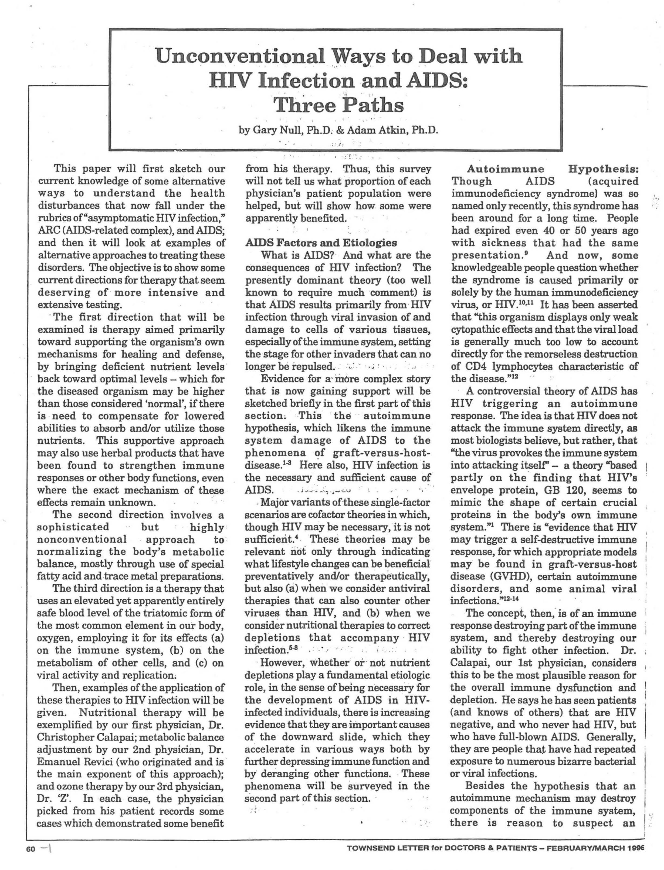

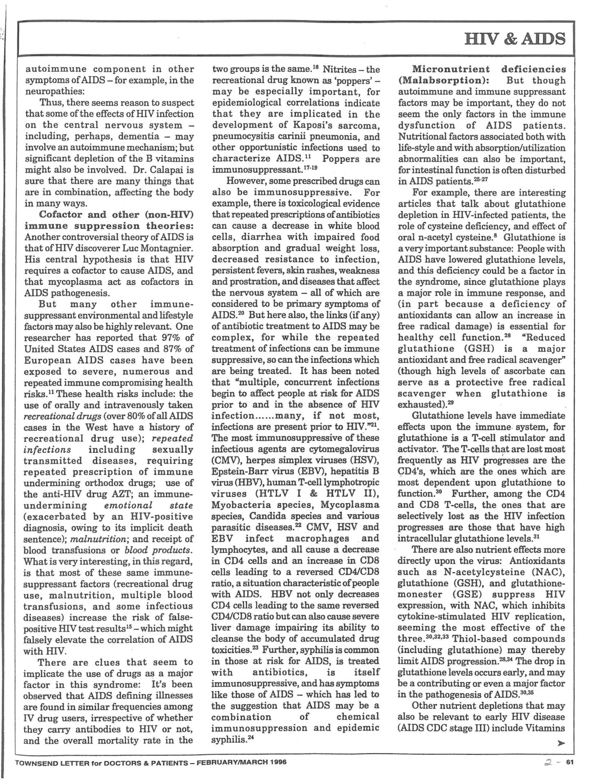
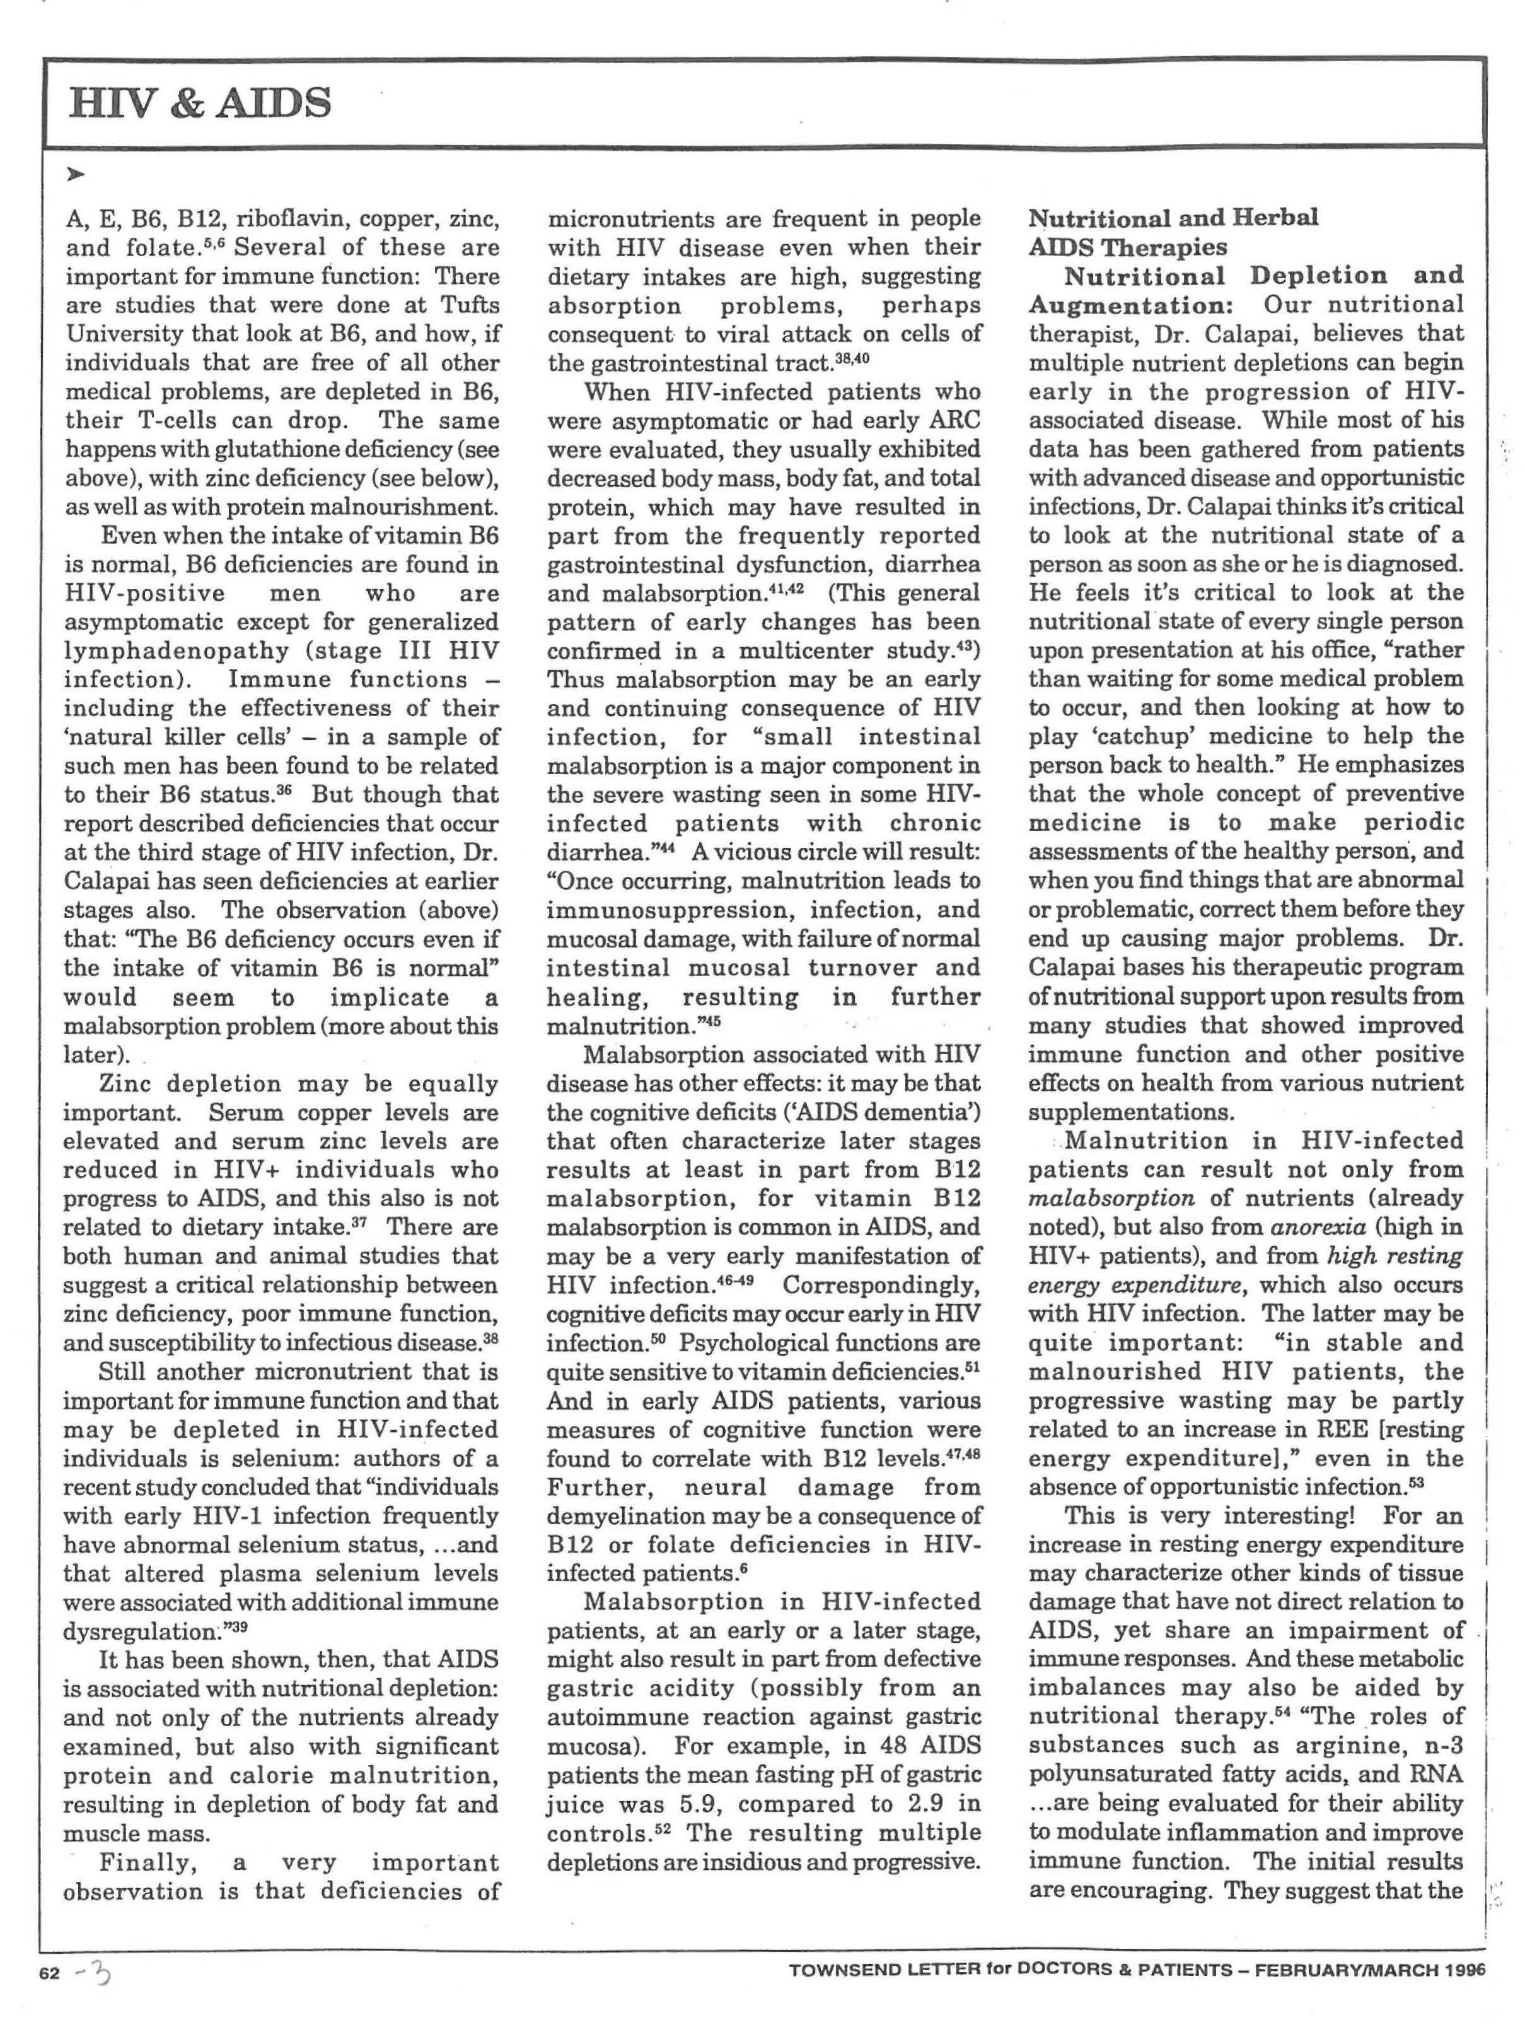

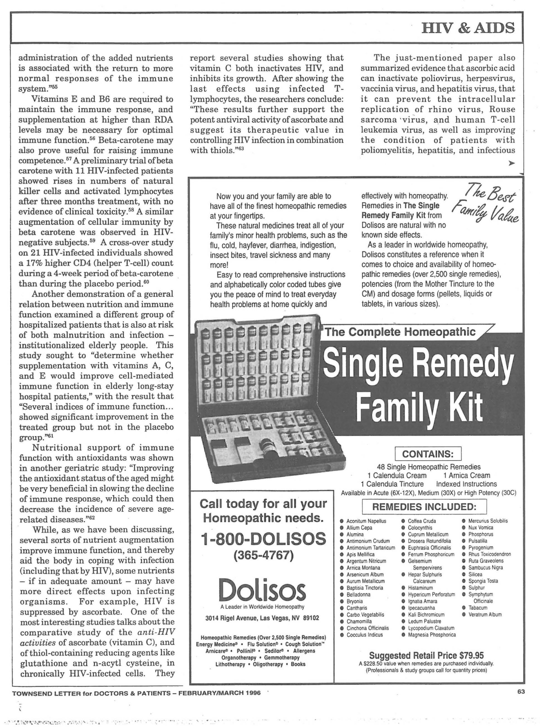

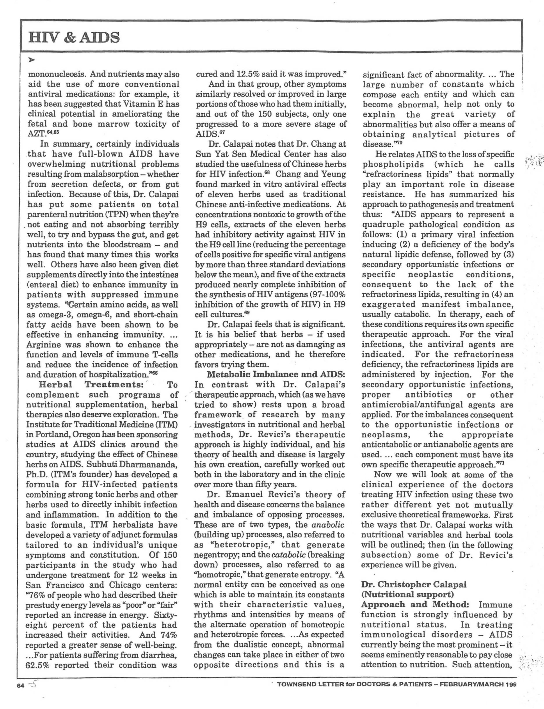
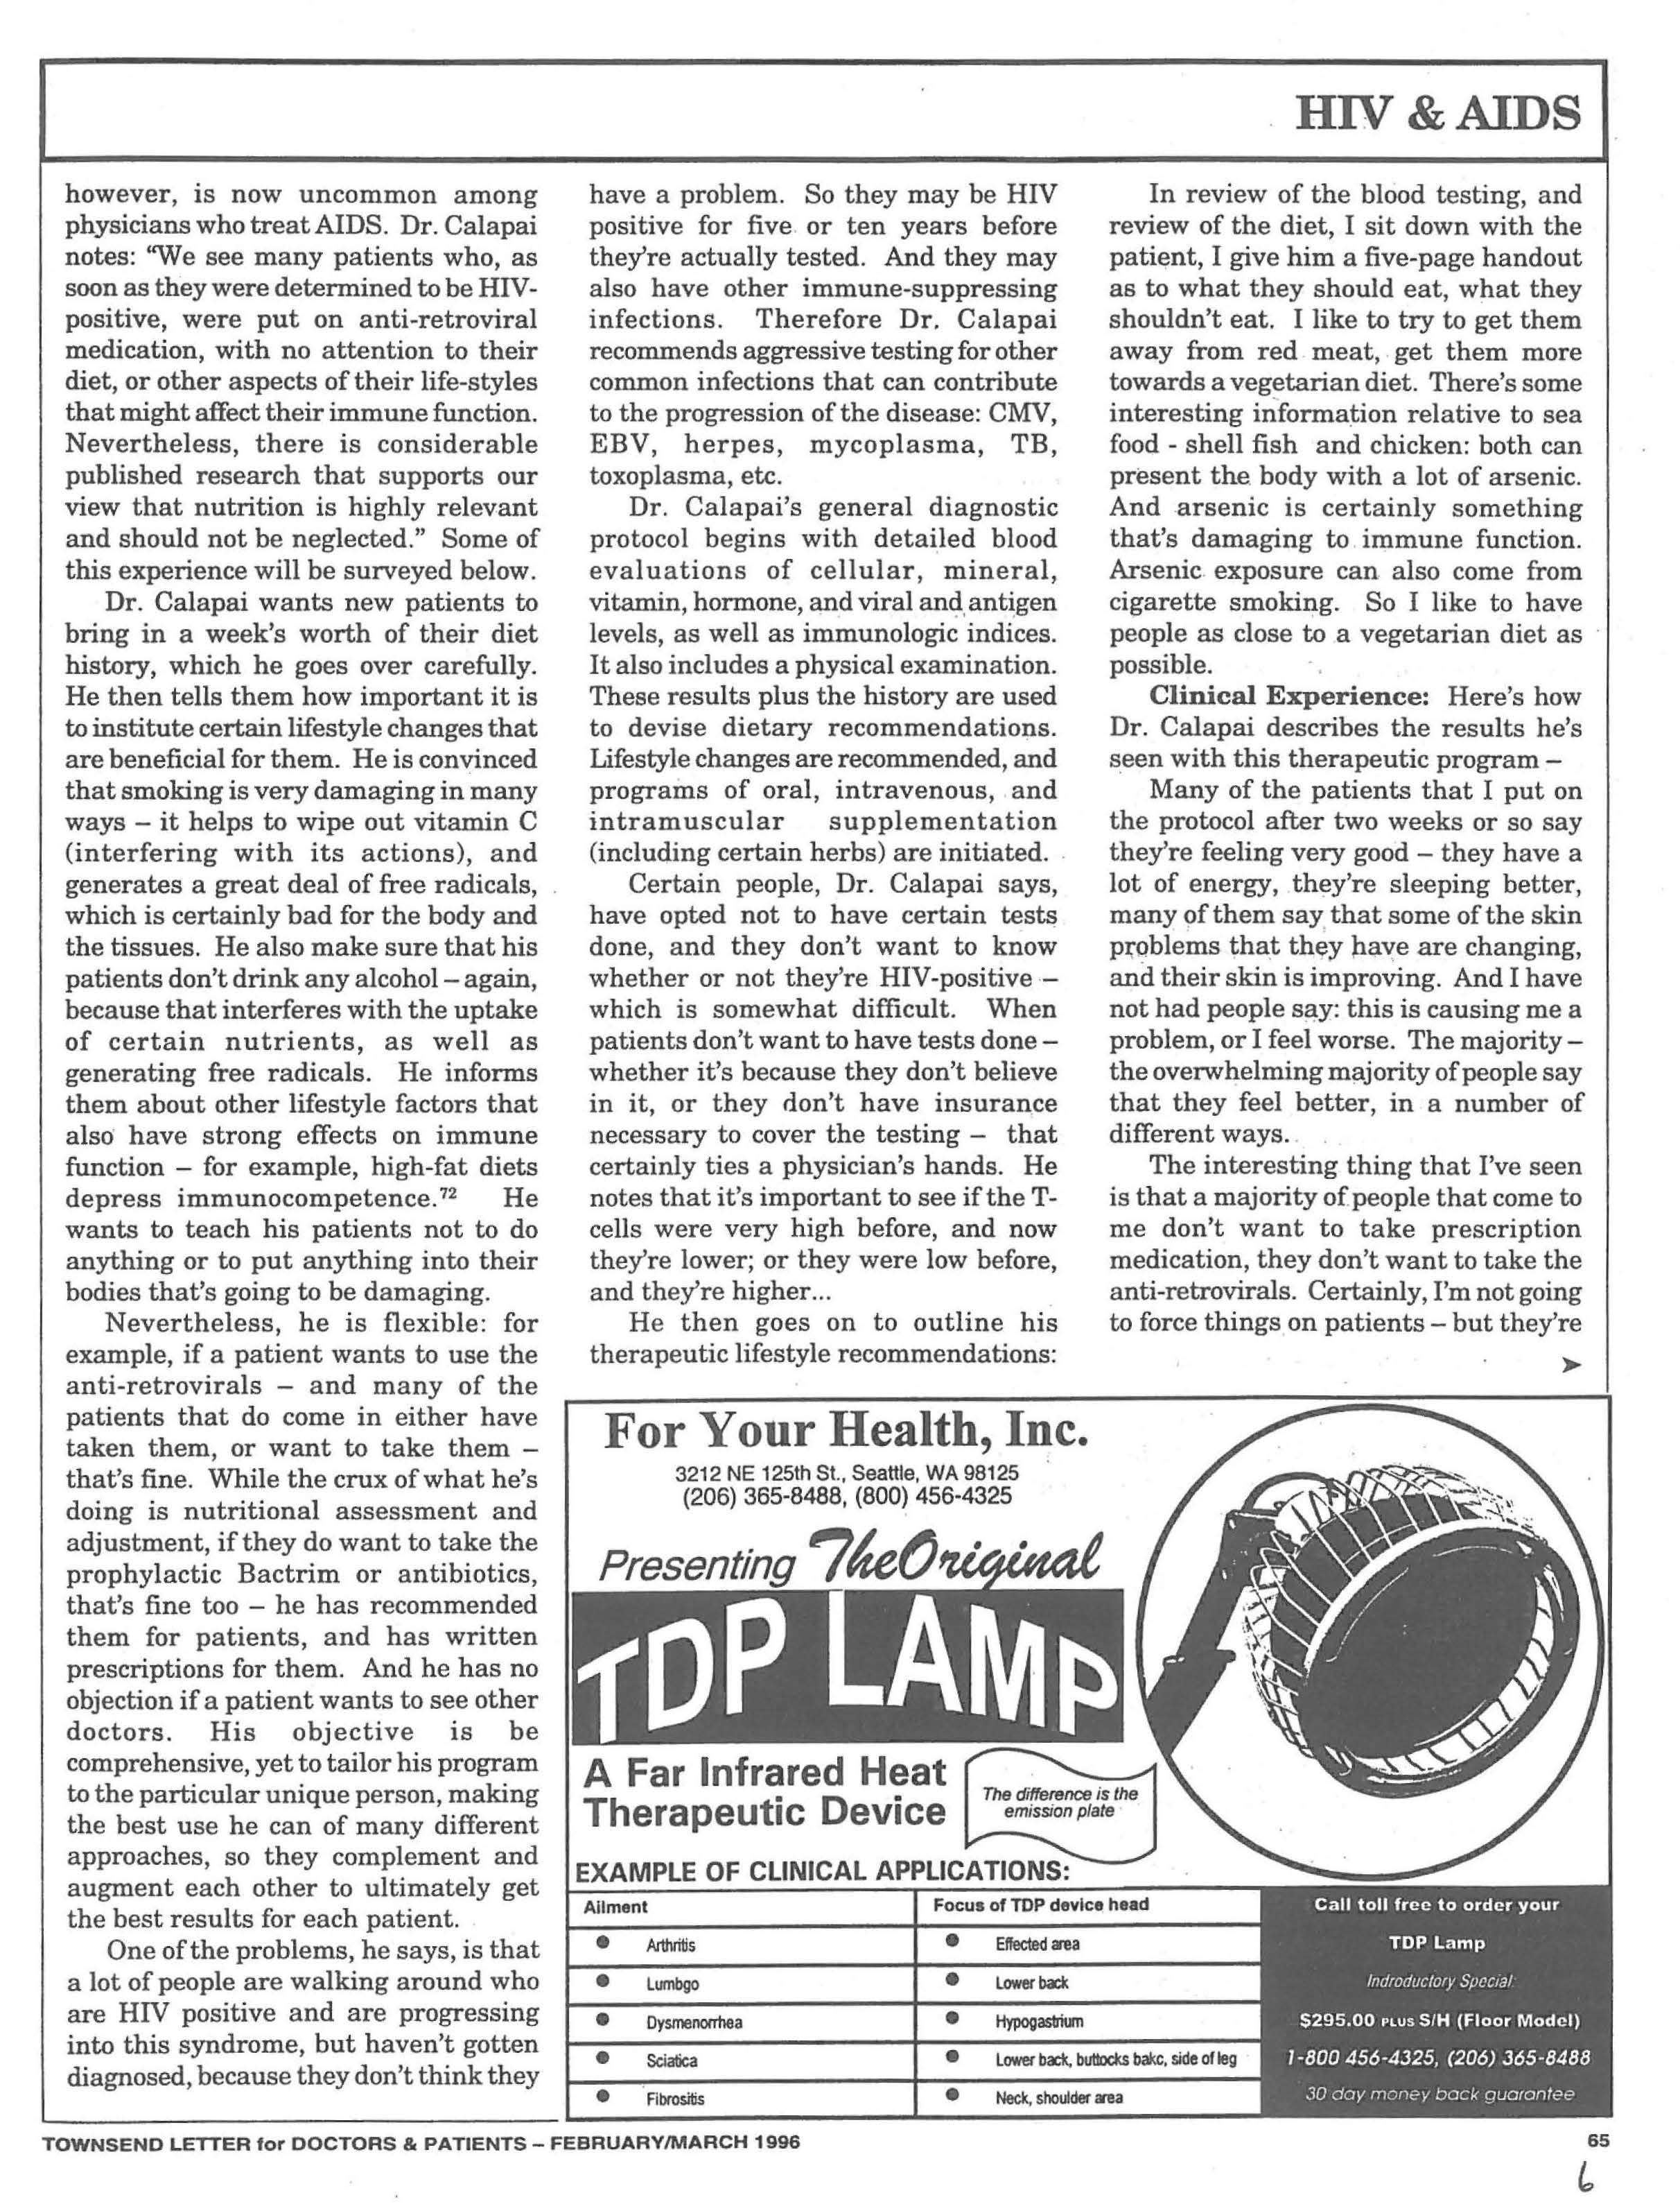
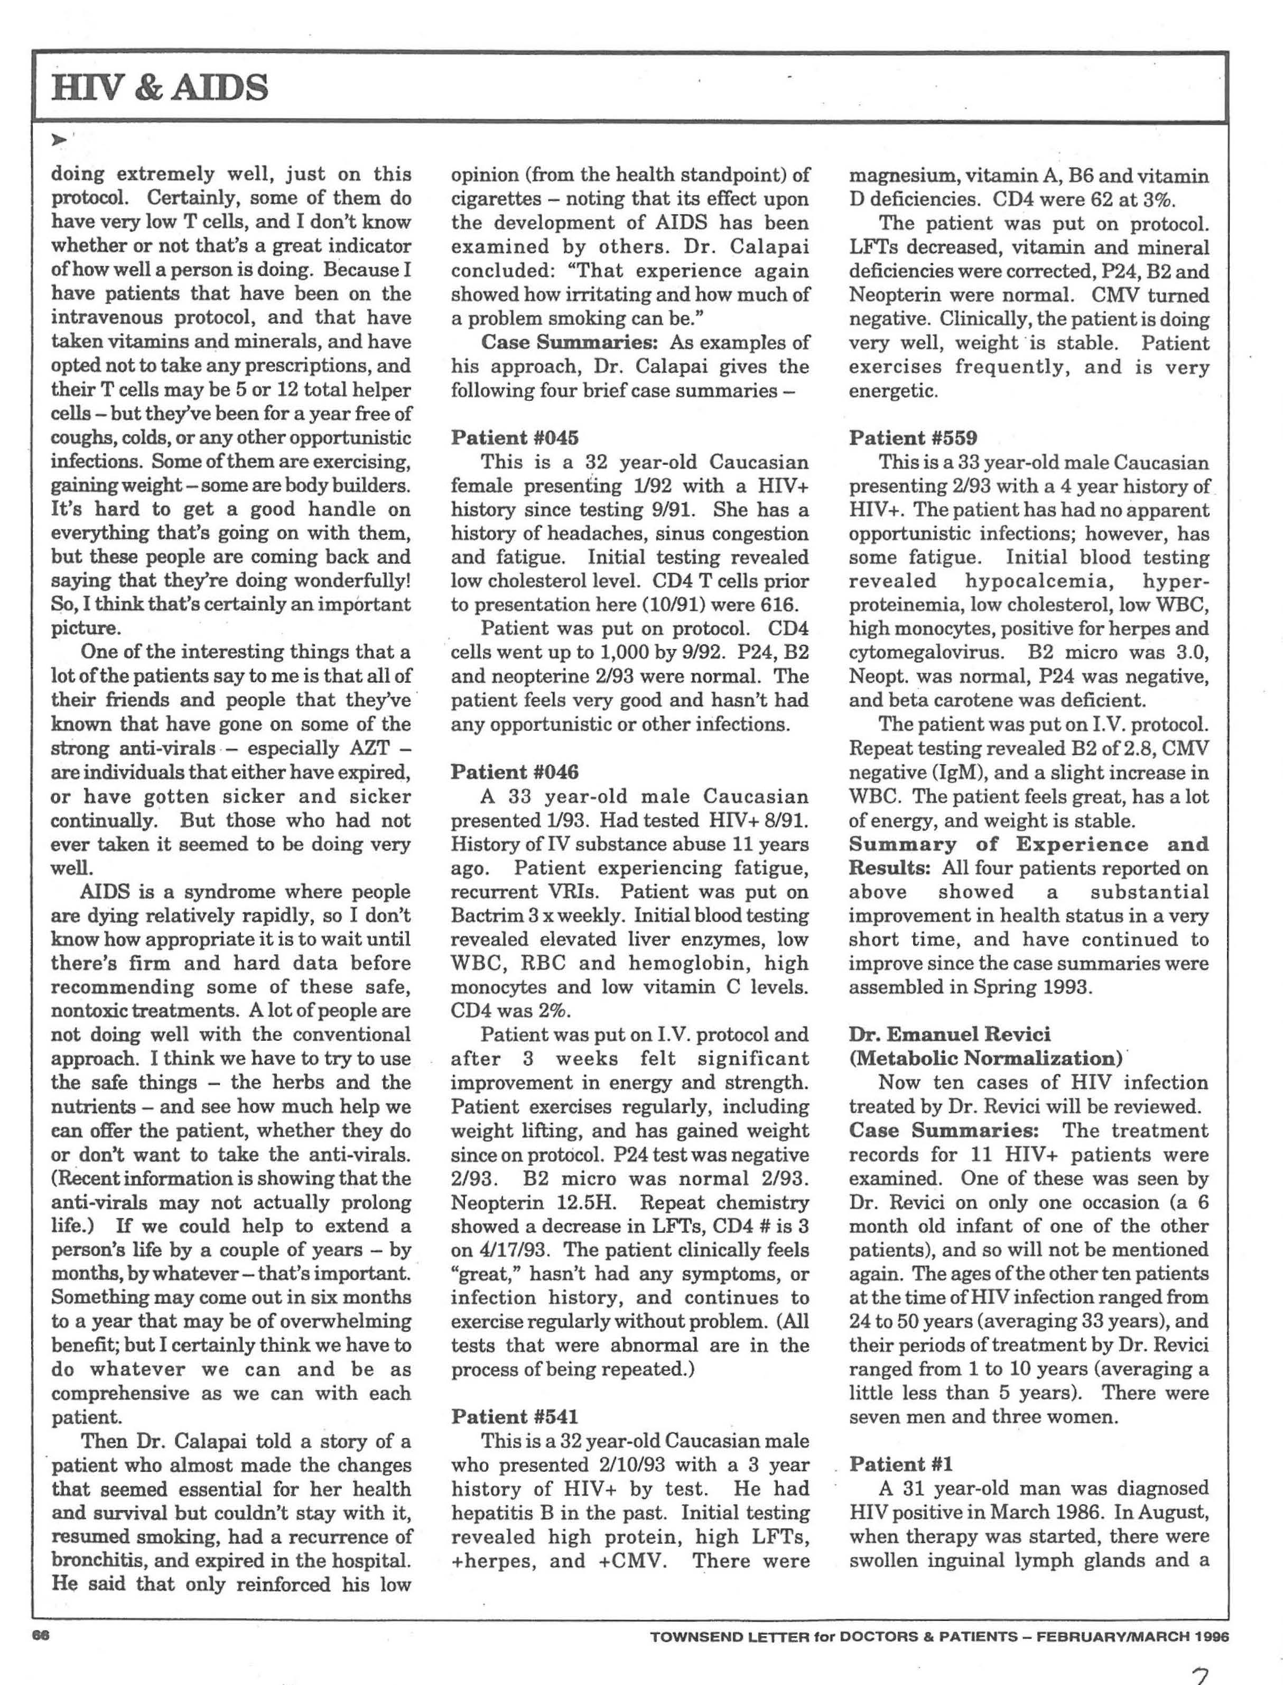
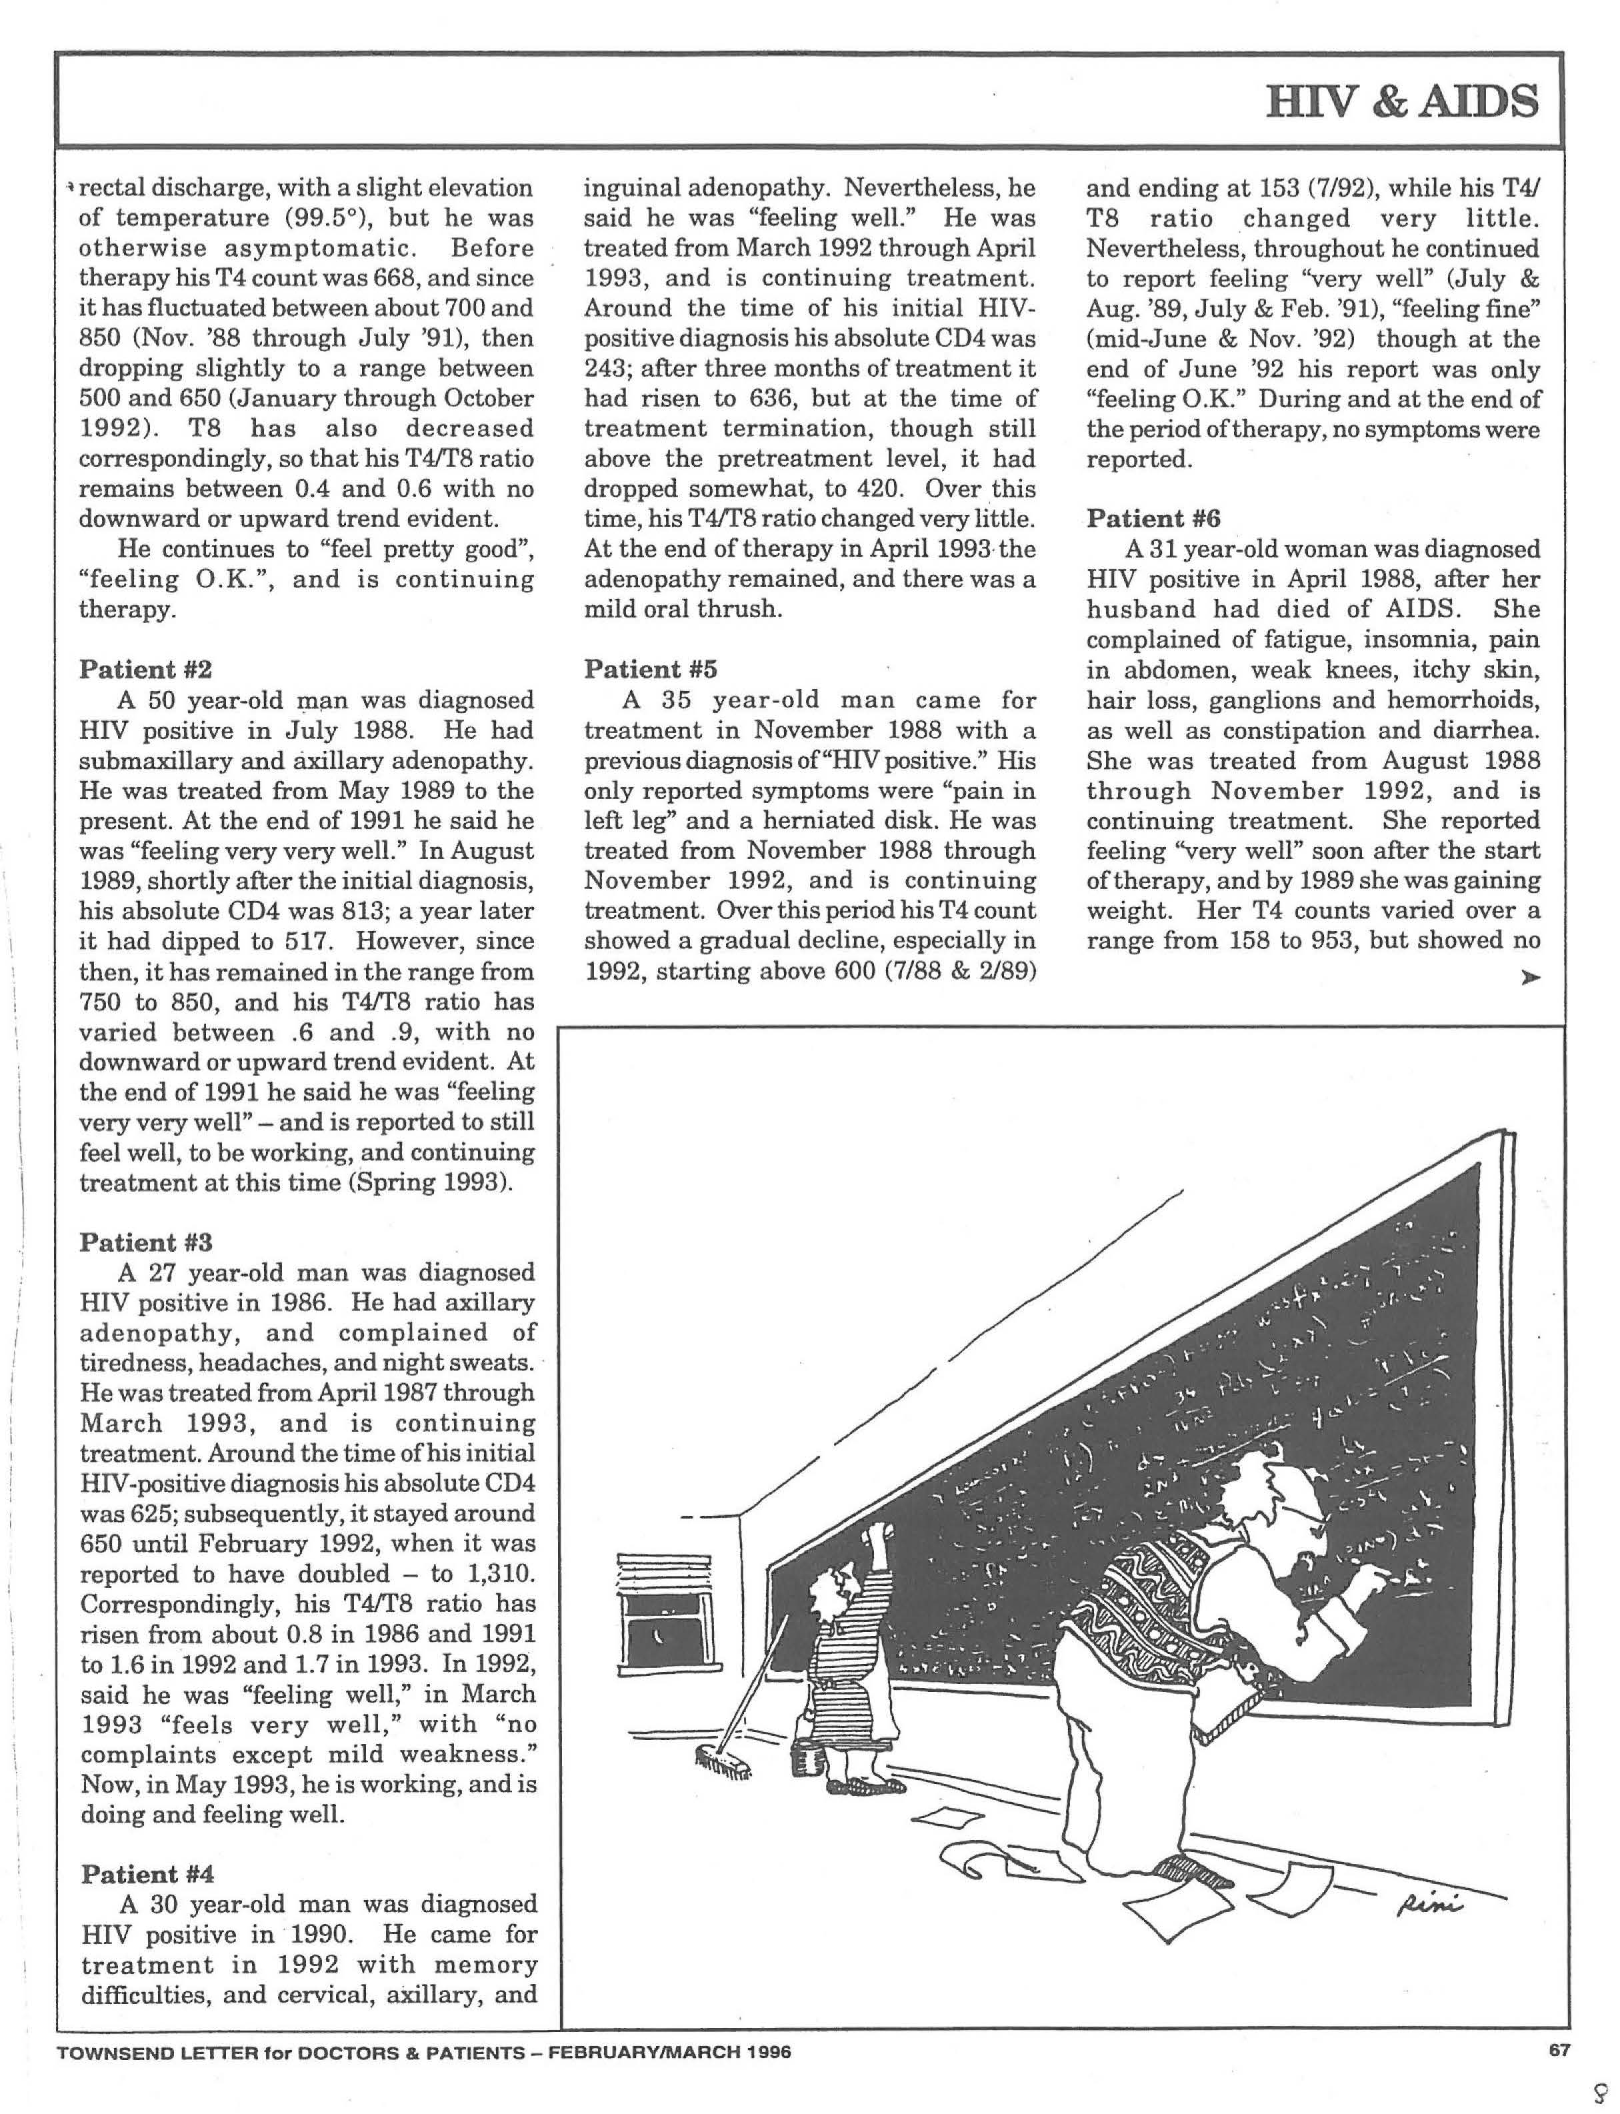
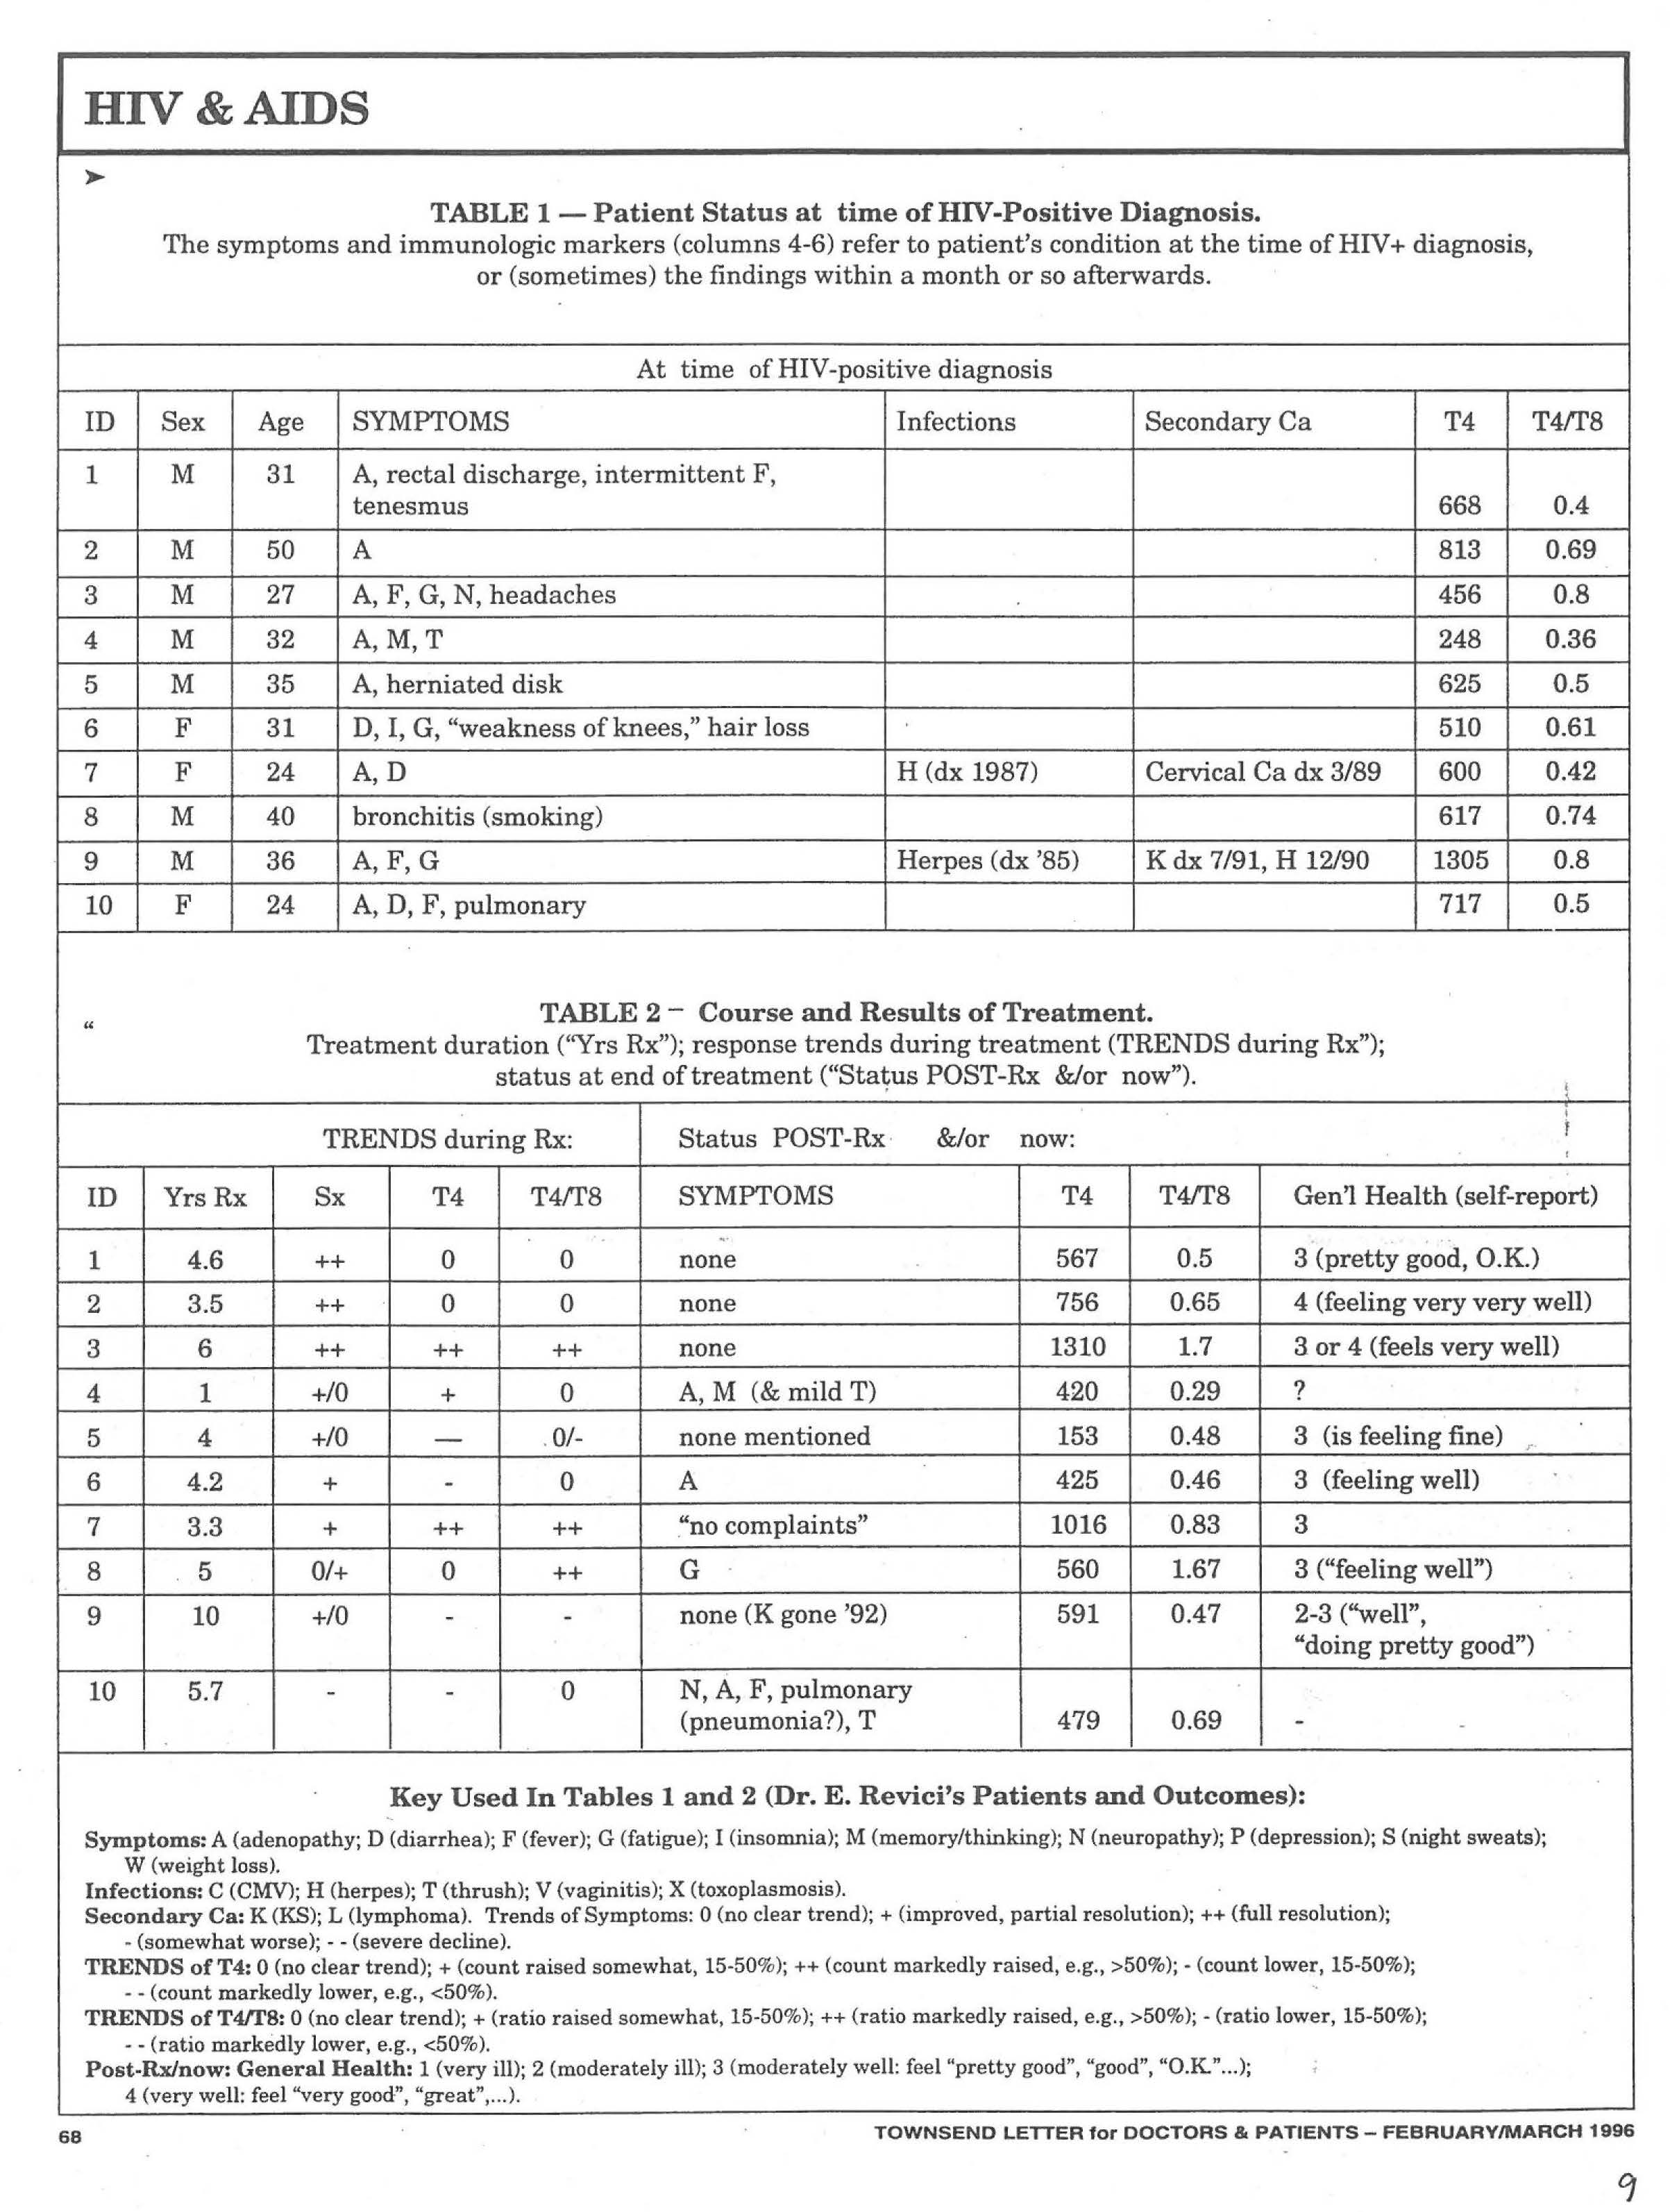
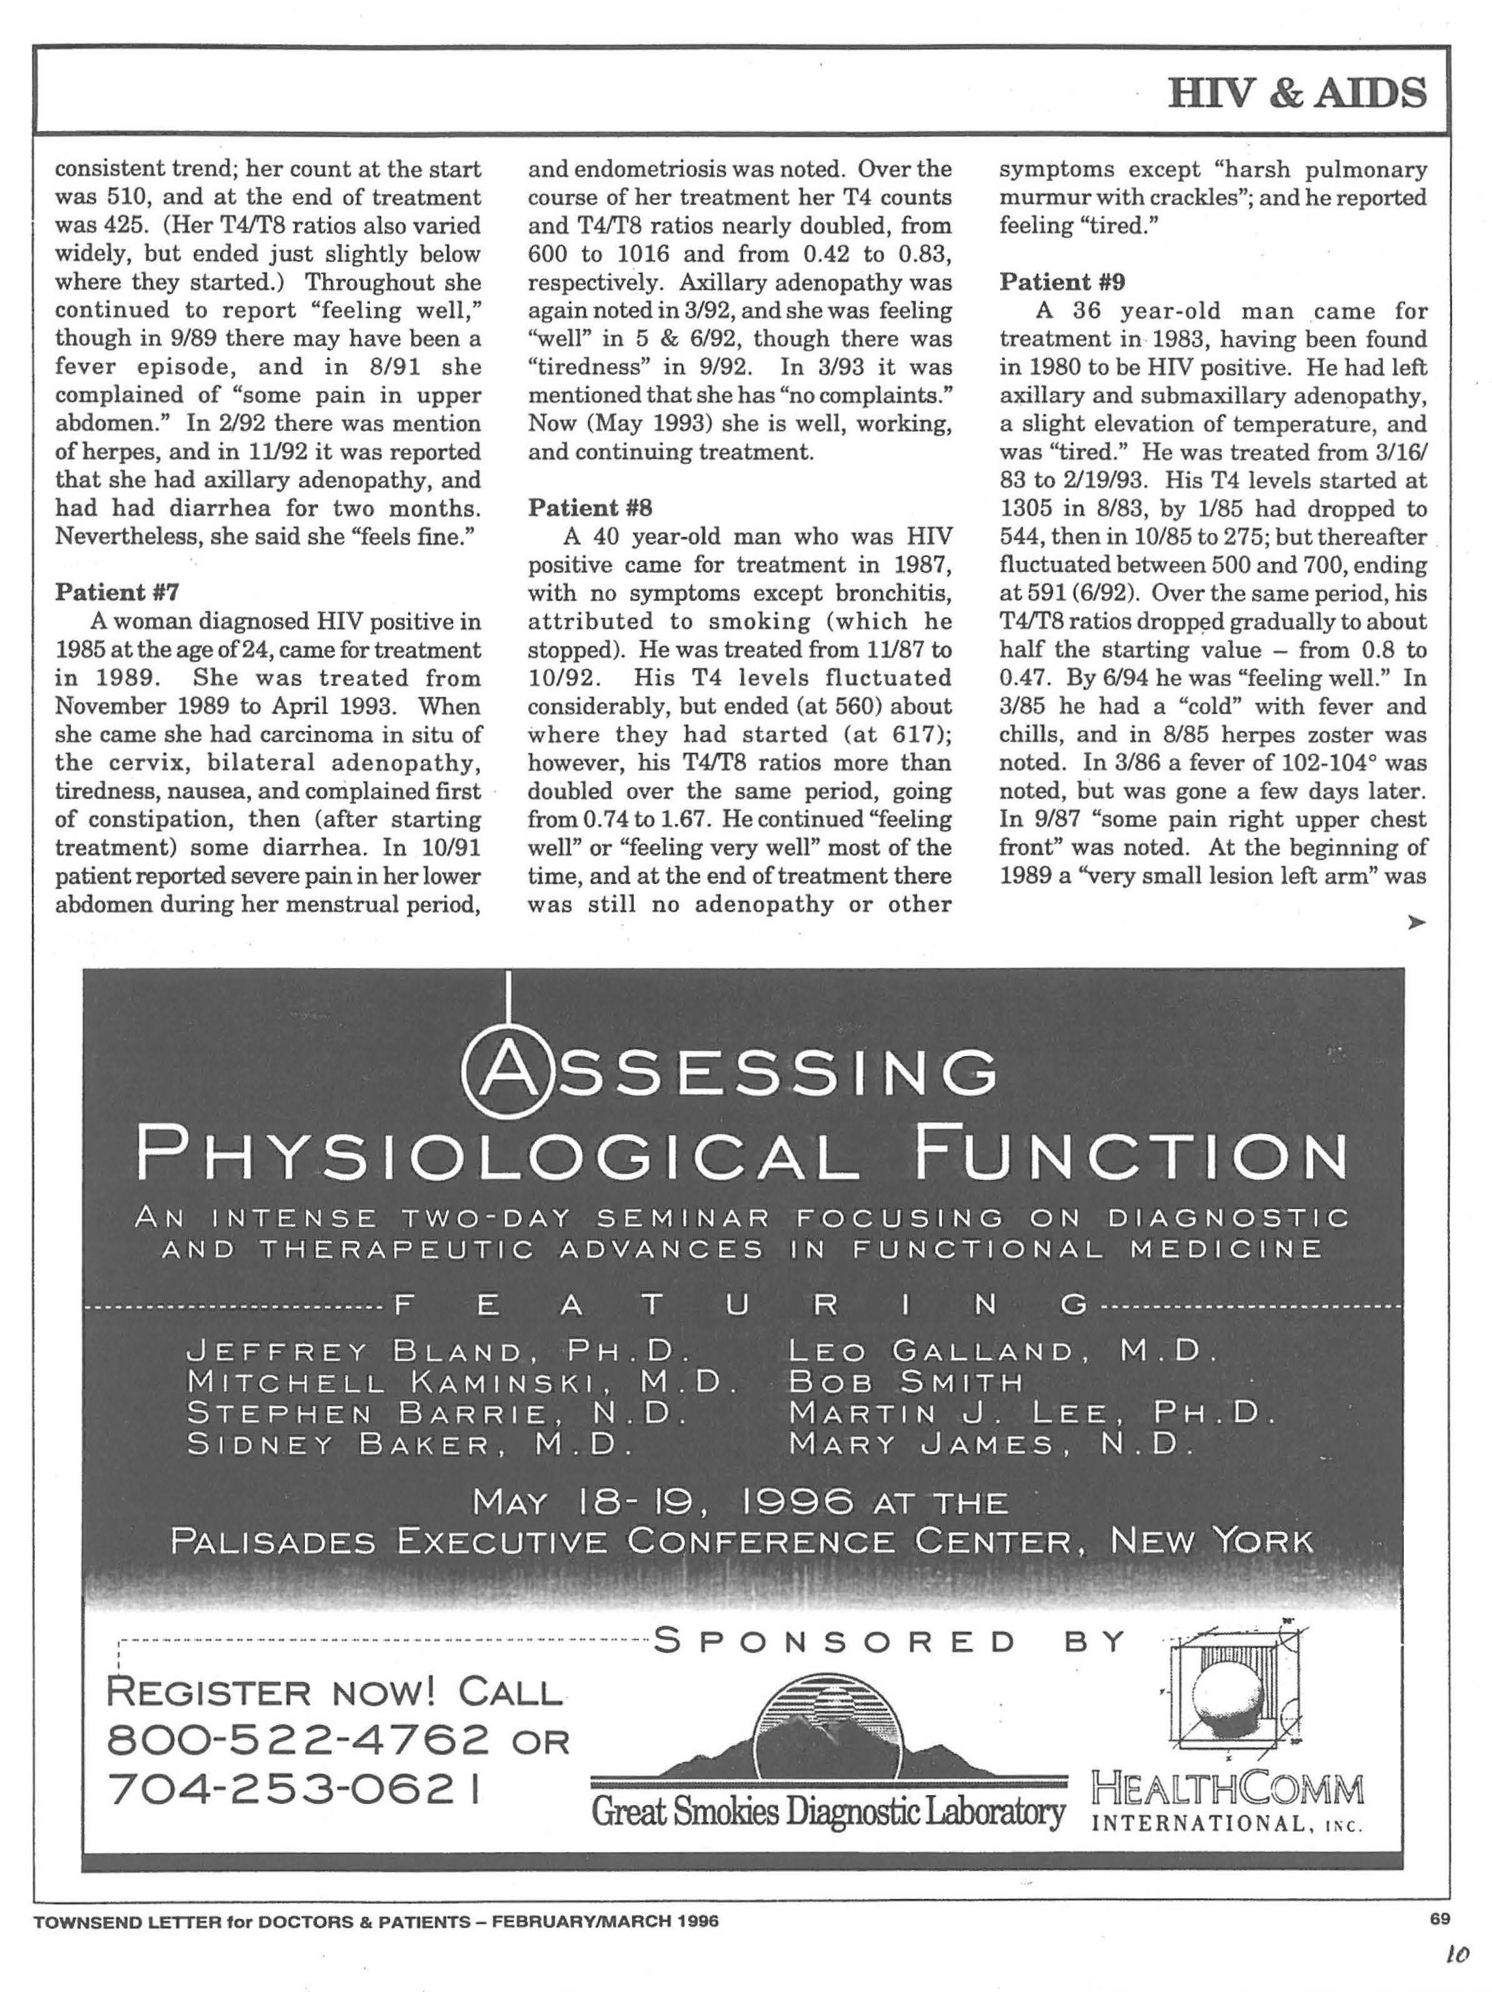
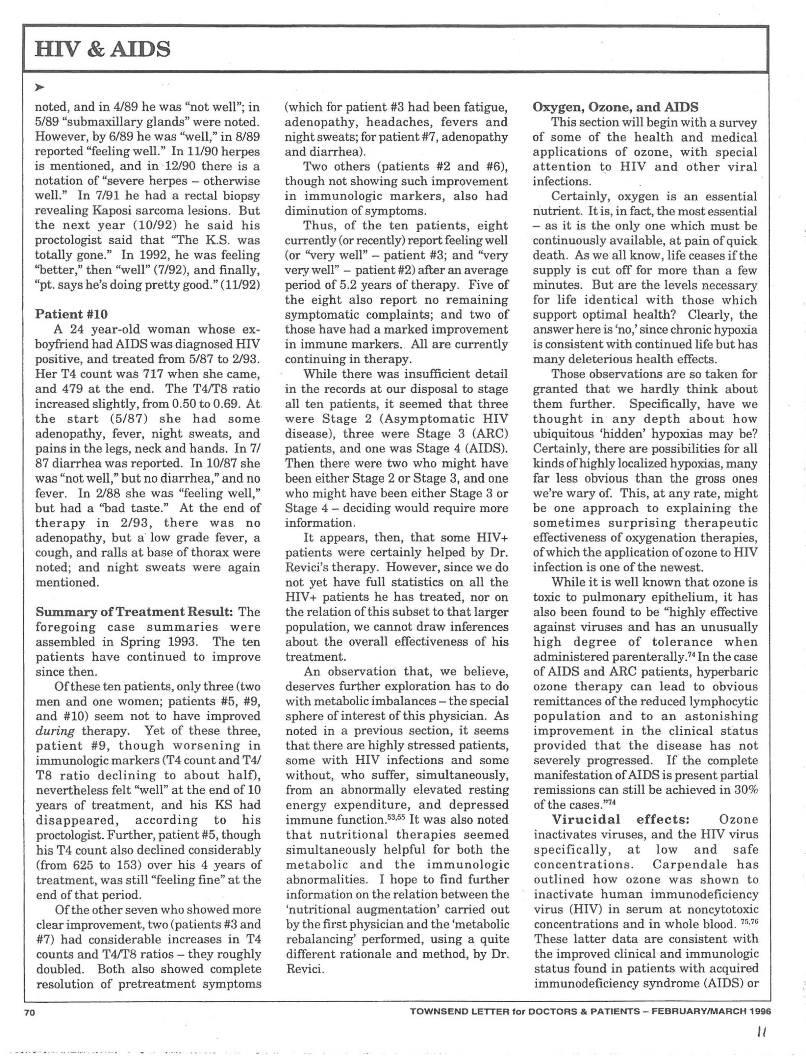
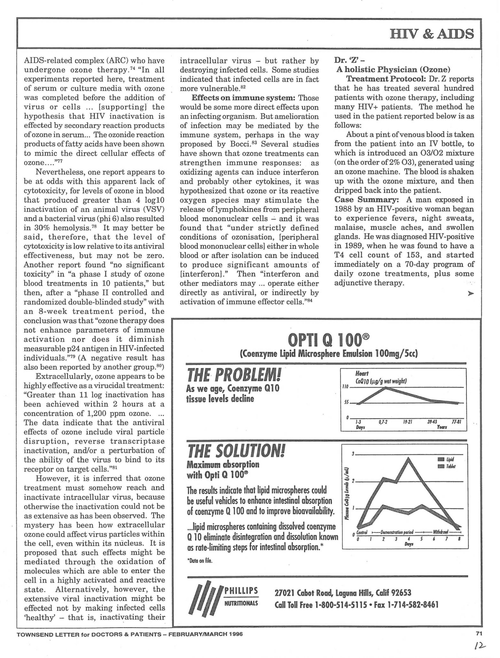
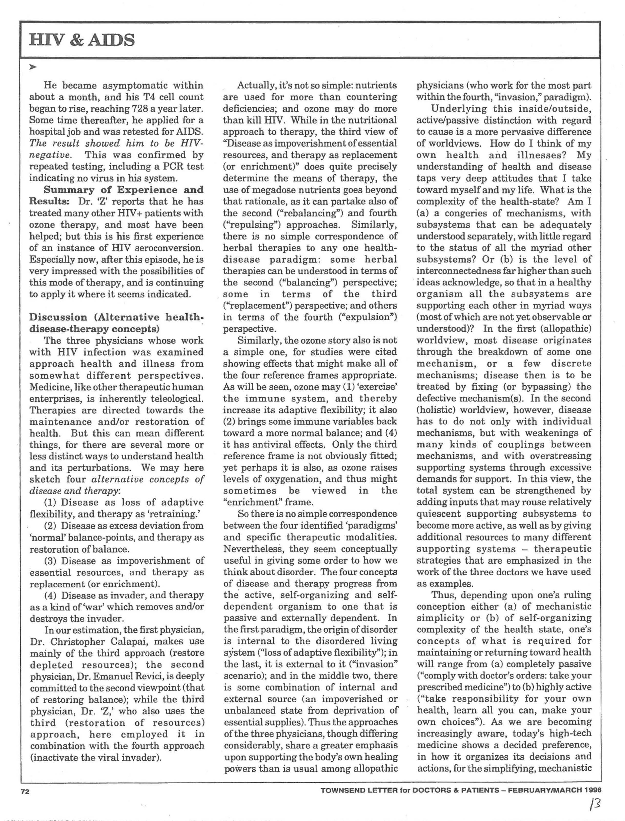
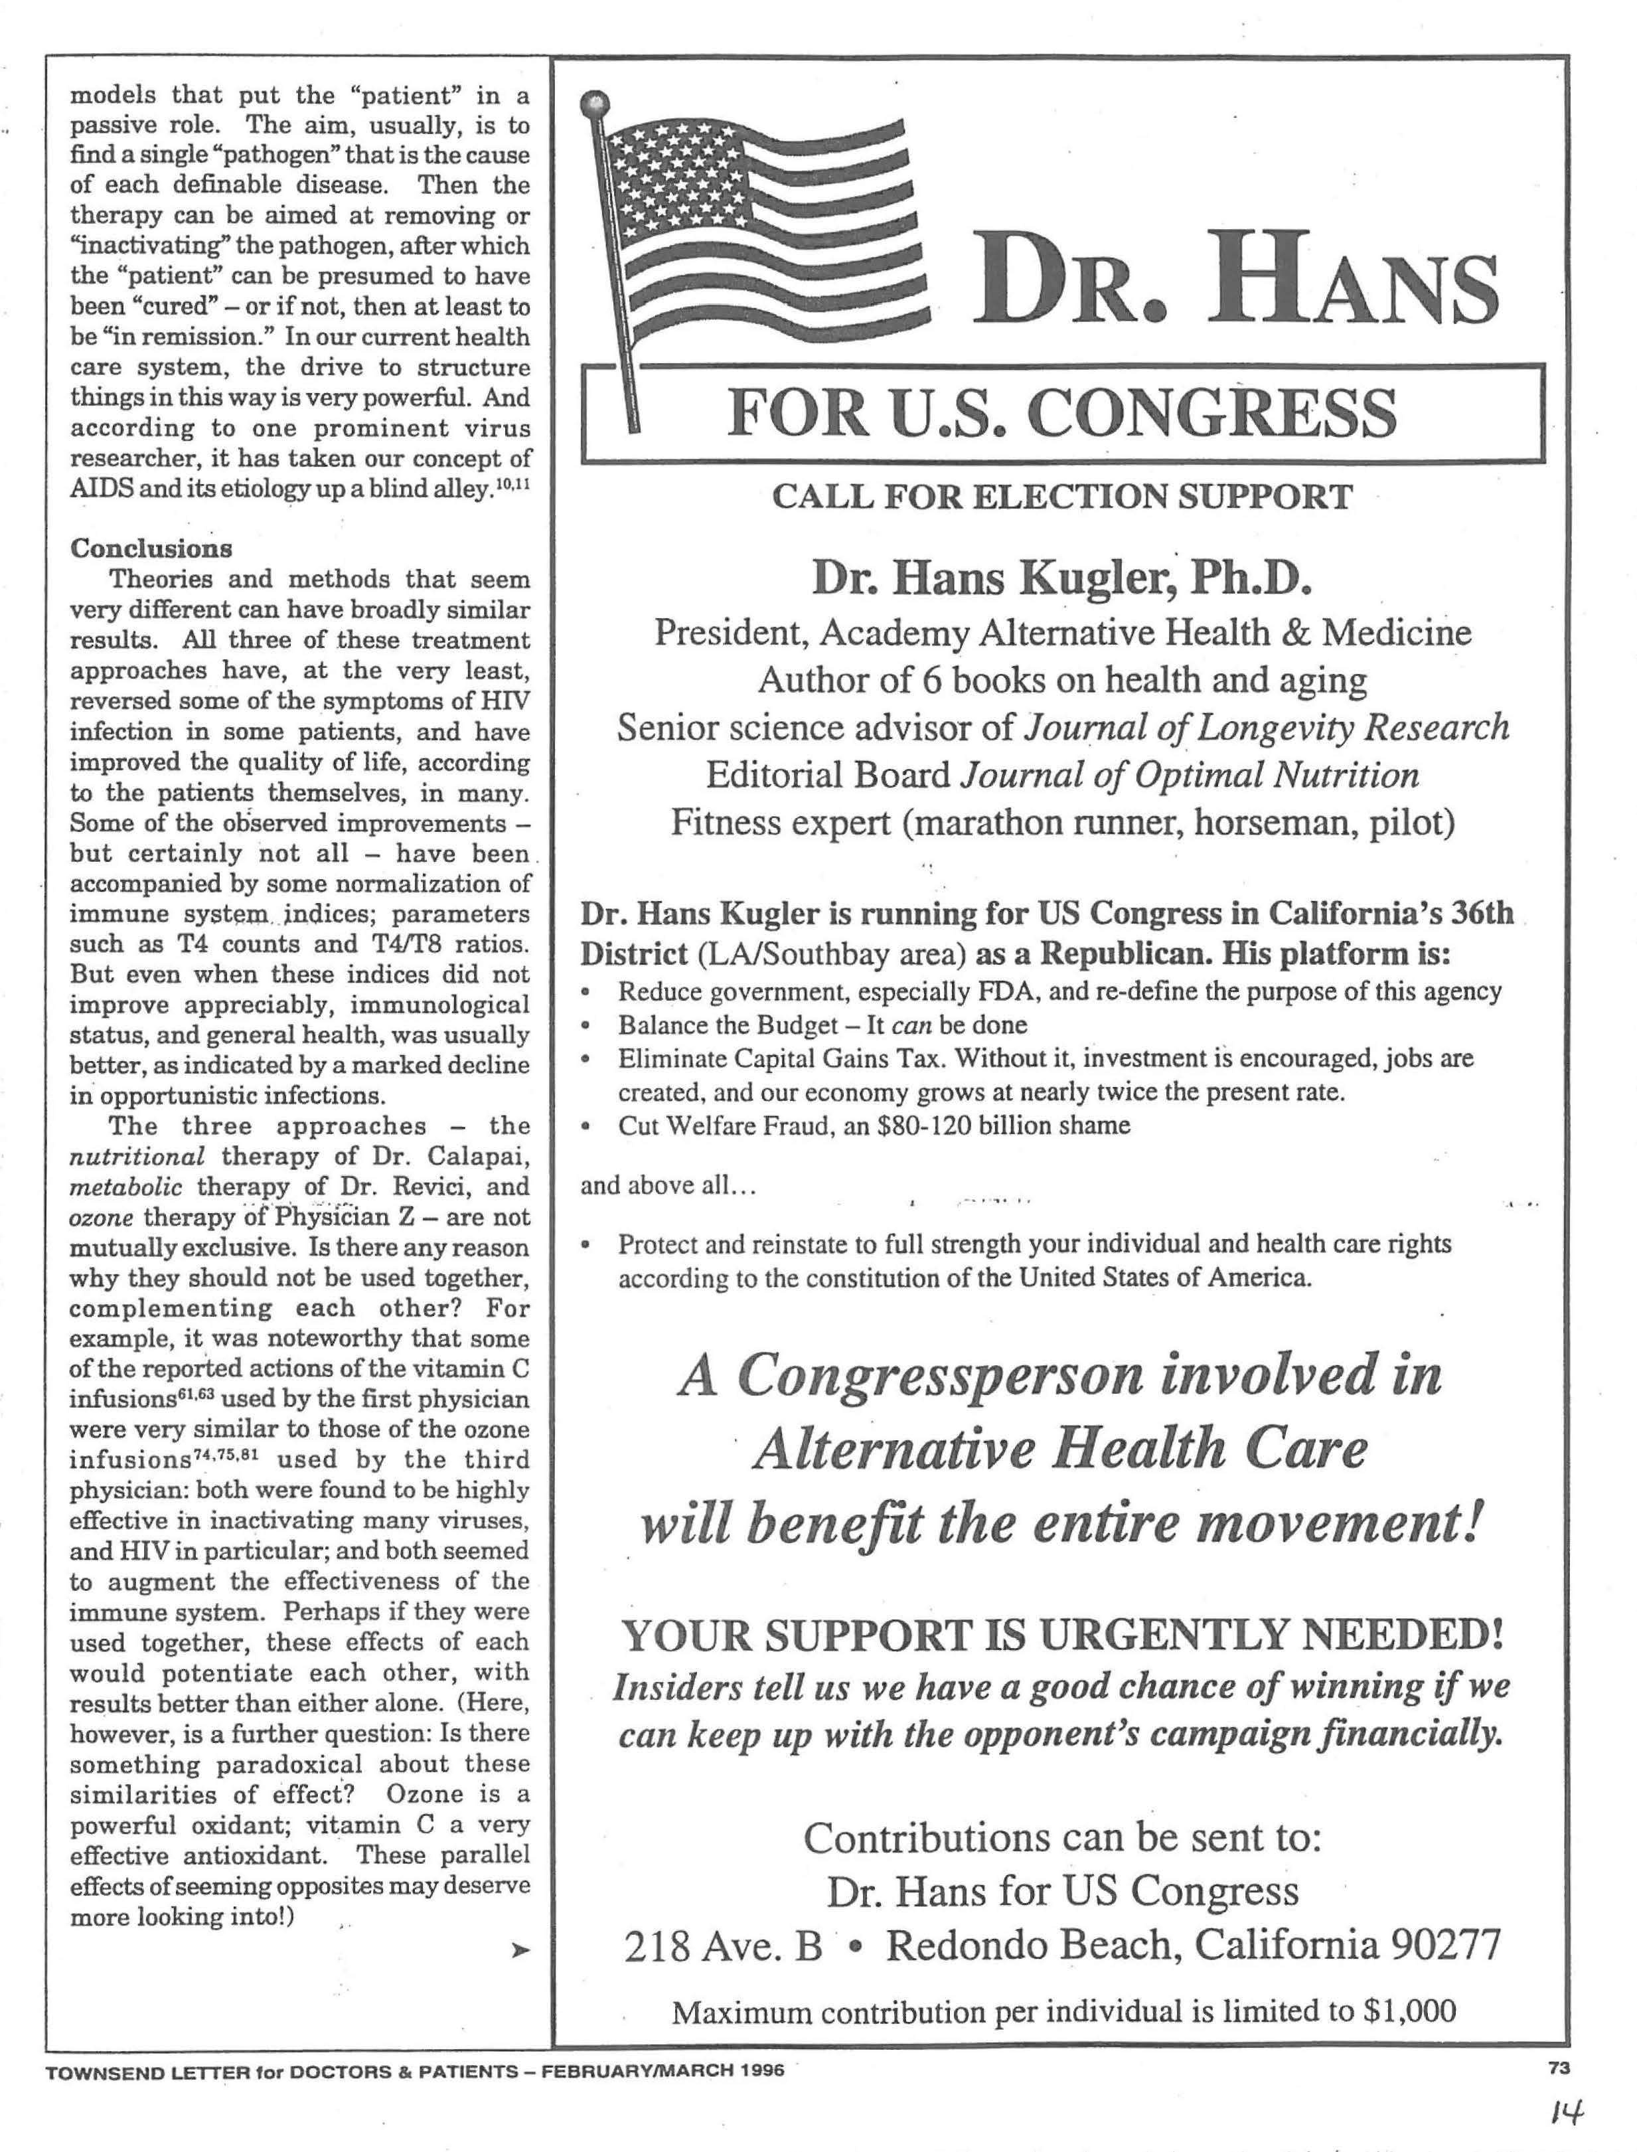
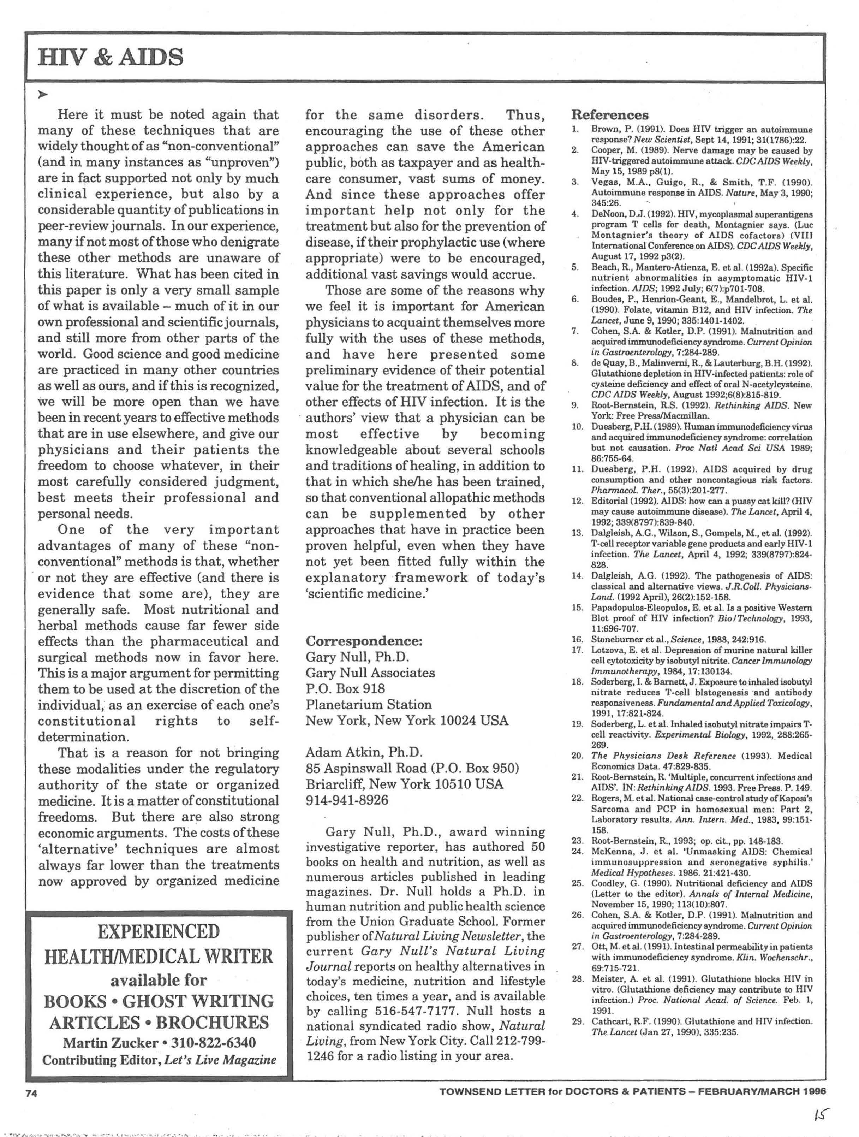
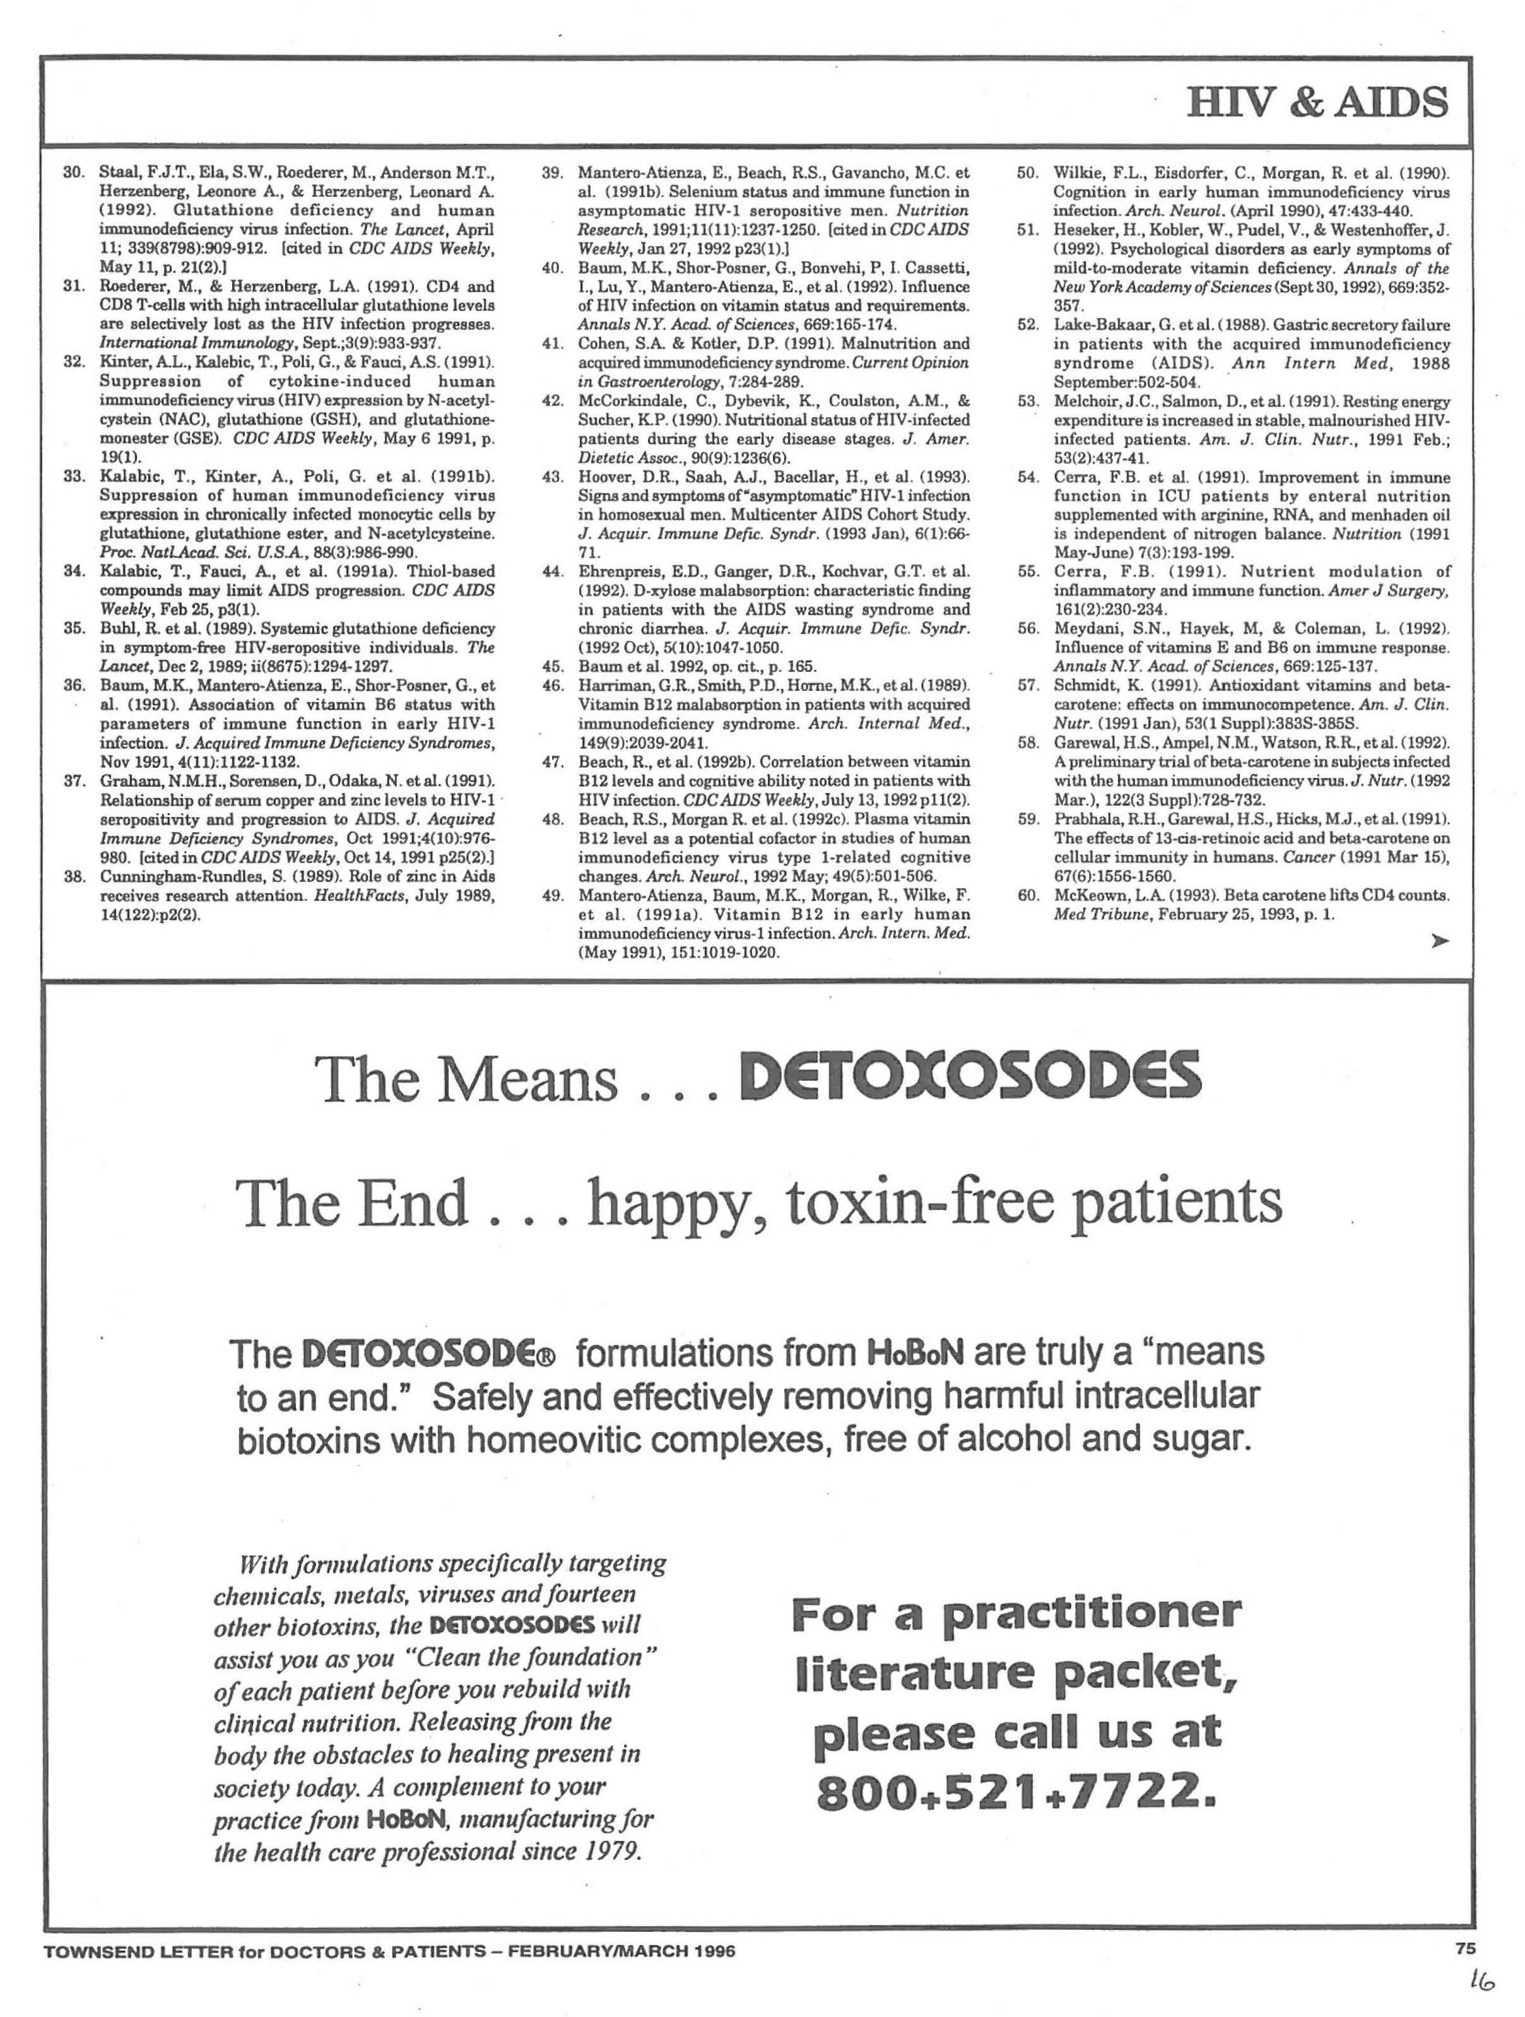
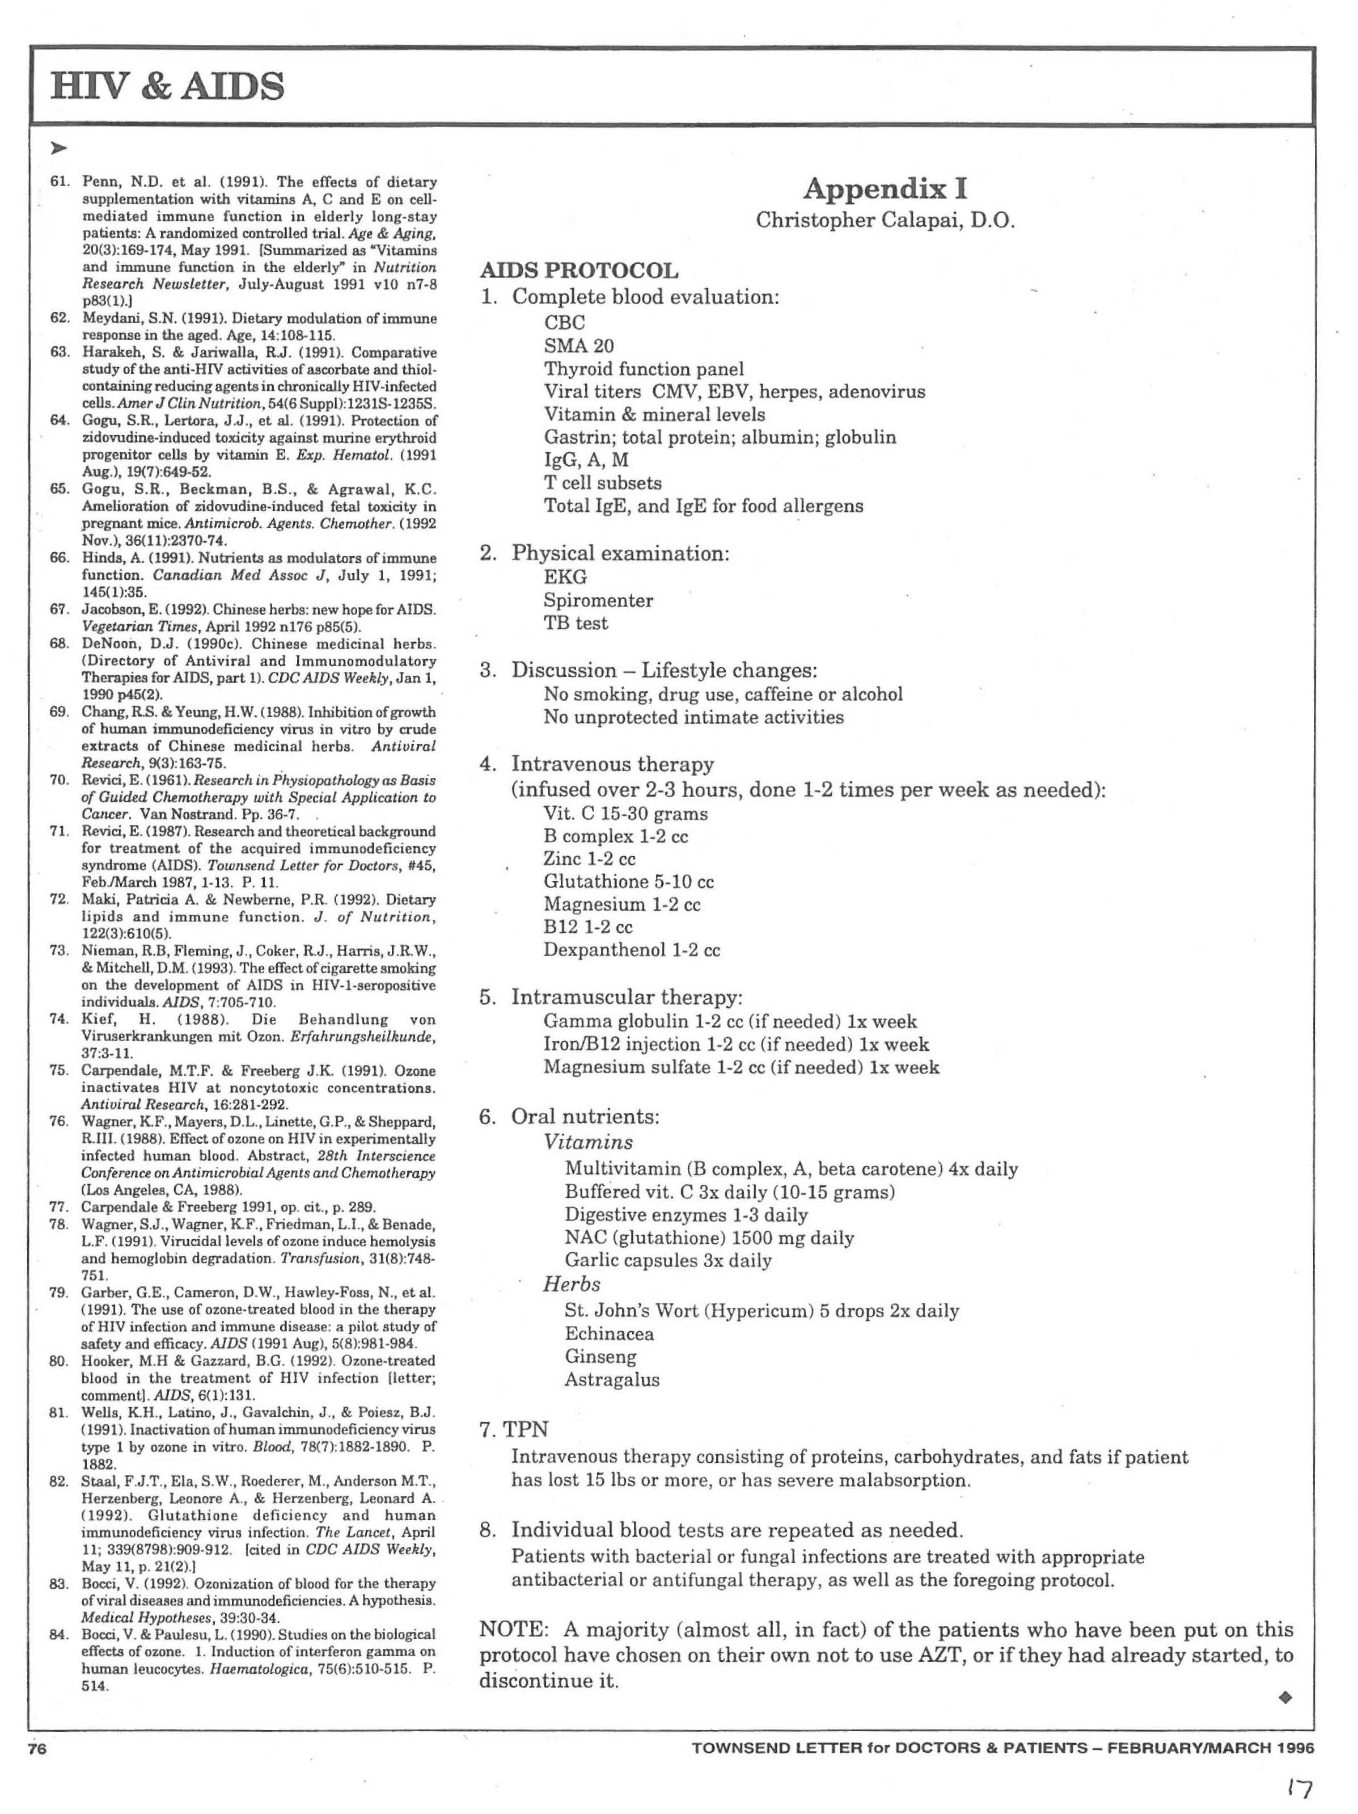

Appendix E









Culp-Ressler, Tara. "President Obama Pledges $100 Million In Funding To Help Beat AIDS." ThinkProgress RSS. N.p., 3 Dec. 2013. Web. 16 Dec. 2013. <http://thinkprogress.org/health/2013/12/03/3010991/obama-100-million-aids/>.
Ibid
Kiecolt-Glaser, J. K., Glaser, R. (1993).. Mind and immunity. In: D. Goleman & J. Gurin, (Eds.) Mind/Body Medicine (pp. 39-59). New York: Consumer Reports.
Sauter, C., Wolfensberger, C (1989) Anticancer activities as well as antiviral and virus-enhancing properties of aqueousfruit extracts from fifty-six European plant species. European Journal of Cancer and Clinical Oncology Jun;25(6):987-990.
RS, Chang., Yeung, HW. (1988). Inhibition of growth of human immunodeficiency virus in vitro by crude extracts of Chinese medicinal herbs. Antiviral Research (pp. 163-175)
Zheng, MS. (1989). An experimental study of the anti-HSV-II action of 500 herbal drugs. Journal of Traditional Chinese Medicine. Jun;9(2):113-116.
Passwater RA. Antioxidant Nutrients and AIDS: Exploring the Possibilities--An interview with Dr. Luc Montagnier, the discoverer of HIV. Whole Food Magazine, 1995:50-65

